Change Request
for the update of ISO 20022 financial repository items
- Origin of the request:
A.1 Submitter: SMPG CA Working Group.
A.2 Contact person: Jacques Littré, jacques.littre@swift.com, +3226554335
A.3 Sponsors: SMPG CA WG NMPGs members
- Related messages:
seev.001.001.04 MeetingNotificationV04

- Description of the change request:
Add a new optional “Vote/EarlyVoteWithPremiumDeadline” and a new optional “Vote/EarlyIncentivePremium” elements similar to “VoteWithPremiumDeadline” and “IncentivePremium” elements (with same data types respectively).
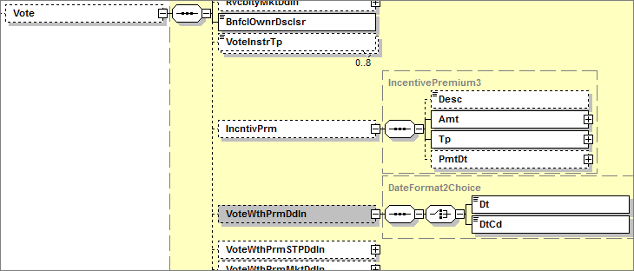
- Purpose of the change:
Each Vote With Premium deadline (STP, Market) can appear only once, however for Bondholder meetings, Vote With Premium Deadline and Vote With Premium STP Deadline could require another instance to reflect early deadlines with different incentive amounts.
- Urgency of the request:
Maintenance cycle 2014/2015
- Business examples:
N/A
- SEG recommendation:

Consider |  | X | Timing
 |  |  | - Next yearly cycle: 2014/2015  (the change will be considered for implementation in the yearly maintenance cycle which starts in 2014 and completes with the publication of new message versions in the spring of 2015) |  | X
- At the occasion of the next maintenance of the messages
(the change will be considered for implementation, but does not justify maintenance of the messages in its own right – will be pending until more critical change requests are received for the messages)
- Urgent unscheduled
(the change justifies an urgent implementation outside of the normal yearly cycle)
 |  |  | - Other timing:
Comments:

Reject
Reason for rejection:

