Change Request
for the update of ISO 20022 financial repository items
- Origin of the request:
A.1 Submitter: SMPG CA Working Group.
A.2 Contact person: Jacques Littré, jacques.littre@swift.com, +3226554335
A.3 Sponsors: SMPG CA WG NMPGs members
- Related messages:
seev.001.001.04 MeetingNotificationV04

- Description of the change request:
Replace the current data type of MeetingDetails/MeetingDate, which is a choice between a date or date code (Unknown), by a choice between a Date alone or a DateTime or a DateCode (“Unknown”).

- Purpose of the change:
In the current data type, the element Date is typed by an ISODateTime data type which is a bit confusing at first. Secondly, for meetings where only the date is known and there is no time yet provided, having only a DateTime data type might also be confusing since the time is mandatory.
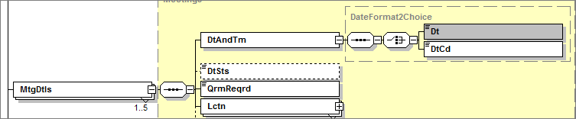
- Urgency of the request:
Maintenance cycle 2014/2015
- Business examples:
N/A
- SEG recommendation:

Consider |  | X | Timing
 |  |  | - Next yearly cycle: 2014/2015  (the change will be considered for implementation in the yearly maintenance cycle which starts in 2014 and completes with the publication of new message versions in the spring of 2015) |  | X
- At the occasion of the next maintenance of the messages
(the change will be considered for implementation, but does not justify maintenance of the messages in its own right – will be pending until more critical change requests are received for the messages)
- Urgent unscheduled
(the change justifies an urgent implementation outside of the normal yearly cycle)
 |  |  | - Other timing:
Comments:

Reject
Reason for rejection:

