Change Request
for the update of ISO 20022 financial repository items
- Origin of the request:
A.1 Submitter: SWIFT.
A.2 Contact person: Jacques Littré, jacques.littre@swift.com, +3226554335
A.3 Sponsors:
- Related messages:
seev.001.001.04 MeetingNotificationV04
seev.002.001.04 MeetingCancellationV04
seev.003.001.04 MeetingEntitlementNotificationV04
seev.004.001.04 MeetingInstructionV04
seev.005.001.04 MeetingInstructionCancellationRequestV04
seev.006.001.04 MeetingInstructionStatusV04
seev.007.001.04 MeetingVoteExecutionConfirmationV04
seev.008.001.04 MeetingResultDisseminationV04

- Description of the change request:
In all the seev.001 to seev.008 messages, align with latest Extension components i.e. rename the last “Extension” element as “SuplementaryData” and typed by “SupplementaryData1” as illustrated below.
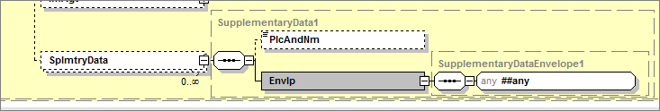
- Purpose of the change:
Migrate to the latest version of the “Extension” component, i.e. the SupplementaryData component agreed by the RMG and requested by the RA in CR0049.

- Urgency of the request:
Maintenance cycle 2014/2015
- Business examples:
N/A
- SEG recommendation:

Consider |  | X | Timing
 |  |  | - Next yearly cycle: 2014/2015  (the change will be considered for implementation in the yearly maintenance cycle which starts in 2014 and completes with the publication of new message versions in the spring of 2015) |  | X
- At the occasion of the next maintenance of the messages
(the change will be considered for implementation, but does not justify maintenance of the messages in its own right – will be pending until more critical change requests are received for the messages)
- Urgent unscheduled
(the change justifies an urgent implementation outside of the normal yearly cycle)
 |  |  | - Other timing:
Comments:

Reject
Reason for rejection:

