Change Request
for the update of ISO 20022 financial repository items

- Origin of the request:
A.1 Submitter: SMPG CA Working Group.
A.2 Contact person: Jacques Littré, jacques.littre@swift.com, +3226554335
A.3 Sponsors: SMPG CA WG NMPGs members
- Related messages:
The list of ISO 20022 messages which would be impacted by the changes, including the Message IDs as shown in the Catalogue of ISO 20022 messages:
seev.034.001.05 - CorporateActionInstructionStatusAdviceV05
seev.041.001.04 - CorporateActionInstructionCancellationRequestStatusAdviceV04
- Description of the change request:
- In the seev.034.001.05 (CorporateActionInstructionStatusAdviceV05), delete the 3 code values “Instruction Irrevocable” (INIR), “Rejected Since In Progress” (DPRG) and “Rejected Since Already Cancelled” (DCAN) in the sequence: InstructionProcessingStatus/Rejected/Reason/ReasonCode/Code in the data type RejectionReason42Code.
- In the seev.034.001.05 (CorporateActionInstructionStatusAdviceV05), delete the 4 code values “Payment Not Made” (NPAY), “Securities Not Delivered” (NSEC) and “Valid For Tax Authorities” (VLDA); “Send to Tax Authorities” (AUTH) in the sequence: InstructionProcessingStatus/Pending/Reason/ReasonCode/Code in the data type PendingReason11Code.
- In the seev.041.001.04 (CorporateActionInstructionCancellationRequestStatusAdviceV05) replace the data type code list AcceptedStatus1Choice in the sequence InstructionCancellationRequestStatus/Accepted by the component “NoSpecifiedReason1” so that the Accepted status has no longer reason codes ADEA, LATE, NSTP, OTHR associated as in the Securities Market Practice Group Market Practice (SMPG MP).
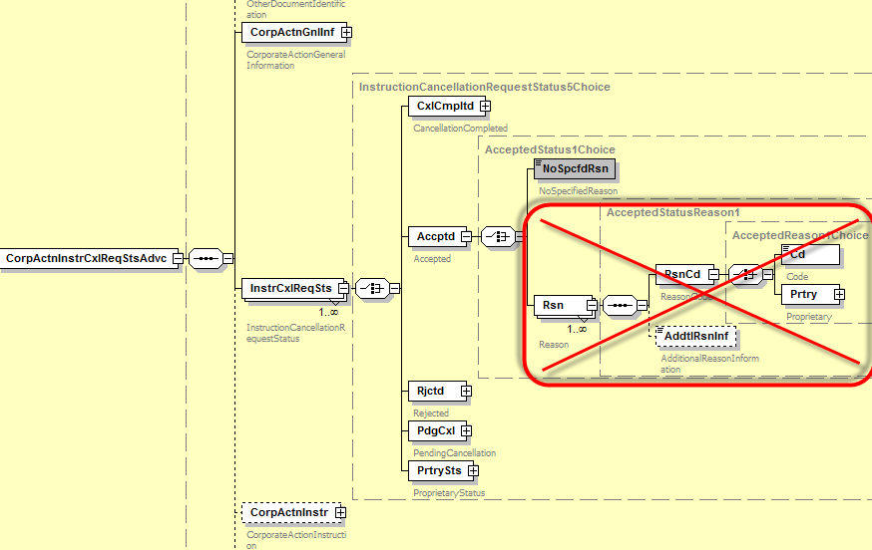

- In the seev.041.001.04 (CorporateActionInstructionCancellationRequestStatusAdviceV04) delete the 3 code values “Cancelled By Another Party” (CANO) and “Cancelled By System” (CANS) and “Cancelled By Subcustodian” (CSUB) in the sequence InstructionCancellationRequestStatus/CancellationCompleted/Reason/ReasonCode/Code in the data type CancelledStatusReason11Code.
- In the seev.041.001.04 (CorporateActionInstructionCancellationRequestStatusAdviceV04) delete the 13 code values CANC, DQUA, DSEC, EVNM, INTV, INVA, LACK, NMTY, OPNM, OPTY, REFT, SAFE, CERT (and leave only ULNK, ADEA, OTHR DCAN, DPRG, INIR, LATE) in the sequence InstructionCancellationRequestStatus/Rejected/Reason/ReasonCode/Code in the data type RejectionReason17Code.
- Purpose of the change:
The reverse engineering exercise from ISO 15022 to ISO 20022 had decided to implement the SMPG MT567 (Corporate Action Status and Processing Advice) status and reason codes market practices directly in the ISO 20022 messages. When analysing the CR 606 change request, it appeared that there were a number of implementation mistakes in the reason codes lists of the InstructionStatusAdvice (seev.034) and InstructionCancellationRequestStatusAdvice (seev.041) messages in the sense that for some statuses, the ISO 20022 messages implement the full reason code list of the ISO 15022 messages and not the SMPG restricted reason code lists (like in the seev.032 status message).
It is proposed to correct those mistakes so that the ISO 20022 Corporate Actions (CA) status messages implements strictly the SMPG market practices as initially agreed.
- Urgency of the request:
Maintenance cycle 2014/2015

- Business examples:
N/A.
- SEG recommendation:

Consider |  | X | Timing
 |  |  | - Next yearly cycle: 2014/2015  (the change will be considered for implementation in the yearly maintenance cycle which starts in 2013 and completes with the publication of new message versions in the spring of 2014) |  | X
- At the occasion of the next maintenance of the messages
(the change will be considered for implementation, but does not justify maintenance of the messages in its own right – will be pending until more critical change requests are received for the messages)
- Urgent unscheduled
(the change justifies an urgent implementation outside of the normal yearly cycle)
 |  |  | - Other timing:
Comments:

Reject
Reason for rejection:

ANNEX: CR 606 of SR2014

CR 000606: MT567 - Delete Reason Codes ADEA & LATE from PACK Qualifier
Origin of request
Requesting Country:
Requesting Group: | SMPG
Sponsors
Complies with regulation
None
Business impact of this request
Business impact:
LOW – Low Impact on business applications
Since very low rate of current usage
Commitment to implement the change
Proportion of messages of this type that will be impacted by this change: Less than 0.2% of MT567
Country, community or group that is committed to use this change: NMPGs members of the CA SMPG
Year they commit to use this change: SR2014
Business context
This CR is a follow up to the approved SR 2013 CR 000407 last year requesting the change of name and definition of the code PACK with the Status Code qualifier :25D::IPRC so as to clarify its semantic to mean that the instruction is considered as “accepted for further processing” and not simply as “acknowledged” which lead to confusion with the status “Pending” especially when similar Reasons Codes can be used with both PACK and PEND statuses.
Last year, the CA SMPG had also issued a new market practice complementing this CR and recommending to no longer use the Reason Codes 24B::PACK//ADEA (“Account Servicer Deadline missed”) and 24B::PACK//LATE (“Market Deadline missed”) that were no longer deemed consistent with the PACK status and should only be used with the PEND status.
This CR is meant to enforce this CA SMPG market practice decided last year and change the standards accordingly by deleting the same 24B::PACK//ADEA and LATE reason codes.
Most part of the community using the instruction status message should benefit from this change in the sense that it will clarifies the instruction status flow, status and reason codes for the account owner.
Nature of change
Delete the codes ADEA (“Account Servicer Deadline missed”) and LATE (“Market Deadline missed”) in the Reason Code qualifier :24B::PACK (“Accepted Reason”) code list from the MT 567 status message.
Message type(s) impacted
MT 567, seev.034
Examples

Standards Illustration
1. ISO 15022 Illustration
A. In the MT 567 message, in the sequence A2a, in the :24B::PACK Reason Code qualifier, delete the code values ADEA (Account Servicer Deadline Missed) and LATE (Market Deadline Missed) as illustrated below.

MT 567 Field Specifications

13. Field 24B: Reason Code

FORMAT
Option B | :4!c/[8c]/4!c | (Qualifier)(Data Source Scheme)(Reason Code)

PRESENCE
Mandatory in optional subsequence A2a

QUALIFIER
(Error code(s): T89)
Order | M/O | Qualifier | R/N | CR | Options | Qualifier Description
1 | M | PEND | N | C1 | B | Pending Reason
 | or | REJT | N | C1 | B | Rejection Reason
 | or | CAND | N | C1 | B | Cancellation Reason
 | or | CANP | N | C1 | B | Cancellation Pending Reason
 | or | PACK | N | C1 | B | Accepted Reason

DEFINITION
This qualified generic field specifies:
CAND | Cancellation Reason | Specifies the reason why the instruction is cancelled.
CANP | Cancellation Pending Reason | Specifies the reason why a cancellation request sent for the related instruction is pending.
PACK | Accepted Reason | Specifies additional information about the processed instruction.
PEND | Pending Reason | Specifies the reason why the instruction/event has a pending status.
REJT | Rejection Reason | Specifies the reason why the instruction/cancellation request has a rejected status.

CODES
If Qualifier is PACK and Data Source Scheme is not present, Reason Code must contain one of the following codes (Error code(s): K24):
ADEA | Account Servicer Deadline Missed | Received after the account servicer's deadline. Processed on best effort basis.
LATE | Market Deadline Missed | Instruction was received after market deadline.
NARR | Narrative Reason | See narrative field for reason.
NSTP | Not STP | Instruction was not STP and had to be processed manually.

2. ISO 20022 Illustration
A. Delete ADEA & LATE Code values in the AcceptedForFurtherProcessing status in Instruction Status Ad
In the seev.034.001.04 (Corporate Action Instruction Status Advice) messages, delete the 2 code values “AccountServicerDeadlineMissed” (ADEA) and “MarketDeadlineMissed” (LATE) in the sequence InstructionProcessingStatus/AcceptedForFurtherProcessing/Reason/ReasonCode/Code in the data type AcknowledgementReason4Code.

SWIFT Comment

Re-checking the full list of status reason codes implemented in the ISO20022 messages, it appears that in a few cases the full list of reason codes of the ISO15022 standards has been implemented instead of the agreed restricted reason codes of the SMPG MP list (as in GMP Part 3 table).
It is proposed to eventually correct those implementation mistakes in this CR.

Working Group Meeting

Discussion
The MWG agrees with the business case to delete ADEA and LATE code values.
The MWG recommends to postpone to next year SR2015 the corrections on the status code lists identified by SWIFT in ISO20022 so that we can implement the SMPG MP on status reason codes (GMP Part 3) in ISO 15022 (alignment with ISO20022) at the same time.
Decision
Approved (only the deletion of ADEA / LATE – not SWIFT proposal B)

