Change Request
for the update of ISO 20022 financial repository items

- Origin of the request:
A.1 Submitter: SWIFT Standards on behalf of SMPG Investment Funds Working Group
A.2 Contact person: Janice.chapman@swift.com +32 2 655 3390
A.3 Sponsors: /

- Related messages:
 | Account Opening Instruction V04 | acmt.001.001.04
 | Account Details Confirmation V04 | acmt.002.001.04

- Description of the change request:
Addition of optional element to specify a transfer reference

Element | Definition | Data Type
TransferReference | Unique and unambiguous identifier for a transfer instruction, as assigned by the instructing party. | Max35Text
The element will be added in the following locations:
[1] Account Opening Instruction acmt.001
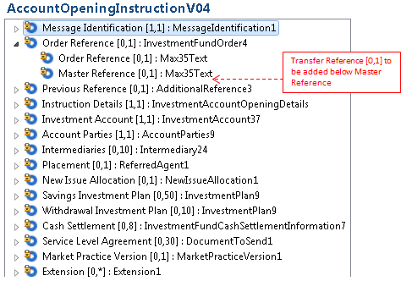

[2] Account Details Confirmation acmt.002
The new element will be made added to OrderReference sequence.

- Purpose of the change:
An account opening message may be sent at the same time an order is placed and therefore the account may not exist yet and reference is made to the order reference of that order. In a similar way, an account opening message may be sent at the same time as a transfer is instructed and therefore a link needs to be made to the transfer reference of the transfer instruction. Currency the account opening and confirmation messages do not have a field for this reference.

- Urgency of the request:
Next yearly maintenance cycle (2014/2015).

- Business examples:
None.

- SEG recommendation:

Consider |  | X | Timing
 |  |  | - Next yearly cycle: 2014/2015  (the change will be considered for implementation in the yearly maintenance cycle which starts in 2014 and completes with the publication of new message versions in the spring of 2015) |  | X
- At the occasion of the next maintenance of the messages
(the change will be considered for implementation, but does not justify maintenance of the messages in its own right – will be pending until more critical change requests are received for the messages)
- Urgent unscheduled
(the change justifies an urgent implementation outside of the normal yearly cycle)
 |  |  | - Other timing:
Comments:

Reject
Reason for rejection:

