Change Request
for the update of ISO 20022 financial repository items

- Origin of the request:
A.1 Submitter: SWIFT Standards on behalf of IMA + UK Fund Cash Forecast Market Practice Working Group
A.2 Contact person: Janice.chapman@swift.com +32 2 655 3390
A.3 Sponsors: /
- Related messages:
 | FundEstimatedCashForecastReportV03 | camt.040.001.03
 | FundConfirmedCashForecastReportV03 | camt.041.001.03
 | FundDetailedEstimatedCashForecastReportV03 | camt.042.001.03
 | FundDetailedConfirmedCashForecastReportV03 | camt.043.001.03
 | FundConfirmedCashForecastReportCancellationV02 | camt.044.001.02
 | FundDetailedConfirmedCashForecastReportCancellationV02 | camt.045.001.02

- Description of the change request:
Addition of optional sequence for information about the currency.
Sequence | Definition | Data Type
CurrencyStatus | Information about the designation of the share class currency, that is, whether it is for onshore or offshore purposes and other information that may be required. | New message component. See below.
New Message Component
Element | Definition | M/O | Data Type
CurrencyDesignation | Specifies whether the currency is settled offshore or onshore. | 0.1 | Code List 1. See below
Location | Location of the offshore currency. | 0.1 | Country Code
Additional Information | Additional information about the off-shore currency. | 0.1 | Max350Text
Code List 1
Code | Code Name | Definition
OFFS | OffShore | Offshore.
ONSH | OnShore | Onshore.

The sequence would be position in the estimated messages as follows:
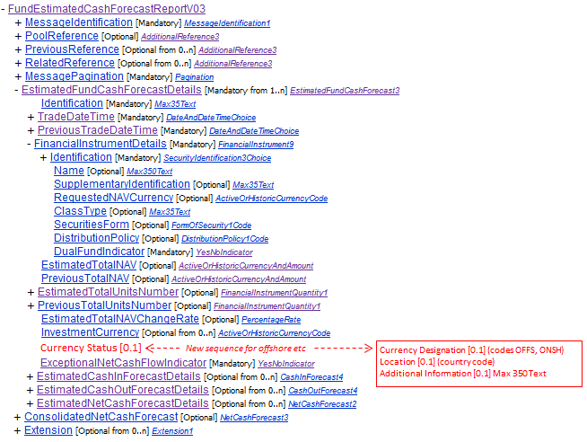

- Purpose of the change:
Market practice work with asset managers for cash forecasts on funds with a ‘hedge share class’ led to the discovery of a gap for the cash forecast reporting messages. The cash forecast report needs to be able to indicate that the CNY is onshore verses offshore and to indicate the location, for example, Hongkong verses Macao and so on.
- Urgency of the request:
Next yearly maintenance cycle (2014/2015).

- Business examples:
None.
- SEG recommendation:

Consider |  | X | Timing
 |  |  | - Next yearly cycle: 2014/2015  (the change will be considered for implementation in the yearly maintenance cycle which starts in 2014 and completes with the publication of new message versions in the spring of 2015) |  | X
- At the occasion of the next maintenance of the messages
(the change will be considered for implementation, but does not justify maintenance of the messages in its own right – will be pending until more critical change requests are received for the messages)
- Urgent unscheduled
(the change justifies an urgent implementation outside of the normal yearly cycle)
 |  |  | - Other timing:
Comments:

Reject
Reason for rejection:

