Change Request
for the update of ISO 20022 financial repository items

- Origin of the request:
A.1 Submitter:
SWIFT SCRL, Avenue Adèle 1, B-1310 La Hulpe, Belgium

A.2 Contact person:
Isabelle Bouille, e-mail: Isabelle.bouille@swift.com, Tel: +32 2 655 44 20
A.3 Sponsors:
Canadian Payments Association (CPA)
Contact: Charlie Clarke _ e-mail: cclarke@cdnpay.ca , Tel: + 1 613 238 41 73

- Related messages:
- pacs.002.001.04: FIToFIPaymentStatusReportV04
- pacs.007.001.04: FIToFIPaymentReversalV04

- Description of the change request:
Proposed changes to the pacs.002 and pacs.007 messages:
Add an “OriginalGroupInformation” block (0..1), in the TransactionInformationBlock. This new OriginalGroupInformation block should contain the same information as currently available in the pacs.004.001.04 (Payment Return) (drawing below), that is “OriginalMessageIdentification” (1..1), “OriginalMessageNameIdentification” (1..1) and” OriginalCreationDateTime” (0..1).
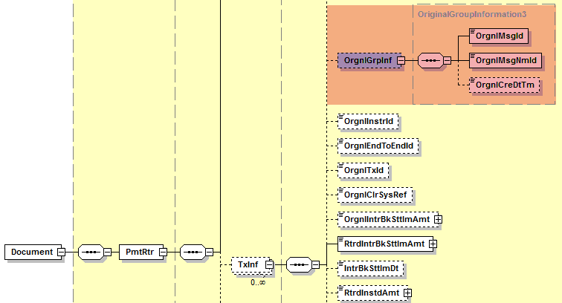
- Purpose of the change:
During implementation work conducted by several communities, including CPA, it was noted that whilst the Payment Return message (pacs.004.001.04) caters for the return of transactions that are part of several different messages, this is not the case for the FIToFIPaymentStatus Report message (pacs.002.001.04) and the FIToFIPaymentReversal message (pacs.007.001.04).

Purpose of this change is to allow the communities to conduct harmonized exceptions and investigation processes. Today the Payment Return (pacs.004.001.04) allows the return of transactions coming from different files sent throughout the day. This allows the banks to keep the number of Payment Return messages to a minimum and facilitate the return processes for Operations teams. The same principle should apply to both the FI to FI Payment Status Report (pacs.002.001.04) and FI to FI Payment Reversal (pacs.007.001.04) messages. After analysis no business reasons are defined that would prevent these re-grouped Payment Reversals and Payment status Reports.

- Urgency of the request:

Next yearly ISO 20022 maintenance cycle 2014/2015
Canada (and other communities) are currently working on their migration plans from proprietary/FIN formats to XML ISO20022, and intend to start their testing in the course of 2015.

- Business examples:
The below illustrates an example for the FI To FI Payment Reversal message with the proposed structure for pacs.007.001.05 (same principle would apply for the FI to FI Payment Status Report message, the pacs.002.001.05).

Bank A submits two FItoFIDirectDebit messages (pacs.003.001.04) to Bank B.
The first message (sent on D, at 09:00), with MessageIdentification AMAR, contains two single direct debit transactions: one for CAD 100 (EndToEndIdentification: ABC, TransactionIdentification: XXX), one for CAD 150 ((EndToEndIdentification: DEF, TransactionIdentification: ZZZ),

The second message (sent on D, at 11:00), with MessageIdentification ULLA, contains one single direct debit transaction for CAD 50 (EndToEndIdentification: ULM, TransactionIdentification: YYY).

On D+1, Bank A is informed by its corporate that 2 of the 3 transactions sent on D (Message ID AMAR and Message ID ULLA) were duplicates. As settlement took place already, Bank A sends a pacs.007 message to Bank B (Message ID VIAY), with two reversed transactions (those that were duplicated), i.e. CAD 100 (EndToEndIdentification: ABC, TransactionIdentification: XXX) and CAD 50 (EndToEndIdentification: ULM, TransactionIdentification: YYY).
This Reversal Message will result with a Credit on the Receiving Bank Institution’s account for a total amount of CAD 150, to be further transmitted to the initial Debtor.

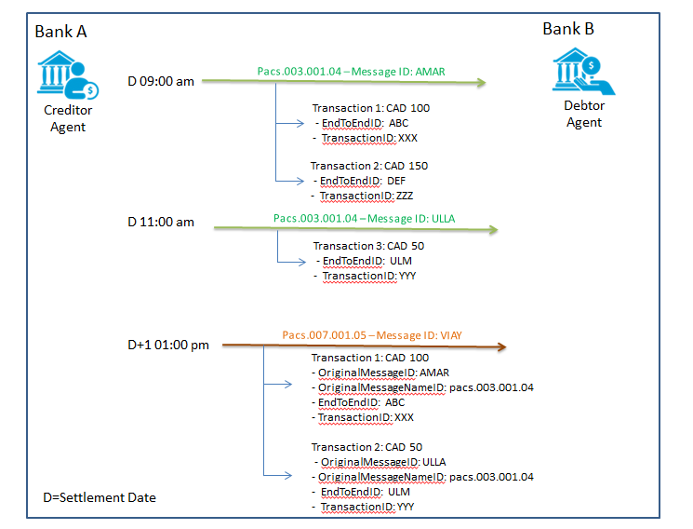
SEG recommendation:
This section is not to be taken care of by the submitter of the change request. It will be completed in due time by the SEG(s) in charge of the related ISO 20022 messages.

Consider |  | X | Timing
 |  |  | - Next yearly cycle: 2014/2015  (the change will be considered for implementation in the yearly maintenance cycle which starts in 2014 and completes with the publication of new message versions in the spring of 2015) |  | X
- At the occasion of the next maintenance of the messages
(the change will be considered for implementation, but does not justify maintenance of the messages in its own right – will be pending until more critical change requests are received for the messages)
- Urgent unscheduled
(the change justifies an urgent implementation outside of the normal yearly cycle)
 |  |  | - Other timing:
Comments:

Reject
Reason for rejection:

