Change Request
for the update of ISO 20022 financial repository items
- Origin of the request:
A.1 Submitter: SWIFT Standards on behalf of Findel & Almus (LU NMPG)
A.2 Contact person:
Janice Chapman janice.chapman@swift.com +32 2 655 3390
A.3 Sponsors: -
- Related messages:

 | Securities Message Rejection V02 | semt.001.001.02

- Description of the change request:
[1] The message contains a usage rule that does not make sense:

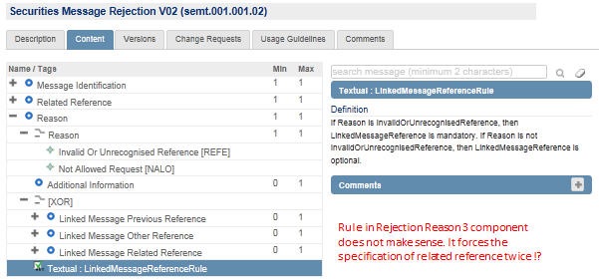

[2] In addition, the XOR construct will be replaced with a choice component.
- Purpose of the change:
The change is needed to [1] correct an error and [2] replace XOR with a Choice to comply with ISO 20022.
- Urgency of the request:
Next yearly maintenance cycle (2014/2015).

- Business examples:
None.
- SEG recommendation:

Consider |  | X | Timing
 |  |  | - Next yearly cycle: 2014/2015  (the change will be considered for implementation in the yearly maintenance cycle which starts in 2014 and completes with the publication of new message versions in the spring of 2015) |  | X
- At the occasion of the next maintenance of the messages
(the change will be considered for implementation, but does not justify maintenance of the messages in its own right – will be pending until more critical change requests are received for the messages)
- Urgent unscheduled
(the change justifies an urgent implementation outside of the normal yearly cycle)
 |  |  | - Other timing:
Comments:

Reject
Reason for rejection:

