Change Request
for the update of ISO 20022 financial repository items

- Origin of the request:
A.1 Submitter: SWIFT Standards on behalf of IMA + UK Fund Cash Forecast Market Practice Working Group
A.2 Contact person: Janice.chapman@swift.com +32 2 655 3390
A.3 Sponsors:
- Related messages:
 | FundEstimatedCashForecastReportV03 | camt.040.001.03
 | FundConfirmedCashForecastReportV03 | camt.041.001.03
 | FundConfirmedCashForecastReportCancellationV02 | camt.044.001.02

- Description of the change request:
[1] Fund Estimated Cash Forecast Report
[a] Addition of optional elements
[a1] New sequence at message level
 | Item | Definition | M/O | Type
1 | Main Fund Details | Information about the main fund when the fund cash forecast details specifies information for a share class of the main fund. Typically used in a ‘hedged share class scenario’. | 0.1 | New message component
[a2] Elements in new sequence Main Fund Details:
 | Item | Definition | M/O | Type
2 | Identification | Identification of the financial instrument. | 0.1 | Security Identification 3 Choice
3 | Name | Name of the financial instrument. | 0.1 | Max 35 Text
4 | Currency | Currency of the financial instrument. | 0.1 | Active Or Historic Currency
5 | Estimated Total NAV | Estimated total value of all the holdings, less the fund's liabilities, of the fund. | 0.1 | Active Or Historic Currency And Amount
6 | Previous Total NAV | Previous total value of all the holdings, less the fund's liabilities, of the fund. | 0.1 | Active Or Historic Currency And Amount
7 | Estimated Total Units Number | Estimated total number of units. | 0.1 | Decimal Number
8 | Previous Total Units Number | Previous total number of units. | 0.1 | Decimal Number
9 | Estimated Percentage of Fund Total NAV | Estimated consolidated net cash flow of all share classes expressed as a percentage of the previous total NAV for the whole fund. | 0.1 | PercentageRate
 | MainFundIDName1 Rule | If MainFundDetails is present then either Identification or Name must be present. Both Identification and Name are allowed.

[a3] Elements in Estimated Fund Cash Forecast Details sequence:
 | Item | Definition |  | M/O | Type
10 | Price |  | Price per unit of the previous trade date. | 0.1 | ActiveCurrencyAnd13DecimalAmount
11 | FX Rate |  | Foreign exchange rate. | 0.1 | ForeignExchangeTerms19 (already exists, comprises Unit Currency, Quoted Currency and Exchange Rate)
12 | Estimated Percentage of Share Class Total NAV |  | Estimated net cash flow of the share class expressed as a percentage of the previous total NAV for the share class. | 0.1 | PercentageRate

[b] Multiplicity Changes:
 | Sequence | Element | Current | Change to
1 | Estimated Fund Cash Forecast Details | Previous Trade Date Time | 1.1 | 0.1
2 | Estimated Fund Cash Forecast Details | Estimated Total NAV | 0.1 | 0.n
3 | Estimated Fund Cash Forecast Details | Previous Total NAV | 0.1 | 0.n

[2] Fund Confirmed Cash Forecast Report
[a] Addition of optional elements
[a1] New sequence at message level
 | Item | Definition | M/O | Type
1 | Main Fund Details | Information about the main fund when the fund cash forecast details specifies information for a share class of the main fund. Typically used in a ‘hedged share class scenario’. | 0.1 | New message component

[a2] Elements in new sequence Main Fund Details:
 | Item | Definition | M/O | Type
2 | Identification | Identification of the financial instrument. | 0.1 | Security Identification 3 Choice
3 | Name | Name of the financial instrument. | 0.1 | Max 35 Text
4 | Currency | Currency of the financial instrument. | 0.1 | Active Or Historic Currency
5 | Total NAV | Total value of all the holdings, less the fund's liabilities, of the fund. | 0.1 | Active Or Historic Currency And Amount
6 | Previous Total NAV | Previous total value of all the holdings, less the fund's liabilities, of the fund. | 0.1 | Active Or Historic Currency And Amount
7 | Total Units Number | Total number of units. | 0.1 | Decimal Number
8 | Previous Total Units Number | Previous total number of units. | 0.1 | Decimal Number
9 | Percentage of Fund Total NAV | Consolidated net cash flow of all share classes expressed as a percentage of the total NAV for the whole fund. | 0.1 | PercentageRate
 | MainFundIDName1 Rule | If MainFundDetails is present then either Identification or Name must be present. Both Identification and Name are allowed.

[a3] Elements in Estimated Fund Cash Forecast Details sequence:
10 | Price | Price per unit | 0.1 | ActiveCurrencyAnd13DecimalAmount
11 | FX Rate | Foreign exchange rate. | 0.1 | ForeignExchangeTerms19 (already exists, comprises Unit Currency, Quoted Currency and Exchange Rate)
12 | Percentage of Share Class Total NAV | Net cash flow of the share class expressed as a percentage of the total NAV for the share class | 0.1 | PercentageRate

[b] Multiplicity Changes:
 | Sequence | Element | Current | Change to
1 | Fund Cash Forecast Details | Total NAV | 0.1 | 0.n
2 | Fund Cash Forecast Details | Previous Total NAV | 0.1 | 0.n

Diagram – Fund Estimated Cash Forecast Report (camt.040)
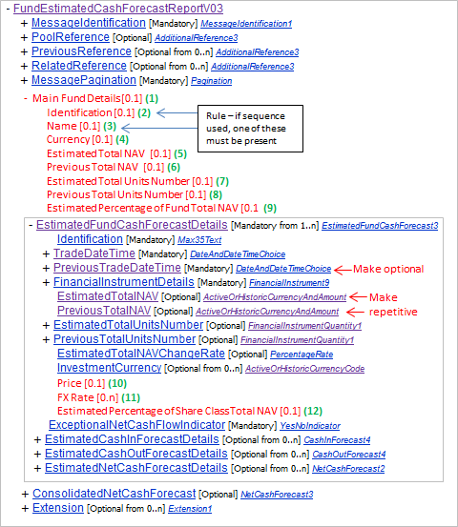

Diagram – Fund Confirmed Cash Forecast Report (camt.041)
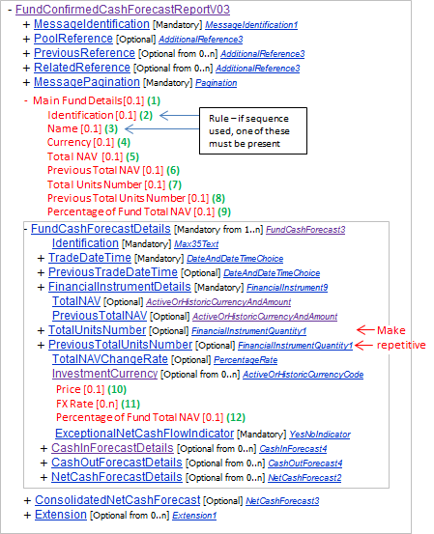

Diagram – Fund Confirmed Cash Forecast Report Cancellation (camt.044)
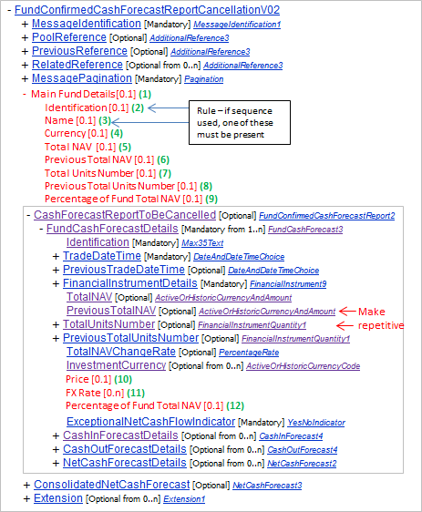
As can be seen Cancellation Forecast Report to be Cancelled \ Fund Cash Forecast Details uses the same sequence as that in the Fund Confirmed Cash Forecast message

- Purpose of the change:
Market practice work with asset managers for cash forecasts on funds with a ‘hedge share class’ led to the identification of gaps in the message and additional data elements are needed, and some data needs to be specified at both the level of the ‘main’ fund and the share class.

- Urgency of the request:
Next yearly maintenance cycle (2014/2015).

- Business examples:
None.

- SEG recommendation:

Consider |  | X | Timing
 |  |  | - Next yearly cycle: 2014/2015  (the change will be considered for implementation in the yearly maintenance cycle which starts in 2014 and completes with the publication of new message versions in the spring of 2015) |  | X
- At the occasion of the next maintenance of the messages
(the change will be considered for implementation, but does not justify maintenance of the messages in its own right – will be pending until more critical change requests are received for the messages)
- Urgent unscheduled
(the change justifies an urgent implementation outside of the normal yearly cycle)
 |  |  | - Other timing:
Comments:

Reject
Reason for rejection:

