Change Request
for the update of ISO 20022 financial repository items
- Origin of the request:
A.1 Submitter: SWIFT Standards
A.2 Contact person: Janice Chapman (janice.chapman@swift.com) +32 2 655 3390
A.3 Sponsor:
- Related messages:
 | Redemption Bulk Order V03 | setr.001.001.03
 | Redemption Bulk Order Cancellation Request V03 | setr.002.001.01
 | Redemption Order V03 | setr.004.001.03
 | Redemption Order Cancellation Request V03 | setr.005.001.03
 | Subscription Bulk Order V03 | setr.007.001.03
 | Subscription Bulk Order Cancellation Request V03 | setr.008.001.03
 | Subscription Order V03 | setr.010.001.03
 | Subscription Order Cancellation Request V03 | setr.011.001.03
- Description of the change request:
There are a number of cross-element rules that require validation and verification that they should still be kept in the standard. (If cross-element rules are to be kept in the standard, then SWIFT will implement the validation of these message against these rules (where possible) on its network. If the rule is not to be kept in the standard, then the rule needs to be eliminated from the documentation.

The rules are listed in the table below.
The cross-element rules to be verified:
[a] order messages
# | Message Id | Sequence | Component | Rule Name | Rule | Comment
1 | redm.001 | Root | - | RelatedPartiesDetailsRule | Either RelatedPartiesDetails or BulkOrderDetails/IndividualOrderDetails/RelatedPartiesDetails may be present, but not both.
2 | redm.001 | Bulk Order Details | Redemption Bulk Order 4 | BulkCashSettlementDetails5Rule | Either IndividualOrderDetails/CashSettlementDetails or BulkCashSettlementDetails may be present, but not both.
3 | redm.001 | Bulk Order Details | Redemption Bulk Order 4 | CashSettlementDateRule | Either CashSettlementDate is present or all occurences of IndividualOrderDetails/CashSettlementDate are present, but not both.
4 | redm.001 | Bulk Order Details | Redemption Bulk Order 4 | RequestedSettlementCurrencyRule | If RequestedSettlementCurrency is present, it must be the same Currency as in all occurrences of IndividualOrderDetails/SettlementAmount, if present.
5 | redm.001 | Bulk Order Details | Redemption Bulk Order 4 | SettlementCurrency2Rule | If BulkCashSettlementDetails is present, then Currency in IndividualOrderDetails/SettlementAmount, if present, must be the same in all occurrences of IndividualOrderDetails.
6 | redm.001 | Individual Order Details | Redemption Order 7 | OrderOriginatorEligibility3Rule | Either InvestmentAccountDetails/OrderOriginatorEligibility or (one or more instances of RelatedPartiesDetails/OrderOriginatorEligibility) may be present, but not both. | Issue – see below
7 | redm.001 | Individual Order Details | Redemption Order 7 | PhysicalDeliveryDetailsRule | If PhysicalDeliveryIndicator is "false" or "0" (No), then PhysicalDeliveryDetails is not allowed. If PhysicalDeliveryIndicator is "true" or "1" (Yes), then PhysicalDeliveryDetails must be present.
8 | redm.001 | Investment Account Details | Investment Account 21 | OrderOriginator Eligibility2Rule | OrderOriginatorEligibility may only be present if one or more of the parties identified in OwnerIdentification is/are the originator of the order.
9 | redm.001 | Receiving Side Details | ReceivingPartiesAnd Account3 | ReceiversCustodianRule | If ReceiversIntermediaryDetails is present, then ReceiversCustodianDetails must be present. If ReceiversIntermediaryDetails is not present, then ReceiversCustodianDetails is optional.
10 | redm.001 | Delivering Side Details | DeliveringPartiesAnd Account3 | DeliverersCustodianRule | If DeliverersIntermediaryDetails is present, then DeliverersCustodianDetails must also be present. If DeliverersIntermediaryDetails is not present then DeliverersCustodianDetails is optional.
11 | redm.001 | Related Party Details | Intermediary8 | OrderOriginator Eligibility1Rule | OrderOriginatorEligibility may only be present if Role is either UCL1 or UCL2.
1 | redm.004 | Root | - | RelatedPartiesDetailsRule | Either RelatedPartiesDetails or MultipleOrderDetails/IndividualOrderDetails/RelatedPartiesDetails may be present, but not both.
2 | redm.004 | Multiple Order Details | RedemptionMultiple Order4 | BulkCashSettlement Details1Rule | Either IndividualOrderDetails/CashSettlementDetails or BulkCashSettlementDetails may be present, but not both.
3 | redm.004 | Multiple Order Details | RedemptionMultiple Order4 | CashSettlementDateRule | Either CashSettlementDate is present or all occurences of IndividualOrderDetails/CashSettlementDate are present, but not both.
4 | redm.004 | Multiple Order Details | RedemptionMultiple Order4 | OrderOriginatorEligibility3Rule | Either InvestmentAccountDetails/OrderOriginatorEligibility or (one or more instances of IndividualOrderDetails/RelatedPartiesDetails/OrderOriginator Eligibility) may be present, but not both | Issue – see section C1’ [4]. Swift Standards thinks this rule should be eliminated.
5 | redm.004 | Multiple Order Details | RedemptionMultiple Order4 | SettlementCurrency5Rule | If BulkCashSettlementDetails is present, then Currency in IndividualOrderDetails/SettlementAmount, if present, must be the same in all occurrences of IndividualOrderDetails.
6 | redm.004 | Investment Account Details | Investment Account 21 | OrderOriginator Eligibility2Rule | OrderOriginatorEligibility may only be present if one or more of the parties identified in OwnerIdentification is/are the originator of the order.
7 | redm.004 | Individual Order Details | RedemptionOrder8 | PhysicalDeliveryDetailsRule | If PhysicalDeliveryIndicator is "false" or "0" (No), then PhysicalDeliveryDetails is not allowed. If PhysicalDeliveryIndicator is "true" or "1" (Yes), then PhysicalDeliveryDetails must be present.
8 | redm.004 | Individual Order Details | RedemptionOrder8 | RequestedSettlement CurrencyRule | If RequestedSettlementCurrency is present, it must be the same Currency as in SettlementAmount, if present.
9 | redm.004 | Receiving Side Details | ReceivingPartiesAnd Account3 | ReceiversCustodianRule | If ReceiversIntermediaryDetails is present, then ReceiversCustodianDetails must be present. If ReceiversIntermediaryDetails is not present, then ReceiversCustodianDetails is optional.
10 | redm.004 | Delivering Side Details | DeliveringPartiesAnd Account3 | DeliverersCustodianRule | If DeliverersIntermediaryDetails is present, then DeliverersCustodianDetails must also be present. If DeliverersIntermediaryDetails is not present then DeliverersCustodianDetails is optional.
11 | redm.004 | Related Party Details | Intermediary8 | OrderOriginator Eligibility1Rule | OrderOriginatorEligibility may only be present if Role is either UCL1 or UCL2.
1 | setr.007 | Root | - | RelatedPartiesDetailsRule | Either RelatedPartiesDetails or BulkOrderDetails/IndividualOrderDetails/RelatedPartiesDetails may be present, but not both.
2 | setr.007 | Bulk Order Details | Subscription Bulk Order 4 | BulkCashSettlementDetails3Rule | Either IndividualOrderDetails/CashSettlementDetails or BulkCashSettlementDetails may be present, but not both.
3 | setr.007 | Bulk Order Details | Subscription Bulk Order 4 | CashSettlementDateRule | Either CashSettlementDate is present or all occurences of IndividualOrderDetails/CashSettlementDate are present, but not both.
4 | setr.007 | Bulk Order Details | Subscription Bulk Order 4 | RequestedSettlementCurrencyRule | If RequestedSettlementCurrency is present, it must be the same Currency as in all occurrences of IndividualOrderDetails/SettlementAmount, if present.
5 | setr.007 | Bulk Order Details | Subscription Bulk Order 4 | SettlementCurrency2Rule | If BulkCashSettlementDetails is present, then Currency in IndividualOrderDetails/SettlementAmount, if present, must be the same in all occurrences of IndividualOrderDetails.
6 | setr.007 | Individual Order Details | Subscription Order 7 | OrderOriginatorEligibility3Rule | Either InvestmentAccountDetails/OrderOriginatorEligibility or (one or more instances of RelatedPartiesDetails/OrderOriginatorEligibility) may be present, but not both. | Issue – see section C1’ [4] Swift Standards thinks this rule should be eliminated.
7 | setr.007 | Individual Order Details | Subscription Order 7 | PhysicalDeliveryDetailsRule | If PhysicalDeliveryIndicator is "false" or "0" (No), then PhysicalDeliveryDetails is not allowed. If PhysicalDeliveryIndicator is "true" or "1" (Yes), then PhysicalDeliveryDetails must be present.
8 | setr.007 | Investment Account Details | Investment Account 21 | OrderOriginator Eligibility2Rule | OrderOriginatorEligibility may only be present if one or more of the parties identified in OwnerIdentification is/are the originator of the order.
9 | setr.007 | Receiving Side Details | ReceivingPartiesAnd Account3 | ReceiversCustodianRule | If ReceiversIntermediaryDetails is present, then ReceiversCustodianDetails must be present. If ReceiversIntermediaryDetails is not present, then ReceiversCustodianDetails is optional.
10 | setr.007 | Delivering Side Details | DeliveringPartiesAnd Account3 | DeliverersCustodianRule | If DeliverersIntermediaryDetails is present, then DeliverersCustodianDetails must also be present. If DeliverersIntermediaryDetails is not present then DeliverersCustodianDetails is optional.
11 | setr.007 | Related Party Details | Intermediary8 | OrderOriginator Eligibility1Rule | OrderOriginatorEligibility may only be present if Role is either UCL1 or UCL2.
1 | setr.010 | Root | - | RelatedPartiesDetailsRule | Either RelatedPartiesDetails or MultipleOrderDetails/IndividualOrderDetails/RelatedPartiesDetails may be present, but not both.
2 | setr.010 | Multiple Order Details | Subscription Multiple Order 4 | BulkCashSettlementDetails1Rule | Either IndividualOrderDetails/CashSettlementDetails or BulkCashSettlementDetails may be present, but not both.
3 | setr.010 | Multiple Order Details | Subscription Multiple Order 4 | CashSettlementDateRule | Either CashSettlementDate is present or all occurences of IndividualOrderDetails/CashSettlementDate are present, but not both.
4 | setr.010 | Multiple Order Details | Subscription Multiple Order 4 | OrderOriginatorEligibility3Rule | Either IndividualOrderDetails/RelatedPartiesDetails/OrderOriginatorEligibility or (one or more instances of InvestmentAccountDetails/OrderOriginatorEligibility) may be present, but not both. | Issue – see section C1’ [4] Swift Standards thinks this rule should be eliminated.
5 | setr.010 | Multiple Order Details | Subscription Multiple Order 4 | SettlementCurrency5Rule | If BulkCashSettlementDetails is present, then Currency in IndividualOrderDetails/SettlementAmount, if present, must be the same in all occurrences of IndividualOrderDetails.
6 | setr.010 | Investment Account Details | Investment Account 21 | OrderOriginator Eligibility2Rule | OrderOriginatorEligibility may only be present if one or more of the parties identified in OwnerIdentification is/are the originator of the order.
7 | setr.010 | Individual Order Details | Subscription Order 8 | PhysicalDeliveryDetailsRule | If PhysicalDeliveryIndicator is "false" or "0" (No), then PhysicalDeliveryDetails is not allowed. If PhysicalDeliveryIndicator is "true" or "1" (Yes), then PhysicalDeliveryDetails must be present.
8 | setr.010 | Individual Order Details | Subscription Order 8 | RequestedSettlementCurrencyRule | If RequestedSettlementCurrency is present, it must be the same Currency as in SettlementAmount, if present.
9 | setr.010 | Receiving Side Details | ReceivingPartiesAnd Account3 | ReceiversCustodianRule | If ReceiversIntermediaryDetails is present, then ReceiversCustodianDetails must be present. If ReceiversIntermediaryDetails is not present, then ReceiversCustodianDetails is optional.
10 | setr.010 | Delivering Side Details | DeliveringPartiesAnd Account3 | DeliverersCustodianRule | If DeliverersIntermediaryDetails is present, then DeliverersCustodianDetails must also be present. If DeliverersIntermediaryDetails is not present then DeliverersCustodianDetails is optional.
11 | setr.010 | Related Party Details | Intermediary8 | OrderOriginator Eligibility1Rule | OrderOriginatorEligibility may only be present if Role is either UCL1 or UCL2.
The rules in the order cancellation messages follow the same principals as those in the order messages and, therefore, any issue with a rule or change required in a rule in an order message must be applied to the relevant order cancellation messages.
In the next section, further information about some of the rules is described visually.
Section C1
The following contains contain screen images of the message structure and notes about the rules. Redm.001 has been used as the example message. Similar rules exists in the subscirption order messages and the redemption and subscription confirmations although, of, couse, path descriptions will be different.
[1] setr.004 - RelatedParties DetailsRule
Location in message | MC | Rule
Root | - | Either RelatedPartiesDetails or MultipleOrderDetails/IndividualOrderDetails/RelatedPartiesDetails may be present, but not both.
Message Diagram:
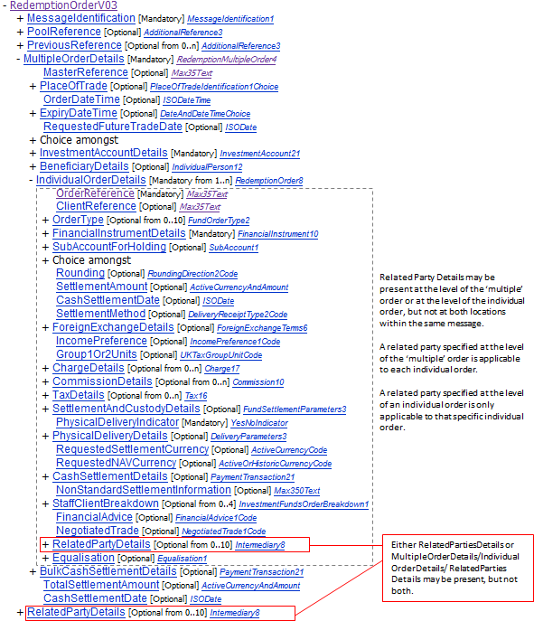
[2] setr.004 - BulkCashSettlementDetails1Rule

Location in message | Message Component | Rule
Multiple Order Details | RedemptionMultipleOrder4 | Either IndividualOrderDetails/CashSettlementDetails or BulkCashSettlementDetails may be present, but not both.
Message Diagram:
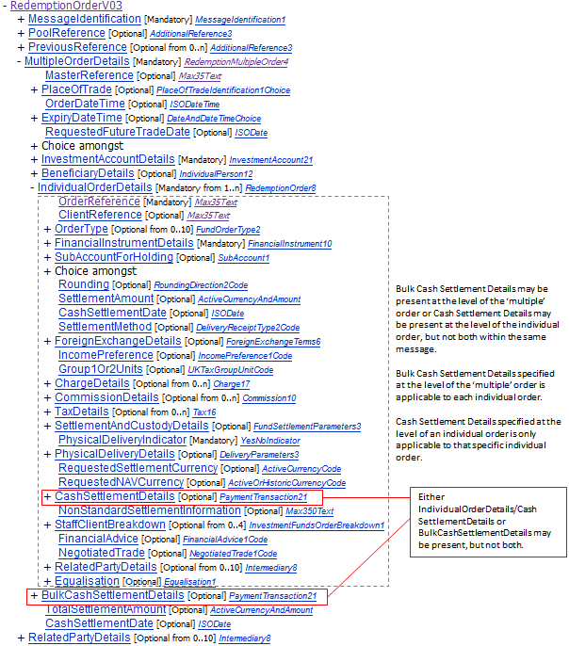

[3] setr.004 – CashSettlementDateRule
Location in message | Message Component | Rule
Multiple Order Details | RedemptionMultipleOrder4 | Either CashSettlementDate is present or all occurences of IndividualOrderDetails/CashSettlementDate are present, but not both.
Message Diagram:
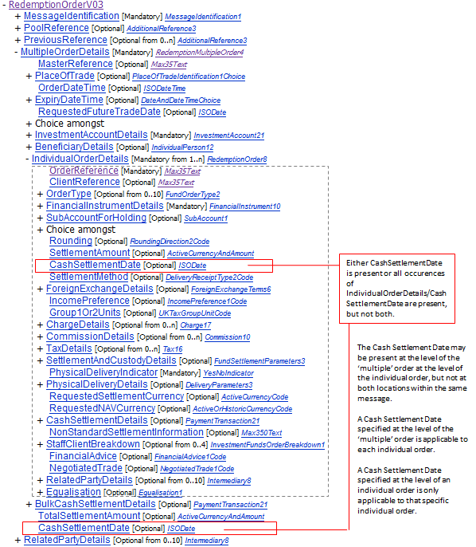

[4] setr.004 - OrderOriginatorEligibility3Rule
Location in message | Message Component | Rule
Multiple Order Details | RedemptionMultipleOrder4 | Either InvestmentAccountDetails/OrderOriginatorEligibility or (one or more instances of IndividualOrderDetails/RelatedPartiesDetails/OrderOriginatorEligibility) may be present, but not both
Message Diagram:
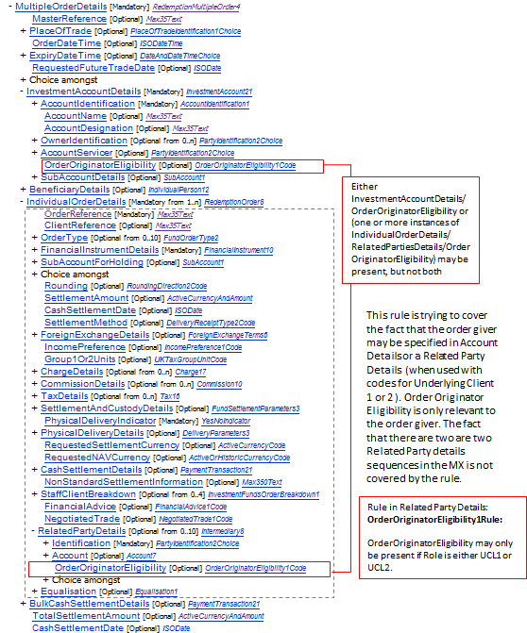
This rule should either be deleted or there should be an additional rule (at the root) to prohibit the presence of Order Originator Eligibility both in the Investment Account Details and the Related Party Details at the root. The fact that Role is optional is another gap. There would also need to be a rule that there cannot be more than one Related Parties Details sequence with the Role code UCL1 or UCL2. And then if both UCL1 and UCL2 being present is to be taken into account, this makes the rule even harder to express. (This kind of complex rule cannot be expressed as a rule on Interact at this stage, in any case). Conclusion from SWIFT Standards: the rule is to be deleted. It is a meaningless rule as currently expressed. Currently Order Originator Eligibility is not used in the order messages.

[5] setr.004 - SettlementCurrency5Rule
Location in message | Message Component | Rule
Multiple Order Details | RedemptionMultipleOrder4 | If BulkCashSettlementDetails is present, then Currency in IndividualOrderDetails/SettlementAmount, if present, must be the same in all occurrences of IndividualOrderDetails.
Message Diagram:
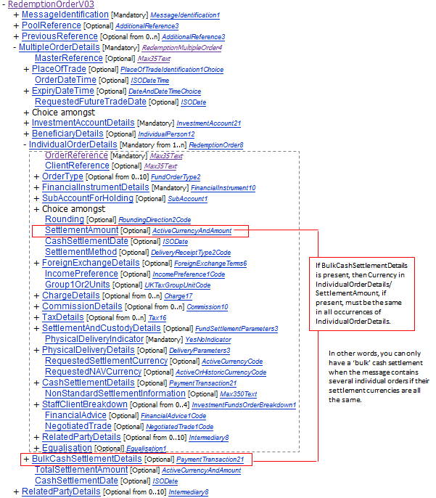
[6] setr.004 - OrderOriginatorEligibility2Rule
Location in message | Message Component | Rule
Investment Account Details | Investment Account 21 | OrderOriginatorEligibility may only be present if one or more of the parties identified in OwnerIdentification is/are the originator of the order.
Message Diagram:

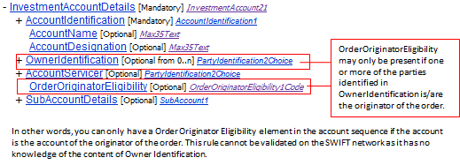

[7] setr.004 - PhysicalDeliveryDetailsRule
Location in message | Message Component | Rule
Individual Order Details | RedemptionOrder8 | If PhysicalDeliveryIndicator is "false" or "0" (No), then PhysicalDeliveryDetails is not allowed. If PhysicalDeliveryIndicator is "true" or "1" (Yes), then PhysicalDeliveryDetails must be present.
Message Diagram:
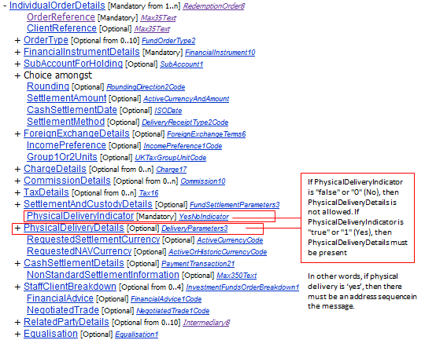
[8] setr.004 - RequestedSettlementCurrencyRule
Location in message | Message Component | Rule
Individual Order Details | RedemptionOrder8 | If RequestedSettlementCurrency is present, it must be the same Currency as in SettlementAmount, if present.
Message Diagram:
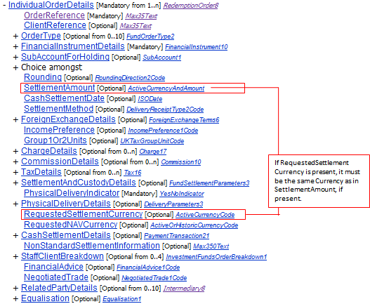

[9] setr.004 - ReceiversCustodianRule
Location in message | Message Component | Rule
Investment Account Details | ReceivingPartiesAndAccount3 | If ReceiversIntermediaryDetails is present, then ReceiversCustodianDetails must be present. If ReceiversIntermediaryDetails is not present, then ReceiversCustodianDetails is optional.
Message Diagram:
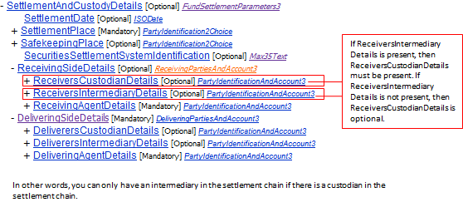
[10] setr.004 - DeliverersCustodianRule
Location in message | Message Component | Rule
Settlement And Custody Details | DeliveringPartiesAndAccount3 | If DeliverersIntermediaryDetails is present, then DeliverersCustodianDetails must also be present. If DeliverersIntermediaryDetails is not present then DeliverersCustodianDetails is optional.
Message Diagram:
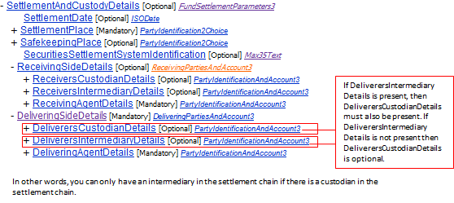

[11] setr.004 - OrderOriginatorEligibility1Rule
Location in message | Message Component | Rule
Related Party Details | OrderOriginatorEligibility1Rule | OrderOriginatorEligibility may only be present if Role is either UCL1 or UCL2.
Message Diagram:
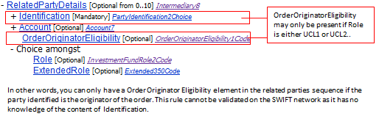
Section C2
The following are screen images of the message structure and notes about the rules for the switch order message. Similar rules exists in the switch cancellation althoug, of course, the paths will be differnet
[1] setr.013 - MultipleSwitchOrderRule
Location in message | MC | Rule
Root | - | If SwitchOrderDetails is present more than once, then SwitchOrderDetails/RedemptionLegDetails and SwitchOrderDetails/SubscriptionLegDetails may only be present once.
Message Diagram:
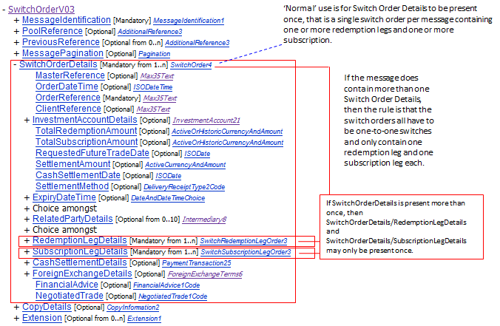

[1] setr.013 - OrderOriginatorEligibility4Rule
Location in message | MC | Rule
Root | - | Either SwitchOrderDetails/InvestmentAccountDetails/OrderOriginatorEligibility or (one or more instances of SwitchOrderDetails/RelatedPartyDetails/OrderOriginatorEligibility) may be present, but not both
Message Diagram:
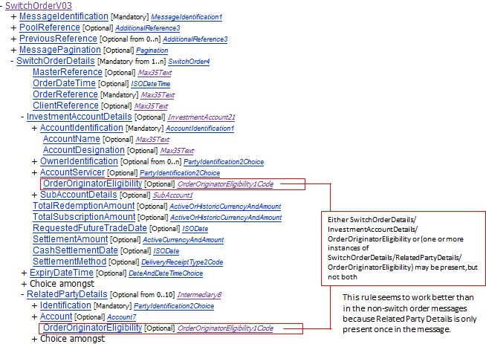

[2] setr.013 - FinancialInstrumentQuantity1Rule
Location in message | MC | Rule
Root | - | If SubscriptionLegDetails/FinancialInstrumentQuantityChoice is not present, then RedemptionLegDetails/FinancialInstrumentQuantityChoice is mandatory in each occurrence of RedemptionLegDetails .  If SubscriptionLegDetails/FinancialInstrumentQuantityChoice is present, then it must be present in each occurrence of SubscriptionLegDetails.
Message Diagram:
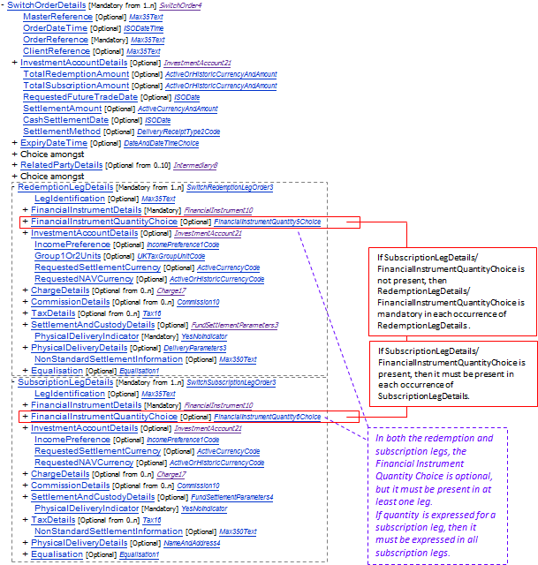
[3] setr.013 - InvestmentAccountDetailsRule
Location in message | MC | Rule
Root | - | Either InvestmentAccountDetails or (all occurrences of SubscriptionLegDetails/InvestmentAccountDetails and of RedemptionLegDetails/InvestmentAccountDetails) must be present, but not both.
Message Diagram:
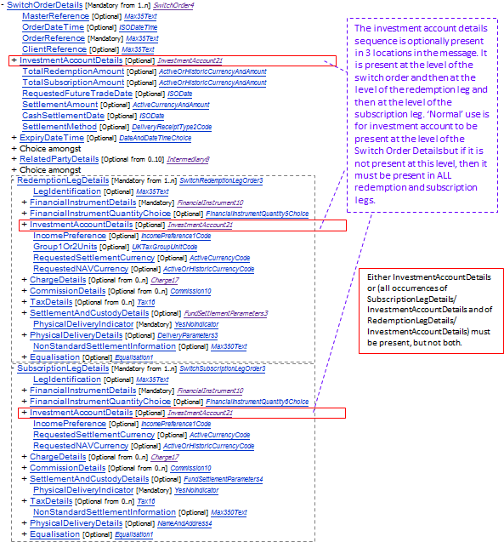

[4] setr.013 - TotalRedemptionAmountRule
Location in message | MC | Rule
Root | - | If SubscriptionLegDetails/FinancialInstrumentQuantityChoice/PercentageOfTotalRedemptionAmount is present, then TotalRedemptionAmount must also be present. If SubscriptionLegDetails/FinancialInstrumentQuantityChoice/PercentageOfTotalRedemptionAmount is not present , then TotalRedemptionAmount is optional.
Message Diagram:
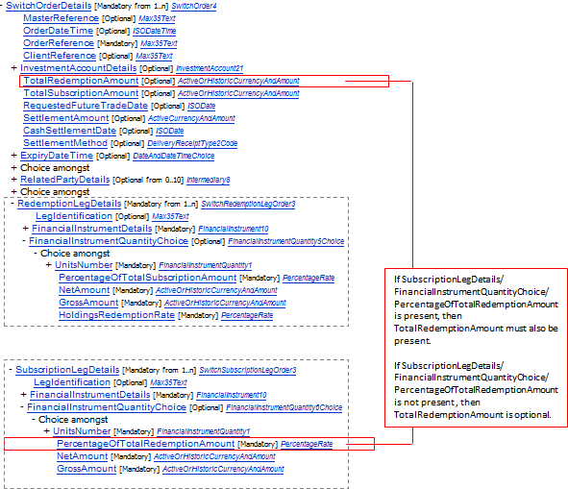

Example: redeem EUR 400 of ISIN 1 and use proceeds to subscribe to 40% ISIN 2 and 60% to ISIN 3.
<SwtchOrdrV03>
<MsgId>
<Id>123456</Id>
<CreDtTm>2014-01-15T10:00:00</CreDtTm>
</MsgId>
<SwtchOrdrDtls>
<OrdrRef>Order 1</OrdrRef>
<TtlRedAmt Ccy="EUR">400</TtlRedAmt> | Rule: Because <PctgOfTtlRedAmt> is present, this field is mandatory. Is this a desirable rule? It makes if there is not no quantity specified in the redemption leg?
<RedLegDtls>
<FinInstrmDtls>
<Id>
<ISIN>LU1111111111</ISIN>
</Id>
</FinInstrmDtls>
<FinInstrmQtyChc>
<GrssAmt Ccy="EUR">400</GrssAmt>
</FinInstrmQtyChc>
<PhysDlvryInd>true</PhysDlvryInd>
</RedLegDtls>
<SbcptLegDtls>
<FinInstrmDtls>
<Id>
<ISIN>LU2222222222</ISIN>
</Id>
</FinInstrmDtls>
<FinInstrmQtyChc>
<PctgOfTtlRedAmt>40</PctgOfTtlRedAmt>
</FinInstrmQtyChc>
<PhysDlvryInd>true</PhysDlvryInd>
</SbcptLegDtls>
<SbcptLegDtls>
<FinInstrmDtls>
<Id>
<ISIN>LU3333333333</ISIN>
</Id>
</FinInstrmDtls>
<FinInstrmQtyChc>
<PctgOfTtlRedAmt>60</PctgOfTtlRedAmt>
</FinInstrmQtyChc>
<PhysDlvryInd>true</PhysDlvryInd>
</SbcptLegDtls>
</SwtchOrdrDtls>
</SwtchOrdrV03>
Purpose of the change:
Ensure that the cross-element rules in the standard are still required.
- Urgency of the request:
The next maintenance cycle in which the maintenance of orders is permitted.
- Business examples:
None
- SEG recommendation:
Consider |  | X | Timing
- Next yearly cycle: after the maintenance freeze pn order messages is lifted
(the change will be considered for implementation in the yearly maintenance cycle which starts in 2015 and completes with the publication of new message versions in the spring of 2016)
 |  |  | - At the occasion of the next maintenance of the messages  (the change will be considered for implementation, but does not justify maintenance of the messages in its own right – will be pending until more critical change requests are received for the messages) |  | X
- Urgent unscheduled
(the change justifies an urgent implementation outside of the normal yearly cycle)
 |  |  | - Other timing:
Comments:

Reject
Reason for rejection

