Change Request
for the update of ISO 20022 financial repository items

- Origin of the request:
A.1 Submitter:
SWIFT
8 Marina View, Asia Square Tower 1, #28-04, Singapore 018960

A.2 Contact person:
Mr. David Dobbing SWIFT Standards Department
Tel: +65 8500 8056

A.3 Sponsors:
Standard Chartered Bank
Address: Marina Bay Financial Centre (Tower 1), 8 Marina Boulevard, Level 22
Singapore 018981

Mr. Mritunjay Singh
Director, Transaction Banking
Phone: +65 65964201
Email: mritunjay.singh@sc.com

Mr. Christopher Wee
Director, Transaction Banking
Phone: +65 6596 9763
Email: christopher.wee@sc.com

Mr. Rob Coombes
Global Head of Financial Crime Compliance, Wholesale Banking
Phone: +65 6596 5298
Email: rob.coombes@sc.com

- Related messages:
LineItemDetails block in Goods block in Baseline in

# | Message ID | Message Name
1 | tsmt.009.001.04 | BaselineAmendmentRequestV04
2 | tsmt.012.001.04 | BaselineReSubmissionV04
3 | tsmt.018.001.04 | FullPushThroughReportV04
4 | tsmt.019.001.04 | InitialBaselineSubmissionV04

- Description of the change request:

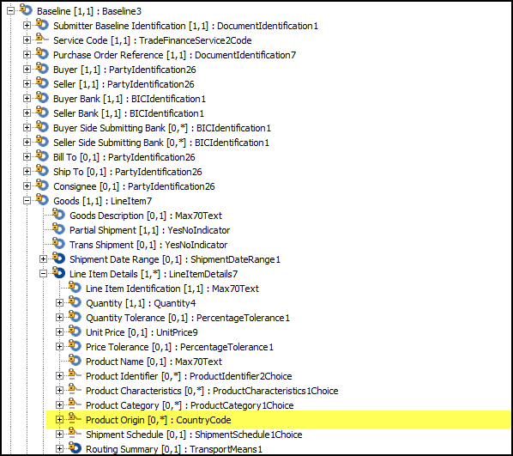
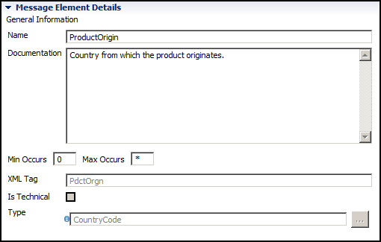
Request change to the element ProductOrigin in LineItemDetails in Goods block in Baseline.
- Change cardinality to make this element mandatory
- Rename element to ‘Product and/or service origin’

- Purpose of the change:
Trade has been identified as being high risk from the perspective of money laundering by regulators and industry associations around the world.
US alone, based on FINCEN’s advisory dated Feb 2010 that SAR reporting related to Trade based money laundering is increasing. Between Jan 2004 and May 2009, the reported transactions involved aggregated to over US$276billion
http://www.fincen.gov/statutes_regs/guidance/pdf/fin-2010-a001.pdf
In order to align with current and evolving regulatory demands in this area, the tsmt messages that support the BPO need to be enhanced to better ensure compliance with these demands.

- Urgency of the request:
To be handled in accordance with the normal yearly maintenance cycle.

- Business examples:
Documents such as Letters of Credit, Bills of Lading, and Invoices all provide for description of goods.

- SEG recommendation:

Consider |  | X | Timing
 |  |  | - Next yearly cycle: 2014/2015  (the change will be considered for implementation in the yearly maintenance cycle which starts in 2014 and completes with the publication of new message versions in the spring of 2015) |  | X
- At the occasion of the next maintenance of the messages
(the change will be considered for implementation, but does not justify maintenance of the messages in its own right – will be pending until more critical change requests are received for the messages)
- Urgent unscheduled
(the change justifies an urgent implementation outside of the normal yearly cycle)
 |  |  | - Other timing:
Comments:
- Change cardinality to make this element mandatory
Use of this element outside of the BPO context may well be optional / not needed.
Recommend that a rule be added that makes ProductOrgin mandatory when used in direct connection with BPO.

Reject
The Trade SEG rejected the following changes:
- Rename element to ‘Product and/or service origin’
Reason for rejection: Origin of service not normally considered to be business essential data and often is not relevant.

