Change Request
for the update of ISO 20022 financial repository items

- Origin of the request:
A.1 Submitter: SWIFT Standards on behalf Findel Group
(submitted 13 February 2014)
A.2 Contact person:
Janice Chapman, SWIFT Janice.Chapman@swift.com + 32 2 655 3390
Charles Boniver Charlesraymond.Boniver@rbc.com +352 2605 9206
A.3 Sponsors: None
- Related messages:
 | PortfolioTransferInstructionV05 | sese.012.001.05
 | PortfolioTransferCancellationRequestV05 | sese.014.001.05
 | PortfolioTransferConfirmationV05 | sese.013.001.05
- Description of the change request:
In the 2011/2012 maintenance cycle, an optional TransferCurrency element was added to the TransferDetails sequence of the transfer instruction and confirmation message set, because some transfer agents register holdings segregated by currency not by ISIN and thus there is this need to identify the currency.
The change request should have also been applied to the portfolio transfer message set since this is information that is determined at the level of the portfolio instruction and is then subsequently instructed in the transfer out instruction.
This element is to be added to the Product Transfer sequence. It should be discussed whether this element is also needed at the level of the financial instrument, that is, within the FinancialInstrumentAssetForTransfer sequence. It may be that it is required at both places in the message.
Portfolio Transfer Instruction (sese.012.001.05)
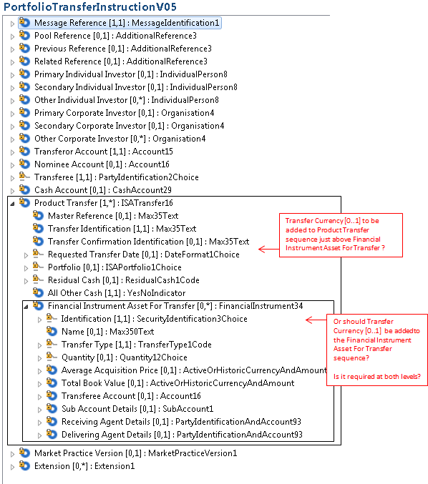

Portfolio Transfer Confirmation (sese.013.001.05)
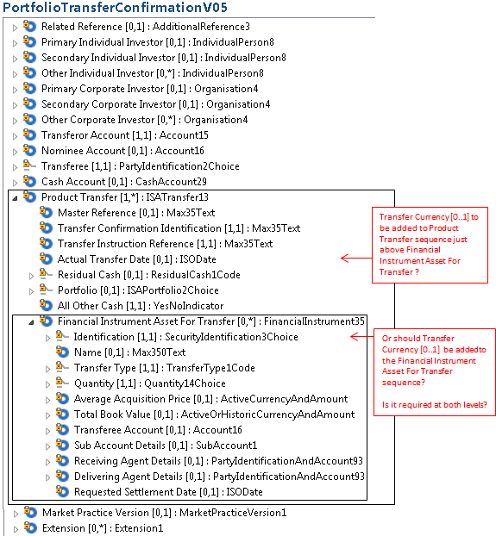

Portfolio Transfer Cancellation Request sese.014.001.05
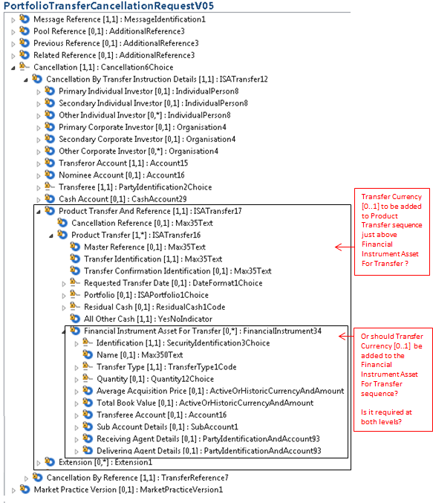
- Purpose of the change:
Introduction of optional Transfer Currency field for alignment with the funds transfers messages. Because some transfer agents register holdings segregated by currency not by ISIN, there is a need for a field to indicate the currency. This is information that is determined at the level of the portfolio instruction and is then subsequently instructed in the transfer out instruction.

Element | Multiplicity | Data Type | Definition
TransferCurrency | [0.1] | CurrencyCode | Identifies the currency to be used to transfer the holdings.
- Urgency of the request:
Next yearly maintenance cycle (2014/2015)
- Business examples:
None
- SEG recommendation:
Consider |  | X | Timing
 |  |  | - Next yearly cycle: 2014/2015  (the change will be considered for implementation in the yearly maintenance cycle which starts in 2014 and completes with the publication of new message versions in the spring of 2015) |  | X
- At the occasion of the next maintenance of the messages
(the change will be considered for implementation, but does not justify maintenance of the messages in its own right – will be pending until more critical change requests are received for the messages)
- Urgent unscheduled
(the change justifies an urgent implementation outside of the normal yearly cycle)
 |  |  | - Other timing:
Comments:

Reject
Reason for rejection:

