Change Request
for the update of ISO 20022 financial repository items
- Origin of the request:
A.1 Submitter : SWIFT Standards (submitted 13 February 2014)
A.2 Contact person:
Janice Chapman janice.chapman@swift.com +32 2 655 3390
A.3 Sponsor:
- Related messages:
 | Statement of Investment Fund Transactions V02 | semt.006.001.02
 | Statement Of Investment Fund Transactions Cancellation V02 | semt.007.001.02
- Description of the change request:
[1] Update the definition of Order Date Time:
Current Definition | Revised Definition
Date and time at which the order was placed by the investor. | Date and time at which the order was placed by the investor or its agent.
This change of definition is proposed as a result of SMPG IF WG work on the funds order messages
[2] Update the definition of Order Reference:
Current Definition | Revised Definition
Unique identifier for an order, as assigned by the sell-side. The identifier must be unique within a single trading day. | Unique and unambiguous identifier for an order, as assigned by the instructing party.
This change means the definition is in line with that in the order messages.
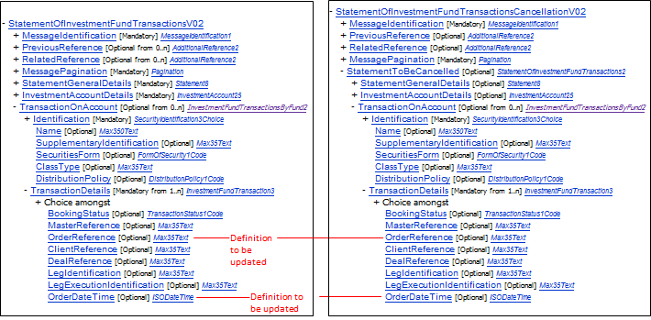
- Purpose of the change:
Fine-tuning of definitions. This is a document update only.
- Urgency of the request:
Next yearly maintenance cycle (2014/2015).
Other change requests have been submitted for the two Investment Funds Statement of Transactions messages, including one correction on the cancellation message, which really should be done as soon as possible (the element SubAccount Details is designated mandatory when it should be optional and this means that vendors cannot offer a full solution).
- Business examples:
None
- SEG recommendation:
Consider |  | X | Timing
 |  |  | - Next yearly cycle: 2014/2015  (the change will be considered for implementation in the yearly maintenance cycle which starts in 2014 and completes with the publication of new message versions in the spring of 2015) |  | X
- At the occasion of the next maintenance of the messages
(the change will be considered for implementation, but does not justify maintenance of the messages in its own right – will be pending until more critical change requests are received for the messages)
- Urgent unscheduled
(the change justifies an urgent implementation outside of the normal yearly cycle)
 |  |  | - Other timing:

Comments:

Reject
Reason for rejection:

