Change Request
for the update of an External Code Set used in ISO 20022

- Origin of the request:
A.1 Submitter: Trade Services SEG
A.2 Contact person: David Dobbing (david.dobbing@swift.com) or Robert Marchal (robert.marchal@swift.com)
A.3 Sponsors: Trade Services SEG members.
- Related External Code Set: 21-Incoterms

- Description of the change request:
Add “- Incoterms 2010” or “(Incoterms 2010)” at the end.

- Purpose of the change:
Incoterms are reviewed from time to time. The last revision is from 2010. Incoterms may be added, deleted or definitions may be updated. It is very important that the version of the Incoterms is specified in a transaction, as this can have legal consequences.

- Urgency of the request:
Next quarterly release
- Business examples:
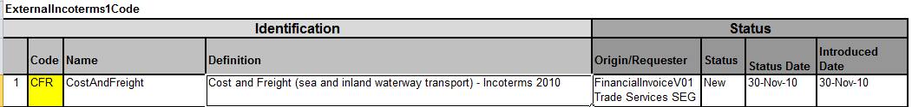
- SEG recommendation:
This section will be completed in due time by the SEG in charge of the related External Code Set.

Accept |  | X | Timing
 |  |  | - Next possible quarterly release |  | 1Q2014
 |  |  | - Other timing:
Comments:

Reject
Reason for rejection:

