Change Request
for the update of an External Code Set used in ISO 20022

- Origin of the request:
A.1 Submitter:

SWIFT
8 Marina View, Asia Square Tower 1, #28-04, Singapore 018960

A.2 Contact person:

Mr. David Dobbing SWIFT Standards Department
Tel: +65 8500 8056

A.3 Sponsors: /

ETDA (Electronic Transactions Development Agency)
120 M.3 Floor 7 The Government Complex, Building B
Chang Watthana Rd, Laksi
Bangkok 10210
Thailand

www.etda.or.th
Tel. +66 2142-1160

Mr. Supachok Jantarapatin
Tel: +66 2142-2505

- Related External Code Set:
5 – Clearing System Identification

- Description of the change request:

Code | Name |  | Definition | Country | Bank  Identifier | Example
THCBC |  | Thai Central Bank Identification Code | Bank Identification code used in Thailand | Thailand | [0-9]{3,3} | 123
Please note that all examples shown in the current external code list need to be revised. The member identification should not be prefixed with the clearing system identification. For example "ATBLZ12345", "AUBSB123456", "CACPA123456789", "CHBCC12345" should be "12345", "123456", "123456789", "12345" respectively. Applies to all examples in the current external code list.
The format of ClearingSystemMemberIdentification changed under the 2009 release of the payments messages and as consequence the MemberIdentification no longer needs to be prefixed with the ClearingSystemIdentification since it is now a specific element in the structure.
2006
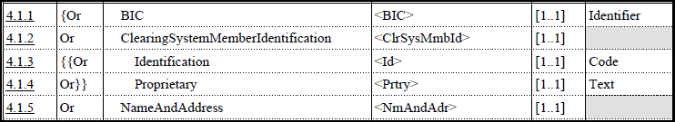

2009
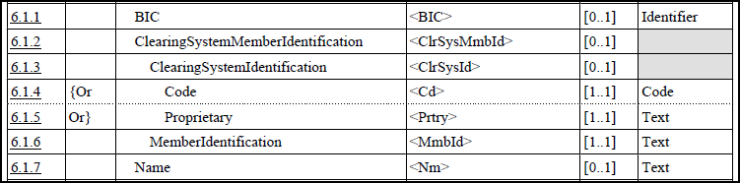

- Purpose of the change:
Additional code is required to support the Thailand payment implementations.

- Urgency of the request:
By default, valid change requests, subsequently approved by the SEG will be included in the following quarterly publication of External Code Sets, unless decided otherwise by the SEG.
Default

- Business examples:

/

- SEG recommendation:

Accept |  | Y | Timing
 |  |  | - Next possible quarterly release |  | X
 |  |  | - Other timing:
Comments:

Reject
Reason for rejection:

