Change Request
for the update of ISO 20022 financial repository items

- Origin of the request:
A.1 Submitter:
German Savings Banks Association (DSGV)
A.2 Contact persons:
Dr. Ralf Schopohl (Ralf.Schopohl@dsgv.de, +49 228 4495 7379)
A.3 Sponsors:
- National Association of German Cooperative Banks (BVR) representing all German Cooperative Banks
- German Savings Banks Association (DSGV) representing all German Savings Banks and regional banks (Landesbanken)
- Deutsche Bundesbank
- Related messages:
camt.052, camt.053, camt.054 (clarification in the MDR)

- Description of the change request:
According to an agreement reached by the DK (Die Deutsche Kreditwirtschaft) in 2009, the German banking industry has decided to use the three cash management messages (camt) based on ISO 20022 for customer statement information.
So actually all German banks are implementing or have implemented camt. Thereby it was detected that it is not self-explanatory how R-transactions are presented/ reported in the several camt-messages.
Two interpretations are possible:
1) The debtor/creditor account (and the related parties and agents) of an R-transaction are the same as the debtor/creditor account in the original underlying transaction. This would be in accordance with the approach of the ISO 20022 pacs R-messages, which do not change the roles in the complete process.
2) The roles “debtor” and “creditor” (and the related parties and agents) of a transaction are always those who give and receive the money via the transaction on hand (which means: debit = debtor and credit = creditor). Consequently the roles have to be changed, ie. a Debtor in the pacs R-message becomes a creditor in the camt message.
The interpretation conflict comes apparent by the following graphics, which show extracts of pacs.002/004 and camt.052/53/54:

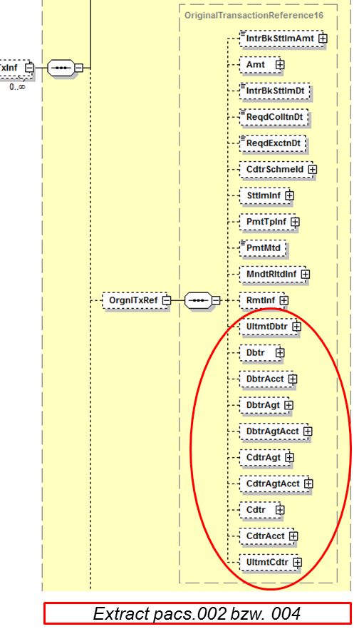
→For R-transactions the ISO-messages pacs.002 and pacs.004 are specified. Creditor and debtor are transmitted in the structure <OrgnlTxRef> which means, that the content of the elements are those of the original underlying transaction.

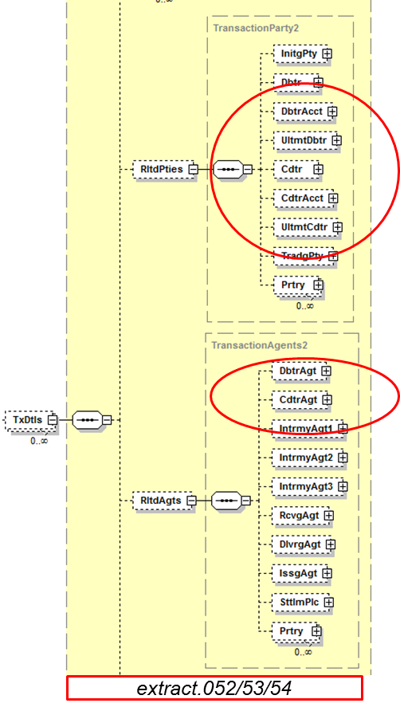
→ In the camt-message we do not have any “original”-structure. So for the mapping of R-transactions into camt all elements have to be mapped 1:1 (interpretation 1) or to be turned (interpretation 2, which means original creditor becomes debtor in the case of R-transactions)

- Purpose of the change:
In the German banking industry both approaches have “followers” – the result is that some banks implemented version 1 and others version 2.
In order to receive a common interpretation a guidance how the parties are interpreted in case of R-transactions is needed. To achieve this clarification guidance in the in the Message Definition Report (MDR) would be very helpful and appreciated.
- Urgency of the request:
The actual status is unacceptable for our customers who would like to introduce the camt messages in the context of their SEPA migration projects. The current situation prevents a consistent use of camt.
In consequence an update of the Message Definition Report is expected for the next yearly maintenance cycle.

- Business examples:
--
- SEG recommendation:

Consider |  | X | Timing
 |  |  | - Next yearly cycle: 2014/2015  (the change will be considered for implementation in the yearly maintenance cycle which starts in 2014 and completes with the publication of new message versions in the spring of 2015) |  | X
- At the occasion of the next maintenance of the messages
(the change will be considered for implementation, but does not justify maintenance of the messages in its own right – will be pending until more critical change requests are received for the messages)
- Urgent unscheduled
(the change justifies an urgent implementation outside of the normal yearly cycle)
 |  |  | - Other timing:
Comments: Revising the MDR Part 1 represents a problem because the two interpretations described in the document are addressed to two different types of communities (CGI and private banks).

Reject
Reason for rejection:

