Change Request
for the update of ISO 20022 financial repository items
- Origin of the request:
A.1 Submitter:
SIX Interbank Clearing Ltd, Zurich (Switzerland)
A.2 Contact person:
SIX Interbank Clearing Ltd, Hardturmstrasse 201, 8021 Zurich
Istvan Teglas | istvan.teglas@six-group.com | +41 58 399 4238
A.3 Sponsors:
UBS AG, CH-8098 Zurich
Credit Suisse, CH-8070 Zurich
Postfinance, CH-3000 Bern
Zürcher Kantonalbank, CH-8001 Zurich
SIX Interbank Clearing Ltd, CH-8021 Zurich
- Related messages:
pain.001.001.03

Comment: a similar rule exists also in the following messages (the change of these rules is not part of this change request):
- Pacs.003 (R7)
- Pacs.008 (R7)
- Pacs.009 (R7)
- Pain.008 (R3)

- Description of the change request:
In the document “Message Definition Report”, the rule 1 limits the use of the group “Payment Type Information” in the pain.001 either to the “Payment Information” or to the “Payment Information / Credit Transfer Transaction” level:
“R1 PaymentTypeInformationRule: If PaymentTypeInformation is present, then CreditTransferTransactionInformation/PaymentTypeInformation is not allowed.”

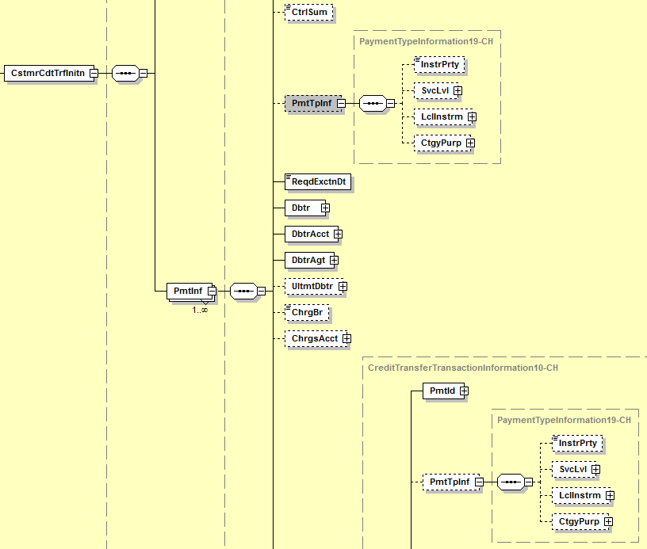

Because the group “Payment Type Information” consist of different elements/sub groups, the limitation should be applied to the sub elements/groups of “Payment Type Information”, instead of the group itself:
- Instruction Priority
- Sevice Level
- Local Instrument
- Category Purpose
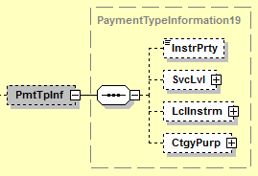

It should be possible to use some of these Elements on “Payment Information” level and some other on “Payment Information / Credit Transfer Transaction” level (but not the same Element on both level). Some transactions might have to be marked differently on the “Payment Information / Credit Transfer Transaction” level, even if some other marks are valid for all transactions and should be done on “Payment Information” level.

In particular the group “Local Instrument” is foreseen to carry “local” instructions (valid for a whole community and not just for a defined creditor agent) and information (“This element is used to specify a local instrument, local clearing option and/or further qualify the service or service level.”). Thus there is the need, for example, to use Instruction Priority on the “Payment Information” level because it is valid for all transaction of this “Payment Information” level, but to use “Local Instrument” on “Credit Transfer Transaction” level with different values in some or in each transaction.

- Purpose of the change:
Business Reason:
For example transactions marked as “Salary “Payment” in the element “CategoryPurpose” on the “Payment Information” level. The content is propagated to all underlying Transactions. The Transactions are used with BIC, National Identifier as well as the different values for the element “Local Instrument” as used in Switzerland for the several local Swiss payment types. This constellation is not supported by ISO Rule 1 saying, that the element “Payment Type Information” has to be either on “Payment Information” level or on “Payment Information / Credit Transfer Transaction” level.
It should also be possible to mark payments on “Payment Information” level in the Element “Payment Information/ Instruction Priority” with “HIGH”, propagated to all underlying Transactions, but to mark some of the underlying transactions in the Element “Credit Transfer Transaction Information/Payment Information/ Instruction Priority/Category Purpose” with “SALA”, and some with “PENS” and let some transactions be without any definition of “Category Purpose”.

- Urgency of the request:
As soon as possible.

- Business examples:
Level “Payment Information” marked in the Element Instruction Priority as “HIGH” with a transaction (level “Credit Transfer Transaction“) marked with Local Instrument “CH01” should be allowed. Some other transactions might follow in the same Payment Information without or with other marks in the Elements Service Level, Local Instrument or Category Purpose, but not with the Element Instruction Priority.

<CstmrCdtTrfInitn>
<GrpHdr>
<MsgId>1000151614</MsgId>
<CreDtTm>2012-05-07T16:42:45</CreDtTm>
<NbOfTxs>1</NbOfTxs>
<CtrlSum>4711.00</CtrlSum>
<InitgPty>
<Nm>Name of the initiating Party</Nm>
</InitgPty>
</GrpHdr>
<PmtInf>
<PmtInfId>100082146</PmtInfId>
<PmtMtd>TRF</PmtMtd>
<BtchBookg>false</BtchBookg>
<PmtTpInf>
<InstrPrty>HIGH</InstrPrty>
</PmtTpInf>
…

<CdtTrfTxInf>
<PmtId>
<InstrId>INSTRID-01-01</InstrId>
<EndToEndId>ENDTOENDID-001</EndToEndId>
</PmtId>
<PmtTpInf>
<LclInstrm>
<Prtry>CH01</Prtry>
</LclInstrm>
</PmtTpInf>
<Amt>
<InstdAmt Ccy="EUR">70000.00</InstdAmt>
</Amt>
…

<CdtTrfTxInf>
<PmtId>
<InstrId>INSTRID-01-02</InstrId>
<EndToEndId>ENDTOENDID-002</EndToEndId>
</PmtId>
<Amt>
<InstdAmt Ccy="EUR">30000.00</InstdAmt>
</Amt>

- SEG recommendation:

Consider |  | Y | Timing
- Next yearly cycle: 2013/2014
(the change will be considered for implementation in the yearly maintenance cycle which starts in 2013 and completes with the publication of new message versions in the spring of 2014)
- At the occasion of the next maintenance of the messages
(the change will be considered for implementation, but does not justify maintenance of the messages in its own right – will be pending until more critical change requests are received for the messages)
- Urgent unscheduled
(the change justifies an urgent implementation outside of the normal yearly cycle)
 |  |  | - Other timing:
Comments:
Consider in the maintenance cycle 2012/2013

Reject
Reason for rejection:

