Change Request
for the update of ISO 20022 financial repository items
- Origin of the request:
A.1 Submitter:
SIX Interbank Clearing Ltd, Zurich (Switzerland)
A.2 Contact person:
SIX Interbank Clearing, Ltd Hardturmstrasse 201, 8021 Zurich
Istvan Teglas | istvan.teglas@six-group.com | +41 58 399 4238

A.3 Sponsors:
UBS AG, CH-8098 Zurich
Credit Suisse, CH-8070 Zurich
Postfinance, CH-3000 Bern
Zürcher Kantonalbank, CH-8001 Zurich
SIX Interbank Clearing Ltd, CH-8021 Zurich

- Related messages:
- camt052.001.02
- camt053.001.02
- camt054.001.02

- Description of the change request:
To add a similar RelatedPrice (NtryDtls/TxDtls/RltdPric) tag context to Ntry level.
As is:
Ntry-Level
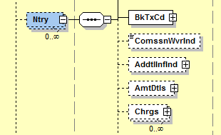

To be

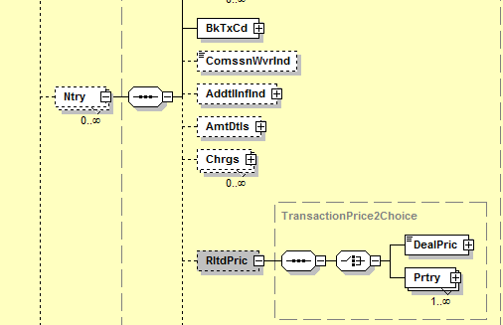

- Purpose of the change:
The element “Charges” provides information to charges included in the entry amount and is available both on Ntry and NtryDtls level.
To provide information to charges/prices, which are not directly included in the entry amount (prices for example entered at the end of month) is the element “RelatedPrice “ available but only on NtryDtls level (NtryDtls/TxDtls/RltdPric).
Having this structure only on NtryDtls level cannot solve all case of charges notification. Such information must also be available as “RelatedPrice” on the Ntry Level: Ntry / RltdPric.

- Urgency of the request:
As soon as possible. camt.0052.001.03, camt.0053.001.003, camt.0054.001.03

- Business examples:
Customer is reported with daily camt.053. Batch or aggregate bookings are according to the use on entry level notified. The entry detail level is used to provide informations on the underlying transactions .
Some charges on batch, aggregate bookings are not entered directly but once at the end of the month and have to be in daily camt.053 on Entry level as information for the customer notified.

As example, outgoing electronic payment order:
- USD 10’000 with 2 underlying transactions (USD 8’000 and USD 2’000)
- Price for payment order treatment: USD 2.00 (will be charged at the end of the month)
- Price for underlying transaction: USD 0.20 (will be charged at the end of the month)

Entry Level

-> Information on aggregate booking with new Element <RltdPric>
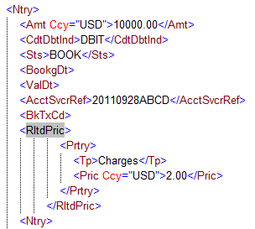
Entry Details Level

-> Information on underlying transactions with existing Element <RltdPric>

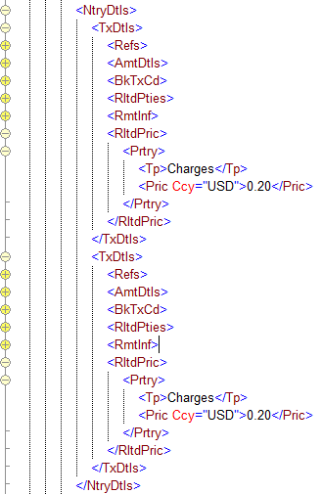

.

- SEG recommendation:

Consider |  | Y | Timing
- Next yearly cycle: 2013/2014
(the change will be considered for implementation in the yearly maintenance cycle which starts in 2013 and completes with the publication of new message versions in the spring of 2014)
- At the occasion of the next maintenance of the messages
(the change will be considered for implementation, but does not justify maintenance of the messages in its own right – will be pending until more critical change requests are received for the messages)
- Urgent unscheduled
(the change justifies an urgent implementation outside of the normal yearly cycle)
 |  |  | - Other timing:
Comments:
Consider in the 2012/2013 maintenance cycle

Reject
Reason for rejection:

