Change Request
for the update of ISO 20022 financial repository items

- Origin of the request:
A.1 Submitter: CGI
A.2 Contact person:
Tinne Verschueren | tinne.verschueren@swift.com | +32 2 655 4606
Marcel Winterhalder | marcel.winterhalder@db.com | +49(69)910-36251

A.3 Sponsors:
CGI (Common Global Implementation) Working group 2 on B2C reporting
www.swiftcommunity.net/communities/CGI

- Related messages:
camt.052.001.03 | BankToCustomerAccountReportV03
camt.053.001.03 | BankToCustomerStatementV03
camt.054.001.03 | BankToCustomerDebitCreditNotificationV03

- Description of the change request:
Restrict the data type of TotalNetEntryAmount (exclude negative values) to remove ambiguity on current elements in TransactionsSummary.
The TotalNetEntryAmount currently is typed with DecimalNumber.
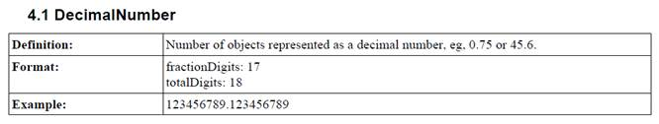
This data type does not exclude negative values.
Furthermore, the element CreditDebitIndicator is optional. If both elements (TotalNetEntryAmount and CreditDebitIndicator) are used, there can potentially be confusion or contradiction.
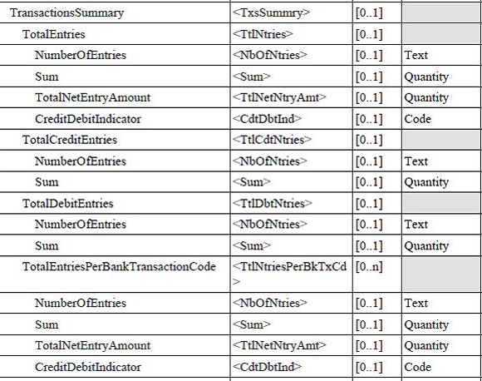

- Purpose of the change:
Make the Standards Evaluation Group aware of the ambiguity in the existing schemes and open the discussion to restrict the data type and/or impose the use of the CreditDebitIndicator or keep the data type and remove the CreditDebitIndicator. CGI’s preference is to at least restrict the data type.

- Urgency of the request:
For inclusion in the next ISO 20022 maintenance release.

- Business examples:
Examples of ambiguity:
<TtlNtries>
<NbOfNtries>5</NbOfNtries>
<TtlNetNtryAmt>-500</TtlNetNtryAmt>
<CdtDbtInd>CRDT</CdtDbtInd>
</TtlNtries>

Or

<TtlNtries>
<NbOfNtries>5</NbOfNtries>
<TtlNetNtryAmt>-500</TtlNetNtryAmt>
</TtlNtries>

- SEG recommendation:

Consider |  | Y | Timing
 |  |  | - Next yearly cycle: 2012/2013  (the change will be considered for implementation in the yearly maintenance cycle which starts in 2012 and completes with the publication of new message versions in the spring of 2013) |  | X
- At the occasion of the next maintenance of the messages
(the change will be considered for implementation, but does not justify maintenance of the messages in its own right – will be pending until more critical change requests are received for the messages)
- Urgent unscheduled
(the change justifies an urgent implementation outside of the normal yearly cycle)
 |  |  | - Other timing:
Comments:

Reject
Reason for rejection:

