Change Request
for the update of ISO 20022 financial repository items

- Origin of the request:
A.1 Submitter: This request is submitted by the Berlin Group on behalf of its members from the European Card Payments Industry, which include Atos Wordline, Borica, BKM, Ceca, Cetrel, Trionis, EAPS, Euro Kartensysteme, Equens, e-rsb, DIAS, First Data International, German Banking Industry Committee, MBU, National Bank of Serbia, PAN Nordic Card Association, Payfair, Equens Italy, SIA, SIBS, Visa Europe, VocaLink, and others.
A.2 Contact person:
The following persons can be contacted by the RA, RMG or SEG to get additional information on the project and/or its business justification:
Ortwin Scheja, SRC Security Research & Consulting GmbH, Bonn, Germany, phone: +492282806109, email: ortwin.scheja@src-gmbh.de

- Related messages:

The bank to customer report messages:
  - camt.052 BankToCustomerAccountReport
  - camt.053 BankToCustomerStatement
  - camt.054 BankToCustomerDebitCreditNotification

- Description of the change request:
The ISO 20022 financial repository describes payment messages for Direct Debits and Credit Transfers. The Berlin Group as a European standardisation organisation has developed a payment model and a message format for the clearing of card transactions by using the Direct Debit messages from the ISO 20022 repository, i.e. “pain” and “pacs” messages of the standard resulting in a SEPA Card Clearing Framework (SCC), cp. www.berlin-group.org.
Whilst the ISO 20022 repository is fully sufficient for the clearing process between the Debtor and Creditor Bank itself also for card transactions, more data elements are required to transport card transaction related data from the Creditor to the Debtor or their respective reference parties for the cardholder account statement or the dispute management between the acquirer of the card transaction and the issuer of the card. To solve this in a short term perspective, the Berlin Group has introduced proprietary encodings for SCC within subfields of the payment messages, especially a TLV encoding of the unstructured remittance information field.
With the extension of ISO 20022 payment messages by the supplementary data field methodology within the transactions and with the upcoming card data container submitted by the Berlin Group to the ISO 20022 repository, these messages now will meet the requirements of a well-structured clearing of card based transactions.
Up to now, the usage of the card data container is intended to be used by the SCC framework for the customer-to-bank and bank-to-bank messages. The camt messages within the bank-to-customer interface have not been addressed in detail, since these messages have been extended through CR0021 (Febelfin) anyhow by card transaction related data. The Berlin Group has been included into the discussions of the underlying model, while extending the camt messages by card data.
Nevertheless, due to the on-going development of the supplementary data extension and due to the fact that the Berlin Group has not been officially involved into the commenting process of the new camt messages, some data needed in the card’s part of the camt messages from the Berlin Group perspective, have not been included into the camt messages. Thus, the Berlin Group is asking for extending the card details field within the new camt messages for some more data components and elements.
Design Impact on card detail field within card messages
The Entry component 5.1.176 CardTransaction of the camt.052, camt.053 and camt.054 messages within the bank-to-customer sphere should be extended by the following data elements:
- Amount (optional, present as ISO 20022 sub field as defined in CAPE 2.143 respectively CardAmountAndCurrencyExchange1) with currency with the types of entry
  - Cash Back (present)
  - Gratuity (present)
  - Original (present)
  - InterchangeFee (present)
  - Surcharge (present)
  - ServiceFee (present)
- Payment Context (optional, present as ISO 20022 sub field as defined in CAPE 2.86 respectively PaymentContext3) with the substructures present in the ISO 20022:
  - Card Presence (True/False)
  - Cardholder Presence (True/False)
  - Attendance
  - Authentication method
  - Card Data Entry Mode
  - Transaction Channel
- RePresentmentReason (optional, new field for ISO 20022 with external code list)
- ICC related Data (optional, present as ISO 20022 sub field as defined in CAPE 2.164)
- MerchantCategoryCode (optional, present as ISO 20022 sub field as defined in CAPE 2.109)
- TransactionDateTime (optional, present as ISO 20022 sub field as defined in CAPE 2.111)
- TransactionReference (optional, present as ISO 20022 sub field as defined in CAPE 2.112)
- SaleReferenceNumber (optional, present as ISO 20022 sub field as defined in CAPE 2.99)
- AdditionalService (optional, present as ISO 20022 sub field as defined in CAPE 2.107)
- PrepaidAccount to be loaded (optional, new field for ISO 20022 defined as CashAccount24) with the subfields
  - Account to be loaded
  - Account Type
  - Account Issuer Name
More details on card transaction related data to be transported in camt messages can be delivered by the Berlin Group, if needed by the ISO 20022 Payment SEG.
- Purpose of the change:
The Berlin Group intends to issue a new version of its SEPA Card Clearing Framework, based on payment messages, including card data containers in the corresponding pain and pacs messages. The data content of the supplementary data container have to be completely considered by the camt messages with its card data detail field. The purpose is to fully support the card data transport end-to-end from the (ultimate) creditor to the (ultimate) debtor. Only the full end-to-end transport of all card data container content will enable the banks
- to inform the merchants and cardholders about all necessary entries, and
- to translate the payment based clearing into clearing formats of other card payment schemes where necessary.
- Urgency of the request:
The banking industry in some European countries is planning to migrate the card clearing from domestic debit instruments to SEPA standards after February 2014 (SEPA end date). Thus the extension of the ISO 20022 debit and credit messages for card data and here the full functionality of camt messages regarding card data is very urgent to allow the use of fully ISO defined messages.
See additional comment on requested timing on next page.
- Business examples:
Cp. D.
- SEG recommendation:

Consider |  | X | Timing
 |  |  | - Next yearly cycle: 2012/2013  (the change will be considered for implementation in the yearly maintenance cycle which starts in 2012 and completes with the publication of new message versions in the spring of 2013) |  |  | Priority:  high  medium  low
 |  |  | - At the occasion of the next maintenance of the messages  (the change will be considered for implementation, but does not justify maintenance of the messages in its own right – will be pending until more critical change requests are received for the messages) |  | X
- Urgent unscheduled
(the change justifies an urgent implementation outside of the normal yearly cycle)
 |  |  | - Other timing:
Comments:
CR0233 has been approved by the Card SEG during the SEG Conference Call on 03rd Oct. 2012. There are no additional comments. Participants:
- Vanobberghen, William
- Epaillard, Pierre
- Spittler, Pascal
- Herwig, Reinhard
- Scheja, Ortwin
- Chris Starr (apologised)

Next action:
A working group of Card SEG members, the editor of the camt messages and the submitter of CR0233 will be organised to complete the integrated CardTransaction message component beginning of November 2012.

Joint Comment: Berlin Group / SWIFT (28 May 2013)

Following a joint meeting in May 2013, it was agreed that some elements must be implemented in the B2C Cash Management messages in the Card Transaction details component, and suggests that the CR be only implemented at the occasion of the next maintenance of the messages (the change should be considered for implementation, but does not justify maintenance of the messages in its own right).

Following implementation has been agreed in the messages:

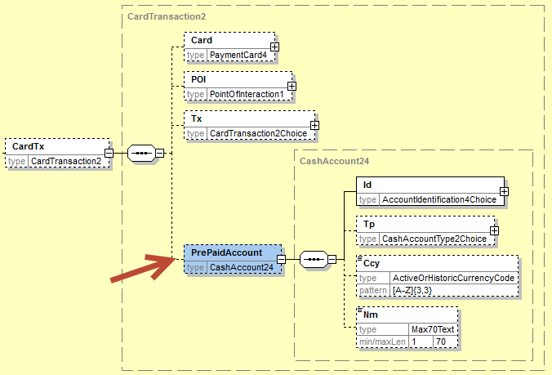

Within the CardTransaction element the PrePaidAccount should be added as already present in the PaymentsSDV01 supplementary data component.

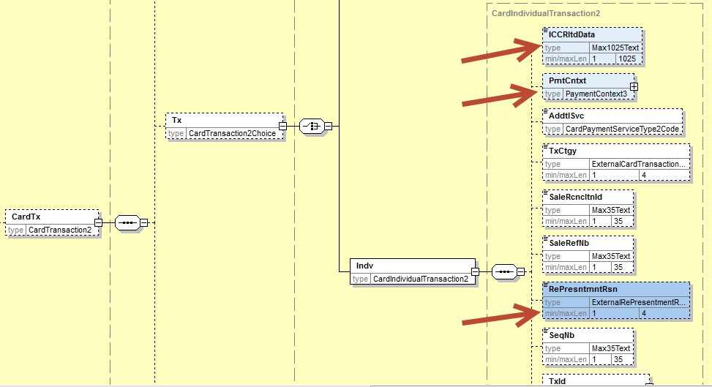

Within the Individual card transaction component, following 3 elements will be added as already present in the PaymentsSDV01 supplementary data component:
- ICC Related Data element
- Payment Context element
- RePresentment Reason element

For all amount elements listed in the CR, the current specifications of the AmountDetails component defined in the Transaction Details already fully support the requested amount types through the ProprietaryAmount element (repetitive element), and no further changes are required.
For all other requested elements, the current Card Transaction component already supports the requirements and the required fields. The definition of the TransactionCategory will be updated to make reference to the MerchantCategoryCode, as those two elements represent the same business concept.

Reject
Reason for rejection:

Payments SEG recommendation: This CR will be considered at the occasion of the next maintenance cycle (2014/2015).

