Change Request
for the update of ISO 20022 financial repository items
(SMPG IF 008)

- Origin of the request:
A.1 Submitter: SMPG Investment Funds
A.2 Contact person: Janice.Chapman@swift.com +32 (0) 2 655 3390

BACKGROUND
See CR 0222.

- Related messages:
Price Report Cancellation reda.002.001.02

- Description of the change request:
New optional ‘expected price correction date’, to be provided as a choice between ISODate and ISODateTime
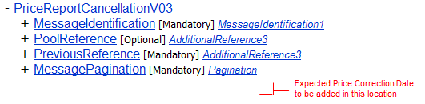
Definition: Date or date and time on which the reporting party expects that a replacement Price Report will be provided.

- Purpose of the change:
This is to give the receiver of the price report cancellation an indication of when the new price/s will be provided.

- Urgency of the request:
The SMPG IF working group propose that the change request (and the other associated price report change requests) should be implemented in the messages for the 2013 cycle, so that these fundamental changes are available before too many institutions automate the price report process

- Business examples:

- SEG recommendation:

Consider |  | Y | Timing
 |  |  | - Next yearly cycle: 2012/2013  (the change will be considered for implementation in the yearly maintenance cycle which starts in 2012 and completes with the publication of new message versions in the spring of 2013) |  | X | Priority:  high  medium  low
- At the occasion of the next maintenance of the messages
(the change will be considered for implementation, but does not justify maintenance of the messages in its own right – will be pending until more critical change requests are received for the messages)
- Urgent unscheduled
(the change justifies an urgent implementation outside of the normal yearly cycle)
 |  |  | - Other timing:
Comments:

Reject
Reason for rejection:

