Change Request
for the update of ISO 20022 financial repository items
(SMPG IF 006)

- Origin of the request:
A.1 Submitter: SMPG Investment Funds
A.2 Contact person: Janice.Chapman@swift.com +32 (0) 2 655 3390

BACKGROUND
See CR 0222.

- Related messages:
Price Report Cancellation reda.002.001.02

- Description of the change request:
Change of multiplicity of Previous Reference from mandatory to optional

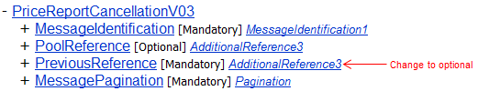

- Purpose of the change:
This is to eliminate the need for a technical reference in the cancellation message. Instead, the reference that is to be quoted is a business reference, that is the new Price Report Identification element (see associated change request CR0226).

- Urgency of the request:
The SMPG IF working group propose that the change request (and the other associated price report change requests) should be implemented in the messages for the 2013 cycle, so that these fundamental changes are available before too many institutions automate the price report process

- Business examples:

- SEG recommendation:

Consider |  | Y | Timing
 |  |  | - Next yearly cycle: 2012/2013  (the change will be considered for implementation in the yearly maintenance cycle which starts in 2012 and completes with the publication of new message versions in the spring of 2013) |  | X | Priority:  high  medium  low
- At the occasion of the next maintenance of the messages
(the change will be considered for implementation, but does not justify maintenance of the messages in its own right – will be pending until more critical change requests are received for the messages)
- Urgent unscheduled
(the change justifies an urgent implementation outside of the normal yearly cycle)
 |  |  | - Other timing:
Comments:

Reject
Reason for rejection:

