Change Request
for the update of ISO 20022 financial repository items
(SMPG IF 004)

- Origin of the request:
A.1 Submitter: SMPG Investment Funds
A.2 Contact person: Janice.Chapman@swift.com +32 (0) 2 655 3390

BACKGROUND
See CR 0222.

- Related messages:
Price Report reda.001.001.03
Price Report Cancellation reda.002.001.02

- Description of the change request:
Change of multiplicity:
[1] Price Report message:
Price Valuation Details \ Identification from mandatory to optional
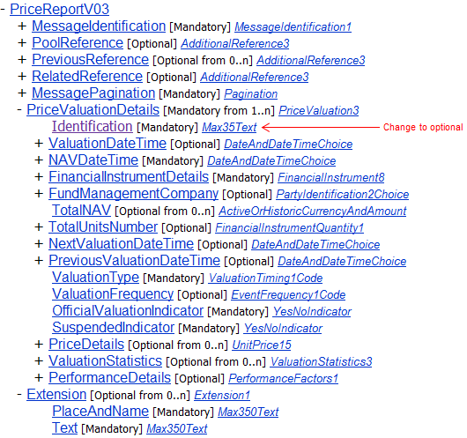

[2] Price Report Cancellation
Price Report To Be Cancelled \Price Valuation Details \ Identification from mandatory to optional

- Purpose of the change:
According to those that have already implemented, this mandatory technical identification at the level of each price is not required. Currently users populate this element with ‘anything’ in order to satisfy schema validation. The price itself is identified with a combination of the ISIN, date and price currency; a technical identification is not required. At this stage it is not proposed that this element is deleted, but left in as optional in order to lessen the impact on those that have already implanted the price report messages.

- Urgency of the request:
The SMPG IF working group propose that the change request (and the other associated price report change requests) should be implemented in the messages for the 2013 cycle, so that these fundamental changes are available before too many institutions automate the price report process.

- Business examples:

- SEG recommendation:

Consider |  | Y | Timing
 |  |  | - Next yearly cycle: 2012/2013  (the change will be considered for implementation in the yearly maintenance cycle which starts in 2012 and completes with the publication of new message versions in the spring of 2013) |  | X | Priority:  high  medium  low
- At the occasion of the next maintenance of the messages
(the change will be considered for implementation, but does not justify maintenance of the messages in its own right – will be pending until more critical change requests are received for the messages)
- Urgent unscheduled
(the change justifies an urgent implementation outside of the normal yearly cycle)
 |  |  | - Other timing:
Comments:

Reject
Reason for rejection:

