Change Request
for the update of ISO 20022 financial repository items
(SMPG IF 003)

- Origin of the request:
A.1 Submitter: SMPG Investment Funds
A.2 Contact person: Janice.Chapman@swift.com +32 (0) 2 655 3390

BACKGROUND
See CR 0222.

- Related messages:
Price Report reda.001.001.03

- Description of the change request:
Add an mandatory element Function (Code).
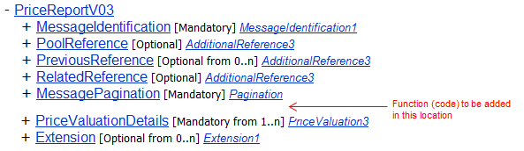

Definition: Function of the price report, that is, whether the price report is a new price report or a replacement of some kind.

Code | Code Name | Definition
NEWP | New Price Report | The price report is ‘new’, that is the report is not being used as a correction of previously sent prices.
REPL | Complete Replacement Price Report | The price report conveys the correction of the complete set of prices previously sent for the same price report identification.
PART | Partial | The price report conveys the correction of some of the prices previously sent for the same price report identification.

- Purpose of the change:
With the change of functionality, a Price Report message will be used to convey ‘new’ prices or corrected prices (the Price Report Correction message is to be withdrawn). Therefore, there needs to be an indication of whether the price report message is being used to convey ‘new’ or corrected prices.

- Urgency of the request:
The SMPG IF working group propose that the change request (and the other associated price report change requests) should be implemented in the messages for the 2013 cycle, so that these fundamental changes are available before too many institutions automate the price report process

- Business examples:

- SEG recommendation:

Consider |  | Y | Timing
 |  |  | - Next yearly cycle: 2012/2013  (the change will be considered for implementation in the yearly maintenance cycle which starts in 2012 and completes with the publication of new message versions in the spring of 2013) |  | X | Priority:  high  medium  low
- At the occasion of the next maintenance of the messages
(the change will be considered for implementation, but does not justify maintenance of the messages in its own right – will be pending until more critical change requests are received for the messages)
- Urgent unscheduled
(the change justifies an urgent implementation outside of the normal yearly cycle)
 |  |  | - Other timing:
Comments:

Reject
Reason for rejection:

