Change Request
for the update of ISO 20022 financial repository items
(SMPG IF 002)

- Origin of the request:
A.1 Submitter: SMPG Investment Funds
A.2 Contact person: Janice.Chapman@swift.com +32 (0) 2 655 3390

BACKGROUND
See CR 0222.

- Related messages:
Price Report reda.001.001.03
Price Report Cancellation reda.002.001.03
- Description of the change request:
Add an new element Cancellation Identification (Max35Text), which would be mandatory in the Price Report Cancellation and optional in the Price Report.
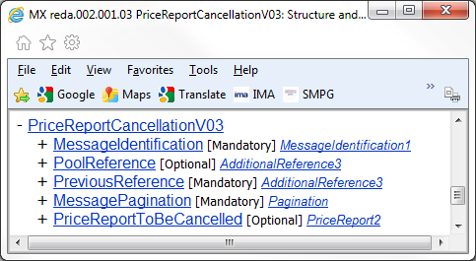
Mandatory Cancellation Identification (Max35Text) to be added in this location
In the Price Report, this new optional element is to be added in a similar location.

Definition: Unique and unambiguous identifier for the cancellation of the price report, as assigned by the reporting party.

- Purpose of the change:
When a price report is cancelled with the Price Report Cancellation message, it should be possible to quote a cancellation reference. And subsequently, if the price is corrected (with a Price Report message), reference can be made to the cancellation identification.
- Urgency of the request:
The SMPG IF working group propose that the change request (and the other associated price report change requests) should be implemented in the messages for the 2013 cycle, so that these fundamental changes are available before too many institutions automate the price report process

- Business examples:

- SEG recommendation:

Consider |  | Y | Timing
 |  |  | - Next yearly cycle: 2012/2013  (the change will be considered for implementation in the yearly maintenance cycle which starts in 2012 and completes with the publication of new message versions in the spring of 2013) |  | X | Priority:  high  medium  low
- At the occasion of the next maintenance of the messages
(the change will be considered for implementation, but does not justify maintenance of the messages in its own right – will be pending until more critical change requests are received for the messages)
- Urgent unscheduled
(the change justifies an urgent implementation outside of the normal yearly cycle)
 |  |  | - Other timing:
Comments:

Reject
Reason for rejection:

