Change Request
for the update of ISO 20022 financial repository items
(SMPG IF 001)

- Origin of the request:
A.1 Submitter: SMPG Investment Funds
A.2 Contact person: Janice.Chapman@swift.com +32 (0) 2 655 3390

BACKGROUND
The SMPG Investment Funds (IF) working group has discussed how cancellation and correction of price report information should work and agreed on the business process. The following is a diagram showing the sequencing of messages as a result of this agreed business process:
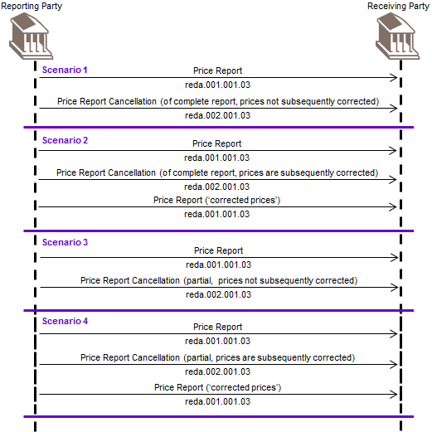

The price report messages need to be modified to support this process and this change request (and other associated price report change requests) is the result a gap analysis between this process and the current ISO price report messages. This is one of a series of change requests related to this work.

Summary of CRS that are submitted:
Identification # | Message/s | Description
SMPG IF 001 | - Price Report | New element: Price Report Identification (mandatory)
SMPG IF 002 | - Price Report  - Price Report Cancellation | New element: Cancellation Identification (optional)
SMPG IF 003 | - Price Report | New element: Function (code) (mandatory)
SMPG IF 004 | - Price Report  - Price Report Cancellation | Change of multiplicity: Price Valuation Details\Identification
SMPG IF 005 | - Price Report Cancellation | New choice component, choice between new element Price Report Identification and Price Report DetailsTo Be Cancelled (previously called Price Report To Be Cancelled)
SMPG IF 006 | - Price Report Cancellation | Change of multiplicity: Previous Reference
SMPG IF 007 | - Price Report Cancellation | New element: Cancellation Reason (code) (optional)
SMPG IF 008 | - Price Report Cancellation | New element: Expected Price Correction Date (optional)
SMPG IF 009 | - Price Report Cancellation | Documentation: modified and additional scope/usage information
SMPG IF 010 | - Price Report Correction | Withdrawal of message.

- Related messages:
Price Report reda.001.001.03
- Description of the change request:
Add a mandatory element Price Report Identification (Max35Text).
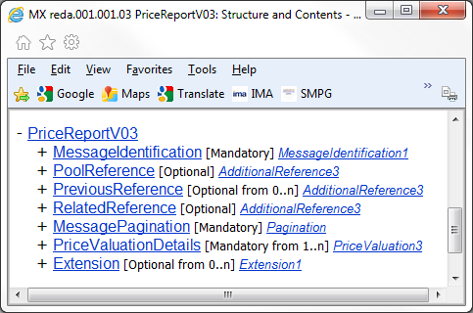
Mandatory Price Report Identification (Max35Text) to be added in this location

Definition: Unique and unambiguous identifier for the price report, as assigned by the reporting party.

- Purpose of the change:
When a price report is cancelled, it should be possible to quote the business reference of the original price report. Currently, there is not a business reference for the price report. This change is intended to add such a reference for the report as a whole, which would be common to all messages for the same report in the event of pagination.

- Urgency of the request:
The SMPG IF working group propose that the change request (and the other associated price report change requests) should be implemented in the messages for the 2013 cycle, so that these fundamental changes are available before too many institutions automate the price report process

- Business examples:

- SEG recommendation:

Consider |  | Y | Timing
 |  |  | - Next yearly cycle: 2012/2013  (the change will be considered for implementation in the yearly maintenance cycle which starts in 2012 and completes with the publication of new message versions in the spring of 2013) |  | X | Priority:  high  medium  low
- At the occasion of the next maintenance of the messages
(the change will be considered for implementation, but does not justify maintenance of the messages in its own right – will be pending until more critical change requests are received for the messages)
- Urgent unscheduled
(the change justifies an urgent implementation outside of the normal yearly cycle)
 |  |  | - Other timing:
Comments:

Reject
Reason for rejection:

