Change Request
for the update of ISO 20022 financial repository items

- Origin of the request:
A.1 Submitter: Tieto, technical issue
A.2 Contact person:
Ulrika Sjödahl, ulrika.sjodahl@tieto.com, +46104818037
Pirkko Vedenpää, pirkko.vedenpaa@tieto.com, +358207257525
A.3 Sponsors: Tieto Corporation

- Related messages:
tsin.004.001.01 (FinancialInvoice)

- Description of the change request:
At invoice level PurchsAcctgAcct can occurs 0 – n times, but message doesn’t support grouping to different accounts/account reference because amount element for grouping is missing.
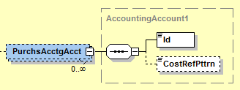
Add optional Amt element (with VAT-attribute) into PurchsAcctgAcct – structure.
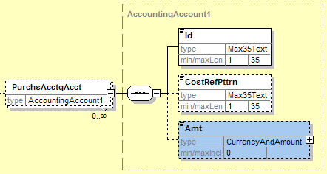

- Purpose of the change:
After this change grouping amounts to different accounts/account references are possible.
- Urgency of the request:
Normal

- Business examples:
For example: company mobile phone invoice with cost pools
Invoice total: 1000
Id: 123, Amount 200
Id: 124, Amount 500
Id: 125, Amount 100
Id: 200, Amount 200

- SEG recommendation:

Consider |  | Y | Timing
- Next yearly cycle: 2012/2013
(the change will be considered for implementation in the yearly maintenance cycle which starts in 2012 and completes with the publication of new message versions in the spring of 2013)
 |  |  | - At the occasion of the next maintenance of the messages  (the change will be considered for implementation, but does not justify maintenance of the messages in its own right – will be pending until more critical change requests are received for the messages) |  | X
- Urgent unscheduled
(the change justifies an urgent implementation outside of the normal yearly cycle)
 |  |  | - Other timing:
Comments:

Reject
Reason for rejection:

