**Change Request**

**for the update of ISO 20022 financial repository items**

1. **Origin of the request:**

*A.1 Submitter*: Tieto on behalf of customers

*A.2 Contact person:*

Ulrika Sjödahl, [ulrika.sjodahl@tieto.com](mailto:ulrika.sjodahl@tieto.com), +46104818037

Pirkko Vedenpää, [pirkko.vedenpaa@tieto.com](mailto:pirkko.vedenpaa@tieto.com), +358207257525

*A.3 Sponsors*: Tieto Corporation

1. **Related messages:**

tsin.004.001.01 (FinancialInvoice)

1. **Description of the change request:**

Attachment file name is missing from Document/FinInvc/TradAgrmt/AddtlRefDoc-structure. Only Document/FinInvc/TradAgrmt/AddtlRefDoc/DocNb –element exist and max length is only 35 chars.

Add own element FileNm for file name to Document/FinInvc/TradAgrmt/AddtlRefDoc –structure. Max length 70 chars.

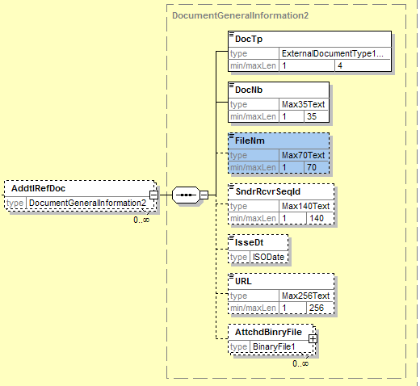

or

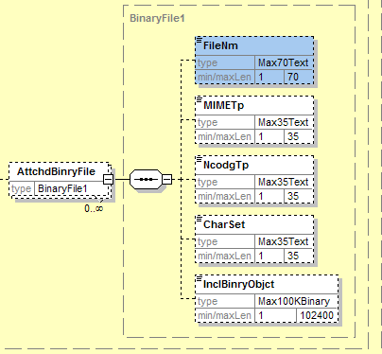

1. **Purpose of the change:**

EmbeddedDocumentBinaryObject –element in UBL 2.0 contains also place for attachment file name. Attachment file name is also needed according to eInvoice requirements in Finland.

Change makes attachment handling better aligned and manageable.

1. **Urgency of the request:**

Normal

1. **Business examples:**

It’s easier to discuss content of invoice and attachment, when payee’s attachment name is used and on view also at receiver’s side.

1. **SEG recommendation:**

|  |  |  |  |
| --- | --- | --- | --- |
| **Consider** | | Y | **Timing** |
|  | | - **Next yearly cycle: 2012/2013**  (the change will be considered for implementation in the yearly maintenance cycle which starts in 2012 and completes with the publication of new message versions in the spring of 2013) | |  |
|  | | - **At the occasion of the next maintenance of the messages**  (the change will be considered for implementation, but does not justify maintenance of the messages in its own right – will be pending until more critical change requests are received for the messages) | | X |
|  | | - **Urgent unscheduled**  (the change justifies an urgent implementation outside of the normal yearly cycle) | |  |  |
|  | | - **Other timing:** | | |  |

Comments:

The file name is to be added to the attachment.

|  |  |
| --- | --- |
| **Reject** |  |

Reason for rejection: