Change Request
for the update of ISO 20022 financial repository items

- Origin of the request:
A.1 Submitter: Peter Hoogervorst, RBS / CGI Group
A.2 Contact person:
Peter Hoogervorst | peter.hoogervorst@rbs.com | +31 20 4641311

A.3 Sponsors:
CGI (Common Global Implementation)
www.swiftcommunity.net/communities/CGI
Susan Colles susan.k.colles@baml.com
Peter Hoogervorst peter.hoogervorst@rbs.com
Francois Lemaire francois.lemaire@utsit.com

- Related messages:
This change request relates to the following payments message definitions that are using the component SequenceType1Code

camt.007.002.03 | RequestToModifyPaymentV03
camt.029.001.03 | ResolutionOfInvestigationV03
camt.055.001.01 | CustomerPaymentCancellationRequestV01
camt.056.001.01 | FIToFIPaymentCancellationRequestV01
pain.002.001.03 | CustomerPaymentStatusReportV03
pain.007.001.02 | CustomerPaymentReversalV02
pain.008.001.02 | CustomerDirectDebitInitiationV02
pain.014.001.01 | CreditorPaymentActivationRequestStatusReportV01
pacs.002.001.03 | FIToFIPaymentStatusReportV03
pacs.003.001.02 | FIToFICustomerDirectDebitV02
pacs.004.001.02 | PaymentReturnV02
pacs.007.001.02 | FIToFIPaymentReversalV02

2012 release versions (still to be published):

camt.087.001.04 | RequestToModifyPaymentV04
camt.028.001.04 | AdditionalPaymentInformationV04
camt.029.001.04 | ResolutionOfInvestigationV04
camt.055.001.02 | CustomerPaymentCancellationRequestV02
camt.056.001.02 | FIToFIPaymentCancellationRequestV02
pain.002.001.04 | CustomerPaymentStatusReportV04
pain.007.001.03 | CustomerPaymentReversalV03
pain.008.001.03 | CustomerDirectDebitInitiationV03
pain.014.001.02 | CreditorPaymentActivationRequestStatusReportV02
pacs.002.001.04 | FIToFIPaymentStatusReportV04
pacs.003.001.03 | FIToFICustomerDirectDebitV03
pacs.004.001.03 | PaymentReturnV03
pacs.007.001.03 | FIToFIPaymentReversalV03

- Description of the change request:
This change request consists of two parts, related to the usage of the SequenceType field and the SequenceType1Code data type.
1) The first proposal is to add a new code value to the below list of Sequence Type codes:
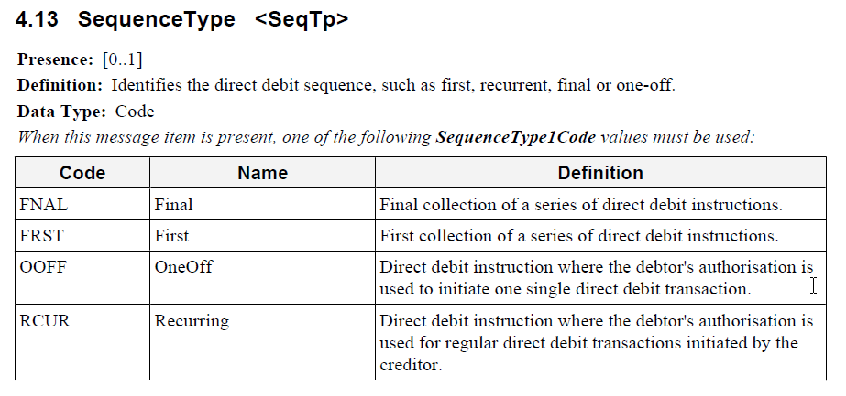
Add:
Code | Name | Definition
RPRE | Re-presented | Collection used to re-present previously reversed or returned direct debit transactions

2) Request that this code list be transformed from an ISO 20022 internal schema defined code list to an ISO 20022 external code list. The reason for this request is the growing adoption of direct debit messages by various countries, and moving the code list for Sequence Type to the external code list allows the community to be prepared for any additional code words required by local communities to successfully process direct debit instructions, without requiring maintenance on the ISO20022 messages themselves.

- Purpose of the change:
In the UK and Irish direct debit schemes, a code must be included for the clearing system to process the direct debit message. Four different codes exist today in the local clearing scheme (applying to both countries):

Local clearing code | Description | SequenceType1Code
01 | First collection | FRST
17 | Regular collection | RCUR
18 | Re-presented collection | Currently not covered
19 | Final collection | FNAL

Sequence Type is considered to be the appropriate field to include this information in the direct debit initiation pain.008.001.02 message, and equivalent codes in the schema exist for three out of four local code values. Current identification is therefore that one code is missing today: a code for the re-presented collection, which is what this change request aims to resolve.
Market usage of direct debit instructions shows the need for an additional codeword to cover re-presented collections, as per market practice for direct debit processing in the UK and the Republic of Ireland. The re-presentation code is actively used in these clearings, with the UK clearing alone having seen almost 18 million transactions containing the code for re-presentation between December 2010 and November 2011 (source: UK Payments Administration).
The common usage of the re-presented collection in these markets not only highlights the need to currently add a codeword to the SequenceType1Code data set, but also to review whether Sequence Type codes should be covered by in-schema codes or through the ISO20022 External Code List.
- Urgency of the request:
A discussion has been started within the Payments SEG to identify whether this change request can still be included in the 2012 run, as there is an urgent need from the market to include the re-presented collection code.
If this is found to not be possible, we would request this change request to be considered for the next submission and approval.
- Business examples:
See Section D (Purpose of the change)
- SEG recommendation:
This section is not to be taken care of by the submitter of the change request. It will be completed in due time by the SEG(s) in charge of the related ISO 20022 messages.

Consider |  | X | Timing
- Next yearly cycle: 2012/2013
(the change will be considered for implementation in the yearly maintenance cycle which starts in 2012 and completes with the publication of new message versions in the spring of 2013)
- At the occasion of the next maintenance of the messages
(the change will be considered for implementation, but does not justify maintenance of the messages in its own right – will be pending until more critical change requests are received for the messages)
- Urgent unscheduled
(the change justifies an urgent implementation outside of the normal yearly cycle)
- Other timing:
Urgent. For inclusion in the current maintenance cycle.
Comments:
The PaySEG accepts this CR for inclusion within the current maintenance cycle 2011/2012 with the following conditions:
- That this be an incremental code value added to the existing internal code list as discusses between the submitter and the SEG on Dec 19, 2011 PaySEG biweekly meeting. An external code list is a suitable technical treatment but is thought to be unneeded give that further changes to this code list are unlikely, infrequent.
- That the schema submitter (SWIFT) has sufficient time to include the change during the current evaluation.

Reject
Reason for rejection:

