Change Request
for the update of ISO 20022 financial repository items
- Origin of the request:
A.1 Submitter: SWIFT.
A.2 Contact person: Karine Taquet, karine.taquet@swift.com, + 32 2 655 37 84.

- Related messages:
SecuritiesSettlementTransactionStatusAdvice (sese.024.001.02)
IntraPositionMovementStatusAdvice (semt.014.001.02)
SecurtiesTransactionCancellationRequestStatusAdvice (sese.027.001.02)
SecuritiesSettlementConditionModificationStatusAdvice (sese.031.001.02)
SecuritiesFinancingStatusAdvice (sese.034.001.02)
SecuritiesBalanceCustodyReport (semt.002.01.04)
SecuritiesSettlementTransactionPendingReport (semt.018.001.02)
SecuritiesSettlementTransactionInstruction (sese.023.001.02)

- Description of the change request:
The below change requests are corrections to the messages in order to be in line with modelling guidelines and/or to be in line with ISO 15022.
  - Negative statuses
In all the status advice messages, the negative status choice component’s message elements that are optional should be changed to mandatory as they should be in a choice component.

Messages impacted
SecuritiesSettlementTransactionStatusAdvice (sese.024.001.02)
IntraPositionMovementStatusAdvice (semt.014.001.02)
SecurtiesTransactionCancellationRequestStatusAdvice (sese.027.001.02)
SecuritiesSettlementConditionModificationStatusAdvice (sese.031.001.02)
SecuritiesFinancingStatusAdvice (sese.034.001.02)

Current situation
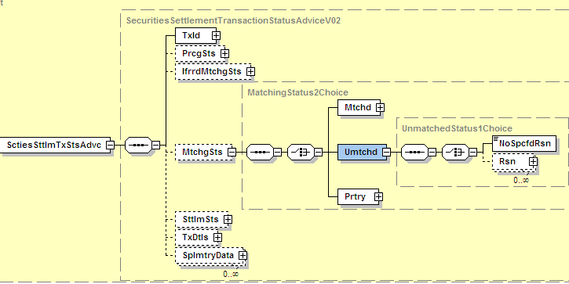

Will be changed to
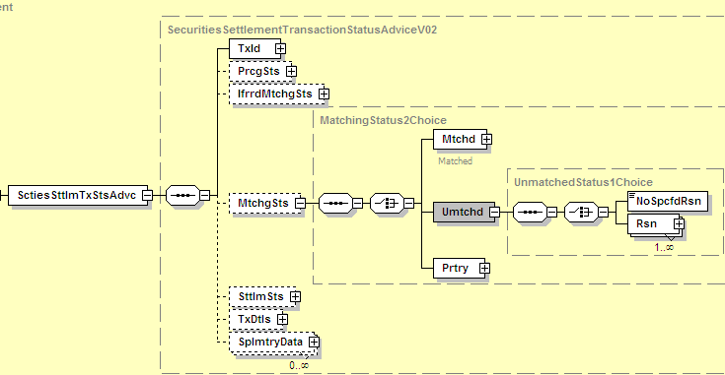

  - ReferenceChoice Components’ optional message elements should be changed to mandatory

References 10Choice, References13Choice and References14Choice contain optional message elements. These elements will be made mandatory as a choice component should contain only mandatory elements

Current situation
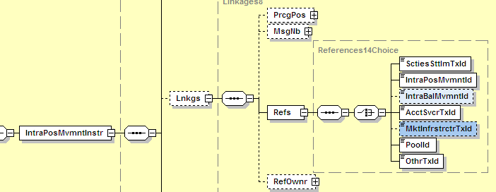

Will be changed to
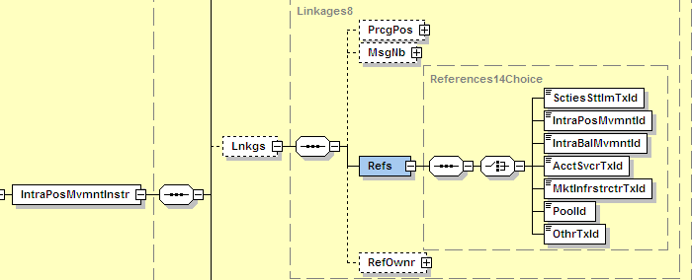

  - Extra level of nesting for StatusReason message component must be removed

In semt.018.001.02, at the level of the Transactions message component there is an unnecessary extra level of nesting for the StatusReason. I.e. it appears twice. This is a mistake and one level should be removed.

Message impacted
SecuritiesSettlementTransactionPendingReport (semt.018.001.02)

Current situation
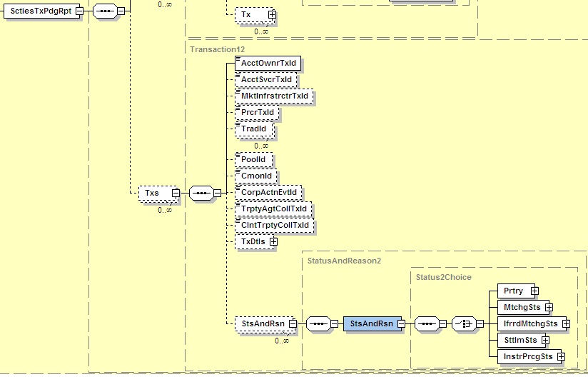

Will be changed to
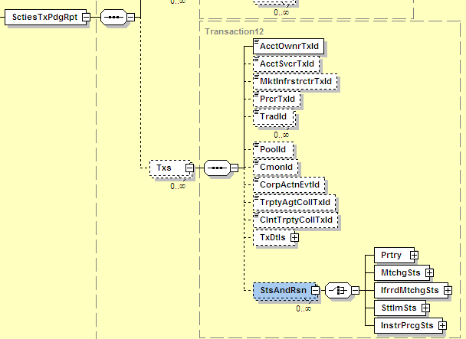

  - Lot Number to be added to the Transaction Details in the semt.014.001.02 mandatory

Last year, the lot number was added to the semt.013.001.02 following an accepted change request. It should also have been added to the semt.014.001.02 but it was not.
Message impacted
IntraPositionMovementStatusAdvice (semt.014.001.02)

Current situation
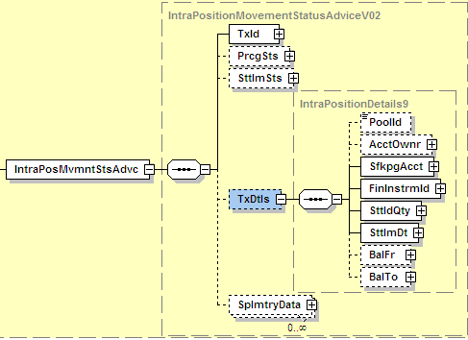

Will be changed to
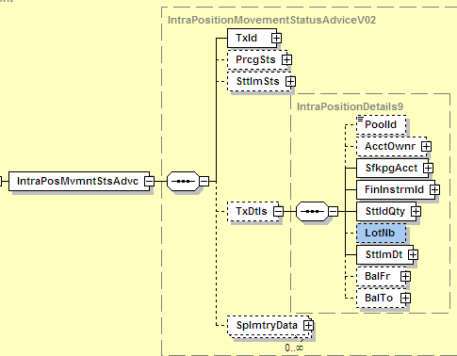

  - All the definitions containing “Target 2 for Securities” should be changed to “ Target 2-Securities”
In a few messages (analysis will have to be done for the exhaustive list), some message elements’ definition include T2S as an example. At the moment it is inappropriately named “Target 2 for Securities”. The correct name should be "Target 2-Securities”.

  - Addition of frequency codes in the semt.002.001.04 SecuritiesBalanceCustodyReport
During the reverse engineering of ISO 15022 messages, semt.002.001.03 was built based on the MT 535 but also semt.002.001.02 created by Investment Funds. During that exercise the following frequency code highlighted in red below which were present in v2 where, by mistake not kept in v3. These codes must now be added again.

EventFrequency1Code | Frequency expressed as a code.
YEAR | Event takes place every year or once a year.
SEMI | Event takes place every six months or two times a year.
QUTR | Event takes place every three months or four times a year.
TOMN | Event takes place every two months.
MNTH | Event takes place every month or once a month.
TWMN | Event takes place two times a month.
TOWK | Event takes place every two weeks.
WEEK | Event takes place once a week.
DAIL | Event takes place every day.
ADHO | Event takes place as necessary.
INDA | Event takes place several times a day.
OVNG | Event takes place overnight.
ONDE | Event takes place on demand.

  - Replacement of the country of residence message element for the Investor in the OtherBusinessParties Message component

CountryOfResidence is used today to identify the nationality of the investor. Nationality and country of residence are two different concepts. The business requirement being to identify the Nationality, the element name will need to be corrected.
Messages impacted
SecuritiesSettlementTransactionInstruction (sese.023.001.02)
SecuritiesSettlementTransactionCOnfirmation (sese.025.001.02)
SecuritiesSettlementTransactionReversalAdvice (sese.026.001.02)

Current situation
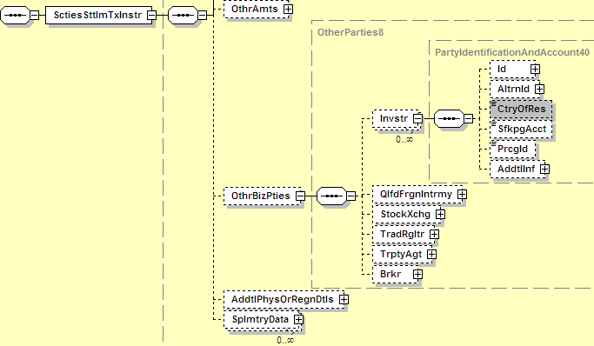

- Purpose of the change:

These are not change requests but corrections of errors that were highlighted during various workshops.
- Urgency of the request:
Next maintenance cycle
- Business examples:
Not applicable
- SEG recommendation:

Consider |  | Y | Timing
 |  |  | - Next yearly cycle: 2011/2012  (the change will be considered for implementation in the yearly maintenance cycle which starts in 2011 and completes with the publication of new message versions in the spring of 2012) |  | Y | Priority:  high  medium  low
- At the occasion of the next maintenance of the messages
(the change will be considered for implementation, but does not justify maintenance of the messages in its own right – will be pending until more critical change requests are received for the messages)
- Urgent unscheduled
(the change justifies an urgent implementation outside of the normal yearly cycle)
 |  |  | - Other timing:
Comments:

Reject
Reason for rejection:

