Change Request
for the update of ISO 20022 financial repository items
- Origin of the request:
A.1 Submitter: SWIFT
A.2 Contact person: Jacques Littré (Jacques.littre@swift.com) / Anne-Catherine Corbu (Anne-Catherine.CORBU@swift.com )

- Related messages:
seev.031.001.02 CorporateActionNotificationV02
seev.032.001.02 CorporateActionEventProcessingStatusAdviceV02
seev.033.001.02 CorporateActionInstructionV02
seev.034.001.02 CorporateActionInstructionStatusAdviceV02
seev.035.001.02 CorporateActionMovementPreliminaryAdviceV02
seev.036.001.02 CorporateActionMovementConfirmationV02
seev.037.001.02 CorporateActionMovementReversalAdviceV02
seev.038.001.02 CorporateActionNarrativeV02
seev.039.001.02 CorporateActionCancellationAdviceV02
seev.040.001.02 CorporateActionInstructionCancellationRequestV02
seev.041.001.02 CorporateActionInstructionCancellationRequestStatusAdviceV02
seev.042.001.02 CorporateActionInstructionStatementReportV02
seev.044.001.02 CorporateActionMovementPreliminaryAdviceCancellationAdviceV02

- Description of the change request:
This CR includes 10 corrections to be made to Corporate Actions messages.
C1. Missing “Intermediate securities Distribution Type” element in CorporateActionMovementConfirmationV02
The confirmation message do no longer include the details of the corporate action event as per the agreed design and hence the “Intermediate Securities Distribution type” element is no longer present whilst it is actually necessary for a rights distribution in order to specify for which type of event this distribution occur.
This requirement for having this element present is actually expressed as a network validated rule (MT 566 Rule C6) in ISO 15022.
Therefore to ensure full coexistence with ISO 15022 , this element must be added into the confirmation message and a new rule created to replicate the NVR C6.
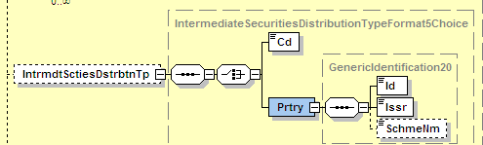
Figure 1 IntermediarySecurityDistributionType in the Notification message

C2. Receiving and DeliveringSettlementParties “Depository” and “Party1” elements to be changed to “Optional” in Securities Movement Details of the CorporateActionMovementConfirmationV02.
This is required in order to be aligned with ISO 15022 in which there is only a single list of delivering parties for both the receiving and delivering sides with only a single Place Of Settlement (Depository) element.
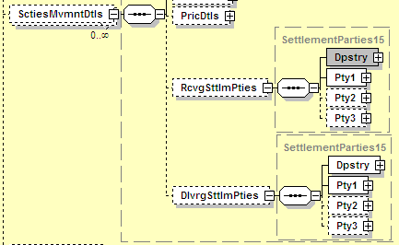
Figure 2 Settlement Parties in the Confirmation message

C3. Add EarlySolicitationFeeRate in the CashMovementDetails/RateAndAmountDetails of the CorporateActionMovementConfirmationV02
This EarlySolicitationFeeRate element was added in SR2011 in the CorporateActionNotificationV02 to accompany the SollicitationFeeRate element. SolicitationFeeRate is also present in the CorporateActionMovementConfirmationV02 confirmation but not the EarlySolicitationFeeRate.
This is probably an omission since there is no reason both element be not in the confirmation message too.
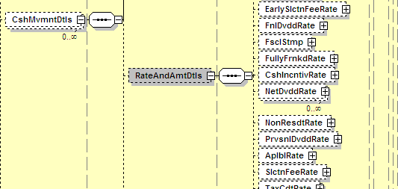
Figure 3: EarlySolicitaionFeeRate and SolicitationFeeRate in the Notification message

C4. Alignement of AdditionalBusinessProcessIndicator between CorporateActionMovementConfirmationV02 and Reversal versus the MT566 in ISO 15022
The ISO 15022 MT566 still contains a full list of Additional business process Indicator (in sequence C :22F::ADDB) whilst the ISO 20022 Confirmation and Reversal messages do only contain 2 of those Additional Business Processe Indicator (ClaimOrCompensation and TaxRefund).
So this is causing issues for coexistence/translation and it is very likely that both additional business processes lists should be aligned either by removing those in surplus in the MT566 or by adding those missing in the Confirmation message.
Additional Business Processes code in MT566 in SR2011:

CODES
If Qualifier is ADDB and Data Source Scheme is not present, Indicator must contain one of the following codes (Error code(s): K22):
ACLA | Automatic Market Claims | Will automatically give rise to market claims by the account servicer (typically, a CSD).
ATXF | Subject to Transformation | As a result of the Corporate Action, all transactions in the underlying security will be cancelled by the system and replaced with transactions in the outturn resource(s).
CLAI | Claim or Compensation | Relates to a claim on the associated corporate action event.
CNTR | Cancel Underlying Trades | As a result of the Corporate Action, all transactions in the underlying security will be cancelled by the system.
CONS | Consent | Relates to a consent within a corporate action event other than a Consent event (:22F::CAEV//CONS).
NAMC | No Automatic Market Claims and Transformations | The event will not automatically give rise to market claims and transformations by the account servicer (typically, a CSD).
NPLE | No Split Election | The issuer only allows a single option to be selected per designated holding.
SCHM | Scheme/Plan of Arrangement | Component event of a scheme/plan of arrangement: a reorganisation of a company or a group of companies, and their capital.
TAXR | Tax Refund | Relates to a tax refund from the authorities on the associated corporate action event.
Additional Business Processes code in Confirmation and Reversal messages in ISO20022 in SR2011:
Code Name Definition
CLAI ClaimOrCompensation - Relates to a claim on the associated corporate action event.
TAXR TaxRefund - Relates to a tax refund from the authorities on the associated

C5. Update in ISO 20022 the ISO 15022 synonym of Accrued Interest Indicator in the Notification message
The Synonym of the AccruedInterestIndicator in ISO20022 is indicated as “17B::ACCRU” while it should actually be “:17B::ACIN”.
C6. Add a “Proprietary” element to the ProcessingStatus element of the Notification message
The ISO 15022 standards allows for a Data Source Scheme (DSS) into the :25D::PROC fields of the MT564 sequence A. This has been omitted in the Notification message in ISO 20022. Therefore for coexistence purpose, a propietary element (DSS equivalent) must be added into the ProcessingStatus element.

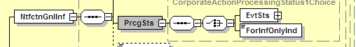
Figure 4: Current Processing Status element in The Notification message
C7. Rename all SecurityIdentification elements as “FinancialInstrumentIdentification”
In all CA messages, rename the element “SecurityIdentification” as FinancialInstrumentIdentification” so as to align with all other S&R ISO 20022 securities messages.
C8.Update incorrect definitions of some of the balances
The following balances in the CA messages have an incorrect definition which is different from the one in ISO 15022. Those definitions need to be updated with the correct ISO 15022 corresponding definitions when they appear in any of the CA messages (Notification, preliminary advice, confirmation, etc..):
BorrowedBalance, CollateralInBalance, CollateralOutBalance, OnLoanBalance, PendingDeliveryBalance, PendingReceiptBalance, OutForRegistrationBalance, SettlementPositionBalance, StreetPositionBalance, InTransshipmentBalance, RegisteredBalance.

C9.Alignement of code list in GenericCashPriceReceivedPerProduct/NotSpecifiedPrice between CorporateActionNotificationV02 the MT564 in ISO 15022
The ISO 15022 MT564 contains a list of codes (in sequence E2 :90E::OFFR) whilst the ISO 20022 Notification message does only contain 1 of those codes (UKWN).
So this is causing issues for coexistence/translation and it is very likely that both code lists should be aligned either by removing those in surplus in the MT564 or by adding those missing in the Notification message.
List of codes in MT564 in SR2011:

CODES
In option E, if Qualifier is OFFR, Price Code must contain one of the following codes (Error code(s): K90):
NILP | Nil Payment | Price will not be paid.
TBSP | To be Specified | Price to be specified by account owner.
UKWN | Unknown Price | Price is unknown by the sender or has not been established.
UNSP | Unspecified | Price is not required to be specified by account owner.
List of code in Notification message in ISO20022 in SR2011:
Code Name Definition
UKWN Unknown - Price is unknown by the sender or has not been established..

C10.Change the data type of FinalDividendRate and ProvisionalDividendRate in the CorporateActionMovementConfirmation in the CorporateActionMovementConfirmationV02
Currently, in the CAConfirmationDetails\CashMovementDetails\RateAndAmountDetails, the data type for both FinalDividendRate and ProvisionalDividendRate is : ActiveCurrencyAnd13DecimalAmount.
Change it to RestrictedFINActiveCurrencyAnd13DecimalAmount.

- Purpose of the change:
Correct misalignment between ISO 15022 and ISO 20022 CA messages and correct some development mistakes impacting directly ISO 15022 / ISO 20022 coexistence.
- Urgency of the request:
Medium – most of the changes are supporting coexistence. Next maintenance cycle.
- Business examples:
N/A
- SEG recommendation:

Consider |  | Y | Timing
 |  |  | - Next yearly cycle: 2011/2012  (the change will be considered for implementation in the yearly maintenance cycle which starts in 2011 and completes with the publication of new message versions in the spring of 2012) |  | Y | Priority:  high  medium  low
- At the occasion of the next maintenance of the messages
(the change will be considered for implementation, but does not justify maintenance of the messages in its own right – will be pending until more critical change requests are received for the messages)
- Urgent unscheduled
(the change justifies an urgent implementation outside of the normal yearly cycle)
 |  |  | - Other timing:
Comments:

Reject
Reason for rejection:

