Change Request
for the update of ISO 20022 financial repository items

- Origin of the request:
A.1 Submitter:
SWIFT SCRL
Avenue Adèle, 1 - 1310 La Hulpe – Belgium
Standards Department
A.2 Contact person:
Mr. David Dobbing SWIFT Standards Department
david.dobbing@swift.com
+32 2 655 4483
A.3 Sponsors:
CGI (Common Global Implementation)
www.swiftcommunity.net/communities/CGI
Mr. Harri.Rantanen Harri.Rantanen@seb.fi
Mr. Serge Rogat serge.rogat@bnpparibasfortis.com

- Related messages:
The component ChargeType1Code is used in the following messages:
camt.052.001.02 | BankToCustomerAccountReportV02
camt.053.001.02 | BankToCustomerStatementV02
camt.054.001.02 | BankToCustomerDebitCreditNotificationV02

- Description of the change request:
Change request is in two related parts that should be reviewed together, but could be subject to independent approval or rejection.
1) Request the addition of two new code values to the below list of Charge Type codes:
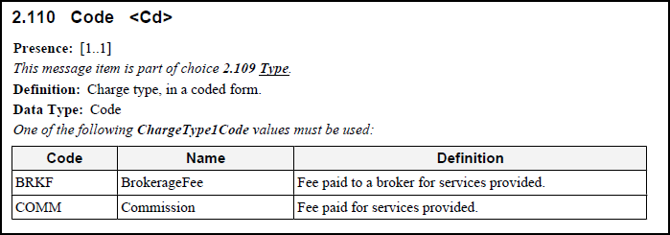
Add:
Code | Name | Definition
SUMM | Summation | Summation of individual fees.
BTCH | Batch | Fee paid for processing a batch of transactions.

2) Request that this code list be transformed from an ISO 20022 internal schema defined code list to an ISO 20022 external code list.

- Purpose of the change:
Required as an enhancement to the existing Account Reporting messages to cater for the implementation of functionality identified by the CGI community of users (44 members, of which 26 members are Financial Institutions). Change will assist in ensuring consistent market practice at a global level for reporting of charges.

- Urgency of the request:
For June 01 2011 submission and approval cycle.

- Business examples:
N/A.

- SEG recommendation:

Consider |  | V | Timing
 |  |  | - Next yearly cycle: 2011/2012  (the change will be considered for implementation in the yearly maintenance cycle which starts in 2011 and completes with the publication of new message versions in the spring of 2012) |  | V | Priority:  high  medium  low
- At the occasion of the next maintenance of the messages
(the change will be considered for implementation, but does not justify maintenance of the messages in its own right – will be pending until more critical change requests are received for the messages)
- Urgent unscheduled
(the change justifies an urgent implementation outside of the normal yearly cycle)
 |  |  | - Other timing:
Comments:

Reject
Reason for rejection:

