Change Request
for the update of ISO 20022 financial repository items

- Origin of the request:
A.1 Submitter: Deutsche Bundesbank.
A.2 Contact person:
Christoph Heid, Email: christoph.heid@bundesbank.de, Tel: +49 69 9566 2764
A.3 Sponsors:
Deutsche Bundesbank on behalf of 4CB for TARGET2-Securities (T2S)

- Related messages:
IntraPositionMovementInstruction (semt.013.001.01)
SecuritiesSettlementTransactionInstruction (sese.023.001.01)
SecuritiesSettlementConditionsModificationRequest (sese.030.001.01)
SecuritiesSettlementConditionModificationStatusAdvice (sese.031.001.01)
SecuritiesSettlementTransactionGenerationNotification (sese.032.001.01)
SecuritiesFinancingInstruction (sese.033.001.01)

- Description of the change request:
Responsible Parent BIC required to properly identify the RefOwner within the linkage block and should be added across all messages containing linkages blocks within S&R for harmonization purposes.

- Purpose of the change:
Business Context:
Based on the SR2011 CRII.19 in which it was requested the addition of Party associated with reference in linkage block, a new element RefOwner was added.
In the context of Linked Instructions, a party may link its instruction to the instruction of another party using the original instructing party reference. To do so, the party specifies the original instructing party reference and the Party identifier (BIC) as a RefOwner within the linkage block of an instruction.
These references can be provided by different parties belonging to different CSDs in T2S. Therefore the RefOwner is not sufficient to identify uniquely the party owning the instruction reference that is required to be linked to.
General T2S business context background and community of interested users:
The cross-border and domestic settlement of securities against central bank money requires harmonised and standardised messages as a part of an effective and efficient communication. The current European post-trade sector is fragmented into multiple national markets. This lack of integration implicates a significant cost burden and inefficiency of cross-border wholesale transactions, and a very significant inhibition of retail transactions. To address this issue at European level, the consolidated, harmonised and non-profit platform TARGET2-Securities (T2S), which will provide settlement services to the Central Securities Depositories (CSDs) and their participants, will be delivered by the Eurosystem to the market by 2014.
The scope of this request covers the maintenance process of ISO registered messages which shall be used by T2S. These messages shall be used for the communication of the system with its users, namely Central Securities Depositories (CSD) and CSD participants as well as other platforms such as collateral management platforms and RTGS systems.
Specific benefits of this change request:
Enable Market Infrastructures to identify uniquely references provided by participants within a linkage block. The adding of the Parent Party Identifier will allow for the identification of the correct instruction as the Owner Reference is unique per Participant but can be common to several Participants. Therefore, it will help to avoid any inconsistency.

- Urgency of the request:
Next maintenance cycle

- Business examples:
Example:

Party1-CSD1 sends an instruction (SI1) with ref “ABC”, T2S duplicate check associates the ref ‘ABC’ to the instructing party Party1-CSD1 identified by a couple of BICs.

Party1-CSD2 sends an instruction (SI2) with ref “ABC”, T2S duplicate check associates the ref ‘ABC’ to the instructing party Party1-CSD2 identified by a couple of BICs.

Party2-CSD1 wants to link its instruction (SI3 / ref “DEF”) with the instruction of Party1-CSD2. (Party2-CSD1 has the privilege to do so)

The references (‘ABC’) and the RefOwners (Party1) are the same; the only distinction is the CSD to which they belong, it is therefore necessary to have an additional field to populate the BIC of the CSD of the instructing party of the linked instruction, i.e. in this case CSD2.
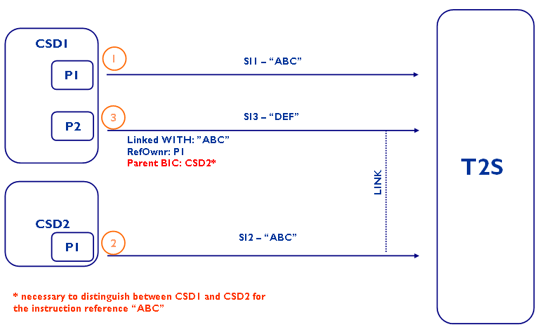

- SEG recommendation:

Consider |  |  | Timing
 |  |  | - Next yearly cycle: 2011/2012  (the change will be considered for implementation in the yearly maintenance cycle which starts in 2011 and completes with the publication of new message versions in the spring of 2012) |  |  | Priority:  high  medium  low
- At the occasion of the next maintenance of the messages
(the change will be considered for implementation, but does not justify maintenance of the messages in its own right – will be pending until more critical change requests are received for the messages)
- Urgent unscheduled
(the change justifies an urgent implementation outside of the normal yearly cycle)
 |  |  | - Other timing:
Comments:

Reject | Y
Reason for rejection:
See MCR n° 60.

