Change Request
for the update of ISO 20022 financial repository items
All change requests conforming to this template received by June 1st will be considered for development in the following yearly ISO 20022 maintenance cycle which completes with publication of new message versions in April/May of the following year.
- Origin of the request:
A.1 Submitter:

SWIFT SCRL
Avenue Adèle, 1 - 1310 La Hulpe – Belgium
Standards Department
A.2 Contact person:

Mr. David Dobbing SWIFT Standards Department
david.dobbing@swift.com
+32 2 655 4483
A.3 Sponsors:
CGI (Common Global Implementation)
www.swiftcommunity.net/communities/CGI
Ms Susan Colles susan.k.colles@baml.com
Ms Mieko Morioka mieko.morioka@swift.com
- Related messages:
This change request relates to the following payments message definitions that are using the component CashAccountType4Code

acmt.007.001.01 | AccountOpeningRequestV01
acmt.008.001.01 | AccountOpeningAmendmentRequestV01
acmt.009.001.01 | AccountOpeningAdditionalInformationRequestV01
acmt.014.001.01 | AccountReportV01
acmt.015.001.01 | AccountExcludedMandateMaintenanceRequestV01
acmt.016.001.01 | AccountExcludedMandateMaintenanceAmendmentRequestV01
camt.007.002.03 | RequestToModifyPaymentV03
camt.027.001.03 | ClaimNonReceiptV03
camt.028.001.03 | AdditionalPaymentInformationV03
camt.029.001.03 | ResolutionOfInvestigationV03
camt.052.001.02 | BankToCustomerAccountReportV02
camt.053.001.02 | BankToCustomerStatementV02
camt.054.001.02 | BankToCustomerDebitCreditNotificationV02
camt.055.001.01 | CustomerPaymentCancellationRequestV01
camt.056.001.01 | FIToFIPaymentCancellationRequestV01
camt.057.001.02 | NotificationToReceiveV02
camt.058.001.02 | NotificationToReceiveCancellationAdviceV02
camt.059.001.02 | NotificationToReceiveStatusReportV02
camt.060.001.02 | AccountReportingRequestV02
pacs.002.001.03 | FIToFIPaymentStatusReportV03
pacs.003.001.02 | FIToFICustomerDirectDebitV02
pacs.004.001.02 | PaymentReturnV02
pacs.007.001.02 | FIToFIPaymentReversalV02
pacs.008.001.02 | FIToFICustomerCreditTransferV02
pacs.009.001.02 | FinancialInstitutionCreditTransferV02
pain.001.001.03 | CustomerCreditTransferInitiationV03
pain.002.001.03 | CustomerPaymentStatusReportV03
pain.007.001.02 | CustomerPaymentReversalV02
pain.008.001.02 | CustomerDirectDebitInitiationV02
pain.009.001.01 | MandateInitiationRequestV01
pain.010.001.01 | MandateAmendmentRequestV01
pain.011.001.01 | MandateCancellationRequestV01
pain.012.001.01 | MandateAcceptanceReportV01
pain.013.001.01 | CreditorPaymentActivationRequestV01
pain.014.001.01 | CreditorPaymentActivationRequestStatusReportV01
We noticed that the component CashAccountType4Code is also used in the trade services messages definitions below. Although the change request doesn't relate to these messages, we leave it to the SEG(s) to decide if it makes sense to also adapt these message definitions for consistency purposes.

tsin.001.001.01 | InvoiceFinancingRequestV01
tsin.002.001.01 | InvoiceFinancingRequestStatusV01
tsin.003.001.01 | InvoiceFinancingCancellationRequestV01
tsin.004.001.01 | FinancialInvoiceV01
tsmt.009.001.03 | BaselineAmendmentRequestV03
tsmt.012.001.03 | BaselineReSubmissionV03
tsmt.014.001.03 | DataSetSubmissionV03
tsmt.017.001.03 | ForwardDataSetSubmissionReportV03
tsmt.018.001.03 | FullPushThroughReportV03
tsmt.019.001.03 | InitialBaselineSubmissionV03
tsmt.044.001.01 | IntentToPayNotificationV01
tsmt.045.001.01 | ForwardIntentToPayNotificationV01

- Description of the change request:
Change request is in two related parts that should be reviewed together, but could be subject to independent approval or rejection.
1) Request the addition of two new code values to the below list of Cash Account Type codes:
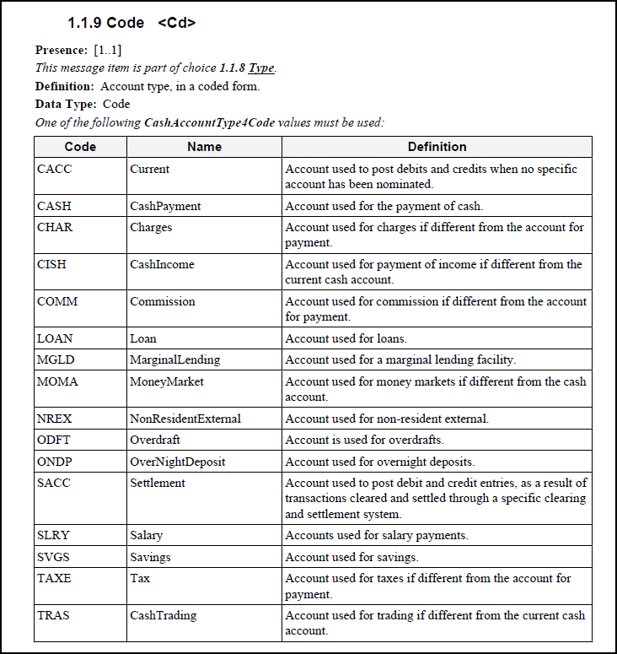

Add:
Code | Name | Definition
LLSV | Limited Liquidity Savings Account | Account used for savings with special interest and withdrawal terms.
OTHR | Other account | Account not otherwise specified.

2) Request that this code list be transformed from an ISO 20022 internal schema defined code list to an ISO 20022 external code list.

- Purpose of the change:
In the Japanese retail payment system messages (Zengin messages), in both C2B and B2B messages, type of creditor’s account is mandatory information. To fully utilize the ISO code rather than proprietary code, 2 new codes are necessary in ISO 20022 messages.

1) Requested Code: LLSV (Limited Liquidity Savings Account)

Limited Liquidity Savings Account (Chochiku-Yokin, Zengin account code 04)
A deposit account with higher interest rate than the savings account (Futsu-Yokin) and has more flexibility (in principle, this account can be freely withdrawn and credit) than the term deposit account (Teiki-Yokin). There are two types of special savings account: (1) special savings account with interest rate differentiated by deposit amount, and (2) special savings account with higher interest rate upon maintaining required minimum amount. Currently, the majority of special savings accounts are type (1). A special savings account is only allowed for individuals. It can be used to receive funds via credit transfers, however, cannot be used for direct debit, and certain types of payments such as salary, pension, dividend, etc.
Each bank offers different conditions for the details of interest rate calculation and the terms of withdrawal: Reduction of interest rate when the amount of deposit was below floor amount, deduct additional charges in case number of withdrawal exceeds the agreed frequency, etc.

http://www.mizuhobank.co.jp/saving/chochiku/index.html
http://www.bk.mufg.jp/tameru/yen/samazama/chochiku/btm/index.html
http://www.smbc.co.jp/kojin/yokin/chochiku/index.html

2) Requested code: OTHR (Other Account)

Other account (Sono-ta, Zengin account code 09)
In the Zengin message, there are 4 account type codes defined, and one of these codes must be present as creditor account information.
01: Ordinary Account (mapped to CACC)
02: Savings Account (mapped to SVGS)
04: Limited Liquidity Savings Account (to be mapped to a new code, LLSV)
09: Other Account (to be mapped to a new code, OTHR)

The Cash Account Type code set is considered a core ISO 20022 code set. The transformation to an ISO 20022 external code list will better facilitate maintenance that may occur in the future. In defining specific financial accounts it is likely that new cash account types can be expected and for interoperability reasons, these should be defined as part of an ISO 20022 code list rather than as proprietary codes.

- Urgency of the request:
For June 01 2011 submission and approval cycle.

- Business examples:
See D (Purpose of Change).

- SEG recommendation:

Consider |  | V | Timing
 |  |  | - Next yearly cycle: 2011/2012  (the change will be considered for implementation in the yearly maintenance cycle which starts in 2011 and completes with the publication of new message versions in the spring of 2012) |  | for Payments messages
 |  |  | - At the occasion of the next maintenance of the messages  (the change will be considered for implementation, but does not justify maintenance of the messages in its own right – will be pending until more critical change requests are received for the messages) |  | for Trade Services messages
- Urgent unscheduled
(the change justifies an urgent implementation outside of the normal yearly cycle)
 |  |  | - Other timing:
Comments:
- The Payments SEG prefers using an external code list
- The Trade Services SEG agrees to implement the external code list to be defined by the Payments SEG at the occasion of the next maintenance of the related tsin and tsmt messages. However, the Trade SEG requests clarification on the use of “othr” as a new external code. ISO 20022 has strived for the use of specific code lists and this request seems to break with that historical philosophy.

Reject
Reason for rejection:

