Change Request
for the update of ISO 20022 financial repository items
- Origin of the request:
A.1 Submitter: LCH.Clearnet SA
A.2 Contact person:

Franck Giraud | Franck.giraud@lchclearnet.com | +33 (0) 1 70 37 67 01

A.3 Sponsors: CCP Clearing Working group

- Related messages:
  - camt.052.001.02
  - camt.053.001.02
- Description of the change request:
Addition of a Debit / Credit indicator in Ntry/NtryDtls/TxDtls/AmtDtls bloc as follows:
<NtryDtls>
<TxDtls>
<Refs>
<TxId>xxxxxx</TxId>
</Refs>
<AmtDtls>
<TxAmt>
<Amt>CCY and Amount</Amt>
</TxAmt>
<CdtDbtInd>Debit or Credit</CdtDbtInd>
</AmtDtls>
</TxDtls>
</NtryDtls>
.
- Purpose of the change:
Within Giovannini Barrier one removal, a standardisation working group led by SWIFT for financial instruments clearing has been set up.
This working group gathers representatives from CCPs (Central Counterparty) and clearing members in Europe and aims to build a complete ISO 20022 clearing messaging solution (trade reporting, position reporting, margin reporting, settlement obligations reporting, buy-in reporting and cash obligations reporting).
Regarding cash obligations reporting, it has been agreed, following SWIFT proposal, to use existing cash management messages (camt.052 and camt 053) which cover CCP needs in term of cash reporting to clearing members.
The implementation of camt.52/ camt 053 messages will provide a high added value allowing CCP members’ back-offices to automatically reconcile cash movements with clearing business reporting (margin reports, fees reports, regularisations, premiums etc.). Moreover, the change will allow making this message as a standard regarding cash reporting in the Financial Instruments clearing area.
The diagram hereafter gives an overview of the CCP business reporting and the use of the camt.052 / camt053.

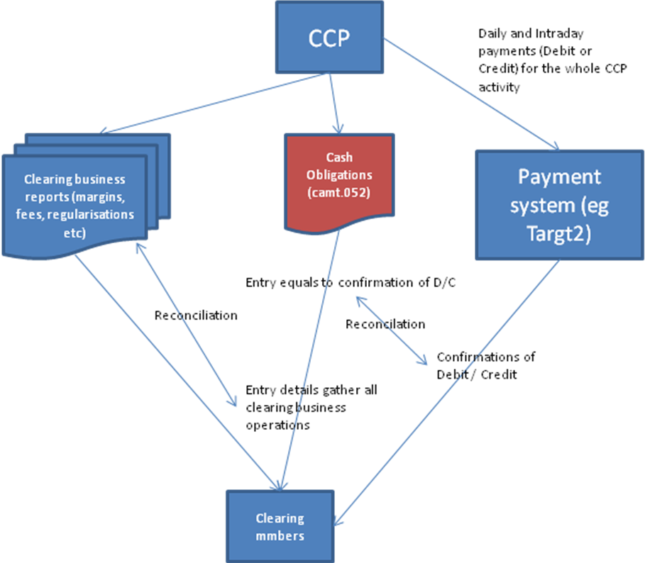

As shown in the diagram above, the Cash obligations report allows the clearing member to reconcile the confirmation of Debit or Credit which occurred on its cash account in the payment system (e.g. Target 2) and all operations related to the clearing activity (margins, fees etc.).
- New Entry level will give the amount debited or credited on the cash account
- New Entry Details will give all elementary clearing elements (Initial margin, variation margin, premium, clearing fees, settlement fees etc.)
Because many of these elementary clearing elements can be either debtor or creditor, it is important to have Debit / Credit indicator in order to facilitate the processing of the report.

Expected traffic is 10000 messages per year (LCH.Clearnet traffic).
- Urgency of the request:
Next ISO 20022 maintenance cycle
- Business examples:
None
- SEG recommendation:

Consider |  | V | Timing
 |  |  | - Next yearly cycle: 2011/2012  (the change will be considered for implementation in the yearly maintenance cycle which starts in 2011 and completes with the publication of new message versions in the spring of 2012) |  | V | Priority:  high  medium  low
- At the occasion of the next maintenance of the messages
(the change will be considered for implementation, but does not justify maintenance of the messages in its own right – will be pending until more critical change requests are received for the messages)
- Urgent unscheduled
(the change justifies an urgent implementation outside of the normal yearly cycle)
 |  |  | - Other timing:
Comments:

Reject
Reason for rejection:

