Change Request
for the update of ISO 20022 financial repository items
All change requests conforming to this template received by June 1st will be considered for development in the following yearly ISO 20022 maintenance cycle which completes with publication of new message versions in April/May of the following year.
- Origin of the request:
A.1 Submitter: Bank of America Merrill Lynch
A.2 Contact person: Susan K Colles, susan.k.colles@baml.com, 214-209-3892
Related messages:
AddtlPmtInf | camt.028
BkToCstmrAcctRpt | camt.052
BkToCstmrDbtCdtNtfctn | camt.054
BkToCstmrStmt | camt.053
CdtrPmtActvtnReq | pain.013
CdtrPmtActvtnReqStsRpt | pain.014
CstmrCdtTrfInitn | pain.001
CstmrDrctDbtInitn | pain.008
CstmrPmtCxlReq | camt.055
CstmrPmtRvsl | pain.007
CstmrPmtStsRpt | pain.002
FinInstnCdtTrf | pacs.009
FIToFICstmrCdtTrf | pacs.008
FIToFICstmrDrctDbt | pacs.003
FIToFIPmtCxlReq | camt.056
FIToFIPmtRvsl | pacs,007
FIToFIPmtStsRpt | pacs.002
NtfctnToRcv | camt.057
NtfctnToRcvCxlAdvc | camt.058
NtfctnToRcvStsRpt | camt.059
PmtRtr | pacs,004
ReqToModfyPmt | camt.007
RsltnOfInvstgtn | camt.029
- Description of the change request:
- Request the inclusion of unlimited occurrences within RemittanceInformation/Structured/ReferredDocumentAmount (RemittanceAmount1) of the following amounts along with the addition of a tag to allow for identification of the type (<Tp>) of tax or discount:
TaxAmt
DscntApldAmt
- Request the addition of a tag within ChequeInstruction (Cheque6) to allow for five (5) occurrence of a dynamic signature identification tag (Max70Text) that would be used on a printed cheque.

- Purpose of the change:
- Multiple discounts and taxes can be applicable to an invoice, credit memo or other document that is included as remittance information. The current structure only allows for one occurrence of each of these amounts. Discounts could encompass a standing discount, an additional promotional discount, and a terms discount – all could be reported by the paying organization. Tax amounts could include local, city, county, and state/province which would need to have unique identification as to the amount that is paid. The retail, grocery, service (cable, telephone) industries currently has a need for this remittance detail. This will allow for the appropriate allocation of taxes and discounts within the beneficiaries business application.
- Maximum 5 signatures on a cheque are common practice based on company financial and legal requirements. Signatures can either be stored within the cheque printing process or dynamically supplied with the cheque instruction. This allows for the submitting organization to instruct the cheque servicer which signatures are to be used on a specific cheque to be printed.
- Urgency of the request:
2011 yearly maintenance cycle
- Business examples:
- Multiple occurrences of DscntApldAmt and TaxAmt
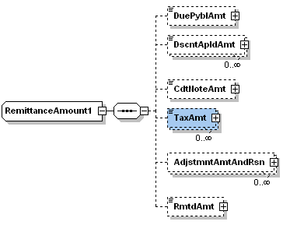

2. New tag – Signature Id (SgntrId), Max70Text, max 5 occurrences

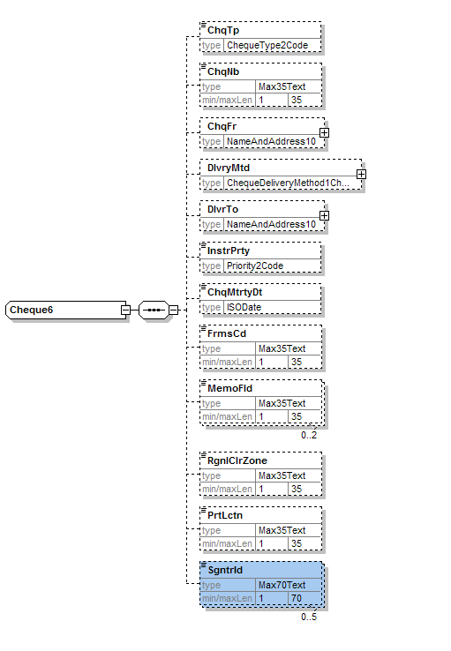
F. SEG recommendation:

Consider |  | V | Timing
 |  |  | - Next yearly cycle: 2011/2012  (the change will be considered for implementation in the yearly maintenance cycle which starts in 2011 and completes with the publication of new message versions in the spring of 2012) |  | V | Priority:  high  medium  low
- At the occasion of the next maintenance of the messages
(the change will be considered for implementation, but does not justify maintenance of the messages in its own right – will be pending until more critical change requests are received for the messages)
- Urgent unscheduled
(the change justifies an urgent implementation outside of the normal yearly cycle)
 |  |  | - Other timing:
Comments:

Reject
Reason for rejection:

