Change Request
for the update of ISO 20022 financial repository items
Note: CR0050 was initially introduced by ANBIMA in June 2010 and already discussed by the ISO 15022 MWG at their 25-26 August 2010 meeting. Recommendations of the MWG are included in the MCR n°54. In June 2011, ANBIMA updated the initial CR to remove some of their initial requests and add detailed examples in appendix.
- Origin of the request:
A.1 Submitter:
ANBIMA – Brazilian Financial and Capital Markets Association
Avenida das Nações Unidas, 8501 - 21º andar
São Paulo, SP - Brazil

A.2 Contact person:
Liliane Dutra/Sergio Mello
e-mail: liliane.dutra@anbima.com.br; sergio.mello@anbima.com.br
tel: 55 11 3471 4297

A.3 Sponsors:

ANBIMA is the Brazilian Financial and Capital Markets Association and it represents 325 associated institutions like commercial, multiple and investment banks, asset managers, brokers, securities and exchange distributors and investment consultants.

- Related messages:
SecuritiesFinancingInstruction - sese.033.001.01
SecuritiesFinancingModificationInstruction - sese.036.001.01
SecuritiesFinancingConfirmation – sese.035.001.01

- Description of the change request:
- Message SecuritiesFinancingInstruction
- Existing Message building block “QuantityAndAccountDetails”
- Proposal is to make message element SafekeepingAccount optional:
As the message will be sent by the Manager to request a securities lending contract to the Broker, he may not have this information at that moment. The Manager can send the allocation to the Broker later in the process. This is the reason this element should be optional.
Brazilian Standard Committee agreed to keep this information mandatory.

- Existing Message building block “SecuritiesFinancingDetails”:
- Proposal is to add the element “Reversible/CallBackCode as optional:
When the Borrower or the Lender ask the Broker for a Securities Lending, they must indicate if the contract will be Reversible, i.e. if the counterpart can ask for call back before the termination date. The contract can be reversible only for the Lender, only for the Borrower, or to none of them. For this reason, it cannot be a “YesOrNoIndicator”, it should be a choice between the following values:
- Reversible (the contract can be called back only by the Borrower)
- Reversible to the Lender (the contract can be called back only by the Lender)
- Fixed (the contract cannot be called back by any party).
Brazilian Standard Committee agreed to keep this information as YesOrNoIndicator.
- Proposal is to add the element “MinimumDateForCallBack” as optional:
When the Securities Lending contract is reversible, “MinimumDateForCallBack” is the date from which the contract can be called back. This date is determined by the Lender.
Sometimes the contract is reversible and it doesn’t have a Minimum Date for Call Back, in this case, it can be called back any day from the first day. For this reason, the element “MinimumDateForCallBack” should be optional.
For example, if a securities lending contract is traded on 1st July, it is reversible, and there is no Minimum Date for Call Back, it can be called back from 2nd July.
- Proposal is to add the element “RollOverIndicator: Yes/No” as optional:
“RollOverIndicator” is used to indicate whether the contract is renewable or not. This condition is determined by the Lender. As a “YesOrNoIndicator”, the possible values would be:
Yes: indicates that the Borrower can renew the securities lending contract in its termination date
No: indicates that the Borrower cannot renew the securities lending contract in its termination date
Brazilian Standard Committee agreed not to use this information in this message anymore
- Proposal is to add the element “PeriodicPayment” as optional:
“PeriodicPayment” indicates if the payment of the Securities Lending fee occurs periodically during the contract or only in the termination date. As this element would be a “YesOrNoIndicator’, the possible values would be:
Yes: indicates that the amount that the Borrower must pay to the Lender will be paid periodically during the contract.
No: indicates that the amount that the Borrower must pay to the Lender will be paid only in the end of the contract (in the termination date or in the call back date).
Brazilian Standard Committee agreed not to use this information in this message anymore
- Proposal is to add the element “MarginCredit: Yes/No” as optional
MarginCredit indicates if the contract requires margin credit by the Borrower and it is defined by the Lender in the beginning of the contract. The element that exists in the message is “StockLoanMargin”, which is used to inform the percentage of the total amount deposited by the Borrower. As this message is sent by the Manager to ask a new securities lending to the Broker, he doesn’t have this information before the deal is closed. As this message element would be a “YesOrNoIndicator”, the possible values would be:
Yes: indicates that the securities lending contract requires a margin deposit by the Borrower
No: indicates that the securities lending contract requires no margin deposit by the Borrower.
Brazilian Standard Committee agreed not to use this information in this message anymore
- Proposal is to add the element “CommissionCalculationDate" with a data type DateTime, "Date" only (i.e. no time information required), as optional
As the element “CommissionCalculationDate” indicates the date in which the price to calculate the commission is based. The commission can be calculated based on the average price of the share in the initial date or termination date. As this date is only a reference to know the price of the share, there’s no information about the time. For this reason, the type of this element should be only “Date”, instead of “Date” or “Date/Time”.
- Proposal is to add “SecuritiesLendingFees” with a data type “Percentage” as optional
“Securities Lending Fee” is the fee that the Borrower will pay to the Lender. In the beginning of the contract, only the fee (as a percentage) is known. The amount will be known only in the termination date or when any party requests call back, because the price for settlement must be known to calculate the amount that the Borrower must pay to Lender. As this message will be used when the Manager asks the Broker for a new lending, in this moment, the amount is unknown.

- Message SecuritiesFinancingModificationInstruction
- Existing Message building block “TradeDetails"
- Proposal is to add a Message Element “BrokerCommission” typed by an amount, as optional
BrokerCommission is what the Manager pays to the Broker for each securities lending transaction. Sometimes the Manager, as Lender or Borrower, doesn’t pay anything to the Broker. In case the Manager is the Lender, he will only receive the fee paid by the Borrower, with no discount. In case the Manager is the Borrower, he will only pay the fee to the Lender with no increment. For this reason, the element “BrokerCommission” should be optional.

- Proposal is to add Message Element “CommissionCalculationDate"with a data type Date/Time "Date" only (i.e. no time information required), as optional
As the element “CommissionCalculationDate” indicates the date in which the price to calculate the commission is based. The commission can be calculated based on the average price of the share in the initial date or termination date. As this date is only a reference to know the price of the share, there’s no information about the time. For this reason, the type of this element should be only “Date”, instead of “Date” or “Date/Time”.

- Existing Message building block “SecuritiesFinancingAdditionalDetails”:
Definition and justification for the changes below are similar as changes requested for the SecuritiesFinancingInstruction
- Proposal is to add the element “Reversible/CallBackCode” as optional
- Proposal is to add the element “Minimum Date for CallBack” as optional
- Proposal is to add the element “RollOverIndicator: Yes/No” as optional
Brazilian Standard Committee agreed not to use this information in this message anymore
- Proposal is to add the element “PeriodicPayment” as optional
Brazilian Standard Committee agreed not to use this information in this message anymore
- Proposal is to add “MarginCredit:Yes/No” as optional
Brazilian Standard Committee agreed not to use this information in this message anymore
- Proposal is to add “SecuritiesLendingFees” with a data type “Percentage” , as optional

- Purpose of the change:
Presently, in the Brazilian market, no standard message is used in the communication between Managers, Brokers, Controllers and Custodians regarding securities lending transactions. This communication is made mainly by telephone or e-mail.
The usage of ISO 20022 by the Brazilian players would result in a considerable gain in terms of more scalability and operational risk reduction.
The community of users will be:
- Fund Managers, whether in the role of Borrower or Lender, will use this message to:
  - Instruct Brokers about the characteristics of a desired securities lending contract. Nowadays, this communication is made through non-standardized forms, such as telephone or e-mail.
  - Send a request for settlement authorization to the Fund Controller. As one Fund Manager may have several funds and each one of them may have a different Controller, for each Fund, the Manager must send a securities lending message using a different lay-out.
  - Communicate the Fund Custodian of the characteristics of a new securities lending contract. As one Fund Manager may have several funds and each one of them can have a different Custodian, for each Fund, the Manager must send a securities lending message using a different lay-out.
- Brokers, who will receive securities lending instructions through a secure and standardized way.
- Fund Controllers, who will receive the request for settlement authorization sent by the Manager in a standardized form.
- Fund Custodians, who will receive the characteristics of the new securities lending contract and send its confirmation to Managers, Brokers and Controllers.
Nowadays, this communication is made through non-standardized forms, as each Custodian or Controller have their own proprietary system.

- Urgency of the request:

We request the SEG to consider this change request for the next maintenance cycle, 2010/2011, since we are planning to implement these messages for the Securities Lending service in March/April 2011.

- Business examples: See appendix

G. SEG recommendation:

Consider |  | Y | Timing
 |  |  | - Next yearly cycle: 2011/2012  (the change will be considered for implementation in the yearly maintenance cycle which starts in 2011 and completes with the publication of new message versions in the spring of 2012) |  | Y | Priority:  high  medium  low
- At the occasion of the next maintenance of the messages
(the change will be considered for implementation, but does not justify maintenance of the messages in its own right – will be pending until more critical change requests are received for the messages)
- Urgent unscheduled
(the change justifies an urgent implementation outside of the normal yearly cycle)
 |  |  | - Other timing:
Comments:

Reject
Reason for rejection:
Appendix: Business Examples

Participants
- Brokers and Dealers:
Ancillary legal entities of the National Financial System who act as intermediaries in the purchase and sale of financial assets for their clients. Their incorporation depends on authorization from the Central Bank and authorization from Brazil's Securities Commission (CVM) is required to do business. In the current legislation on financial asset lending, CVM Instruction 441 requires brokers and dealers to act as intermediaries for the transactions.
- Managers:
An individual or a legal entity may be in charge of managing the assets of the investment fund and in both cases registration and authorization from Brazil's Securities Commission (CVM) is required.
- Custodians:
Institutions responsible for physical and financial settlement of their clients' assets, their safekeeping and management, and for reporting proceeds associated with these assets.
- Asset Controllers:
Institutions responsible for receiving details relating to provisions for expenses, cash balance, number of units issued and redeemed, pricing of assets, determining net asset value and fund unit value, receiving information relating to splits or mergers, and producing accounting data.

Process
In securities lending transactions, in exchange for payment of a fee, the holder of the securities (Lender) authorizes their transfer to the other party (Borrower). For the duration of the agreement, the securities are held by the Borrower, but at the end of the period he must return them to the Lender. The role of Lender or Borrower is taken by the Manager, who conducts security lending transactions on behalf of the Fund.
When lending securities, the broker acts as Registration Agent and is responsible for registering offers in the system in which the transactions are executed.
For the Lender, offering securities to execute a securities lending agreement is characterized as a long-term strategy in which there is no intention of disposing of the securities in the short term. Renting these securities creates an opportunity for additional risk-free gains, equivalent to a fixed-income bond, since there is payment of a fee for the securities lending of the securities and a deposit of assets by the counterparty, in an amount equivalent to the agreement entered into, serving as guarantee in case of default.
For the Borrower, the securities lending service enables it to sell securities without possessing them, enabling managers of investment funds and managed portfolios to run strategies involving arbitrage across different assets or short selling.
In Brazilian Market, offers to lend securities are sent by the Lender to the Broker to be registered in CBLC's Securities Bank (BTC) and made available for securities lending. Similarly, the Borrower also applies for registration of a securities lending offer in the BTC through a broker.
Securities Lending by the Borrower may be:
1 - Voluntary: The institution registers the intention of lending financial securities with the brokers.

2 - Compulsory: There is a need for securities lendings of financial securities for institutions which have sold securities and do not have them available in custody to make delivery on settlement date. The securities lending transaction is made without any instruction from the Manager.

On entering into the securities lending agreement, the following items, among others, are agreed between Borrower and Lender: the asset, the quantity of the asset, the securities lending fee, the guarantee deposits required, and transfer of the securities from Lender to Borrower.
Securities lending transactions (transfer of custody) are registered by the Broker with Brazilian Clearing and Depositary Corporation (CBLC) through the service of the CBLC's financial securities bank (BTC).
The CBLC - BTC securities bank provides a service through which investors (lenders) offer to lend securities and other parties (borrowers) borrow them against guarantees. The Brazilian Clearing and Depository Corporation acts as counterparty in the process and guarantor for the transactions.
Details of transactions for borrower and lender are shown separately, since depending on the side on which the manager is acting, the business flows take place differently.

Flows:

- Instruction Borrower Manager to Broker

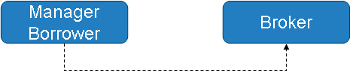

Necessary Information:
Stock (type)
Quantity
Fee
Maturity Date
Devolution: Reversible or Fixed

- Instruction Broker to Lender Manager

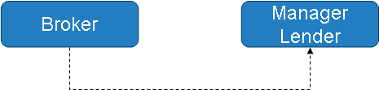

Necessary Information:
Stock (type)
Quantity
Fee
Maturity Date
Devolution: Reversible or Fixed

Notes:
Securities lending contracts are negotiated every day, fees and general conditions depending on the market (volatility, liquidity, etc)
For every single contract between broker and manager there is the possibility to apply a different fee and maturity date as well.
Some securities lending contracts are classified as “fixed” because of maturity date. The borrower has to keep these shares in his portfolio until maturity date.
But, the majority of the contracts are “reversible”. In this case, the borrower can send the shares back to the lender at any time.
This is the reason to inform the fees as a percentage not a value because the manager can send back the shares at any time and the value paid will be proportional.

- Confirmation (or proposal) from Broker to Borrower Manager

One Lender

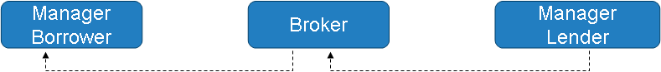

Necessary Information:
Stock (type)
Quantity
Fee
Maturity Date
Devolution Type: Reversible or Fixed
Minimum Date for Call Back
Type of price to calculate commission (Fee)
It could be T-1, T0 or other.

Notes:
Minimum Date for Call Back
There is a minimum date to give back the shares in some contracts. The borrower can send back all shares before maturity date, but there is a period to keep them.

More than one Lender Manager

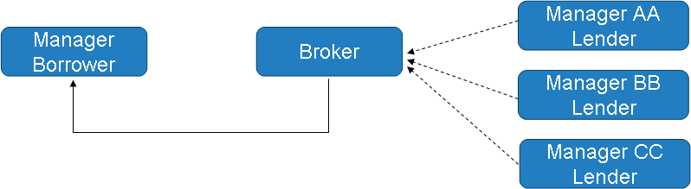

Notes:
Sometimes to have the total quantity asked by the Borrower Manager, the Broker can make a lot of contracts with different Lender Managers.
In Brazilian Financial Market, the securities lending counterparty of both sides are the broker. The contracts are firmed between Borrower Manager and Broker and another one between Lender Manager and Broker. Normally there is not communication between Borrower and Lender Managers.

- Confirmation of the contract – Borrower Manager to Broker

Necessary Information:
Stock (type)
Quantity
Fee
Maturity Date
Devolution: Reversible or Fixed
Minimum Date for Call Back
Type of price to calculate commission (Fee)
It could be T-1, T0 or other.

- Confirmation of the contract – Broker to Lender Manager


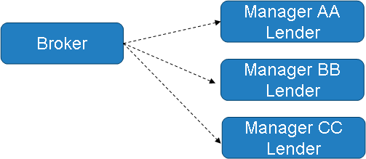

Necessary Information:
Stock (type)
Quantity
Fee
Maturity Date
Devolution: Reversible or Fixed
Minimum Date for Call Back
Type of price to calculate commission (Fee)
It could be T-1, T0 or other.

In this flow, the Broker acts as intermediary for securities securities lendings offered by the Lending Manager, with the Borrower. The Broker will send details of the securities lending agreement signed with the counterparty (Borrower) and the Lending Manager may confirm the details received and authorize the securities lending agreement to be made by the Broker, or may reject the details received. In this case, the Broker shall correct the details and resend to the Manager or cancel the agreement and terminate the flow.
- Confirmation of the contract – Borrower Manager to Asset Controller and Custodian

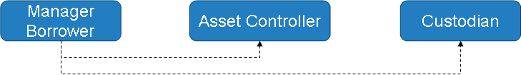

Necessary Information:
Stock (type)
Quantity
Fee
Maturity Date
Devolution: Reversible or Fixed
Minimum Date for Call Back
Type of price to calculate commission (Fee)
* Could be T-1, T+0 or other.

- Confirmation of the contract – Lender Manager to Asset Controller and Custodian

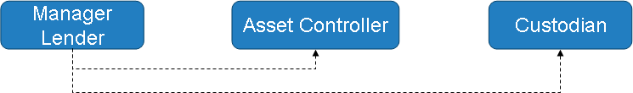

Necessary Information:
Stock (type)
Quantity
Fee
Maturity Date
Devolution: Reversible or Fixed
Minimum Date for Call Back
Type of price to calculate commission (Fee)
* Could be T-1, T+0 or other.

Notes:
The Custodian has to receive the same information to guarantee:
- Share reception (From the Lender)
- Devolution of shares at maturity date (To the Borrower)
- Fee payment at maturity date (To pay the correct value at the correct date)

