Change Request
for the update of ISO 20022 financial repository items
Change Request Name:
Transaction Id expansion within instruction. (Account Owner, Account Servicer, Third Party)
A. Origin of request
Submitter: Deutsche Bundesbank
Contact Person: Dirk Kienitz, Email: Dirk.Kienitz@bundesbank.de, Tel: +49 69 9566 3803
Requesting Group: Deutsche Bundesbank on behalf of 4CB for TARGET2-Securities (T2S)
B. Related Messages
SecuritiesSettlementTransactionStatusAdvice (sese.024.001.01)
SecuritiesSettlementTransactionConfirmation (sese.025.001.01)
IntraPositionMovementStatusAdvice (semt.014.001.01)
IntraPositionMovementConfirmation (semt.015.001.01)
SecuritiesTransactionStatusQuery (sese.021.001.01)
---------------------------------------------
SecuritiesSettlementConditionModificationRequest (sese.030.001.01)
SecuritiesSettlementConditionModificationStatusAdvice (sese.031.001.01)
SecuritiesTransactionCancellationRequest (sese.020.001.01)
SecuritiesTransactionCancellationRequestStatusAdvice (sese.027.001.01)
C. Description of the Change request
Business Context:
The proposed Change request will allow to identify the Transaction by means of a Third Party Identifier identifying the number of parties participating on the settlement chain. Therefore, the Change request will add this Transaction Identification reference (ThirdPartyTransactionIdentification) to the Status Advice messages (including the Status Query) and Confirmation messages.
Aditionally, since the Third Party Identifier is informed in Status Advice and Confirmation messages, this reference can be also used to identify the underlying instruction that the party intends to modify or cancel. Therefore the “ThirdPartyTransactionIdentification” would be added the same as the current “AccountOwnerTransactionIdentification” and the “AccountServicerTransactionIdentification”.

Nature of change:
Add a Third Party Transaction ID
D. Purpose of the change
General T2S business context background and community of interested users:
The cross-border and domestic settlement of securities against central bank money requires harmonised and standardised messages as a part of an effective and efficient communication. The current European post-trade sector is fragmented into multiple national markets. This lack of integration implicates a significant cost burden and inefficiency of cross-border wholesale transactions, and a very significant inhibition of retail transactions. To address this issue at European level, the consolidated, harmonised and non-profit platform TARGET2-Securities (T2S), which will provide settlement services to the Central Securities Depositories (CSDs) and their participants, will be delivered by the Eurosystem to the market by 2013.
The scope of this request covers the maintenance process of ISO registered messages which shall be used by T2S. These messages shall be used for the communication of the system with its users, namely Central Securities Depositories (CSD) and CSD participants as well as other platforms such as collateral management platforms and RTGS systems.
Specific benefits of this change request:
By adding a Third Party Transaction ID, the traceability and identification of an instruction sent by a Third Party, such as a Central Counterparty (CCP) or another CSD Participant, is allowed.
E. Urgency of the request
Default
(All change requests submitted by June 1st will be considered for development in the following yearly ISO 20022 maintenance cycle which completes with publication of new message versions in April/May of the following year)

F. Business examples
The following example describes the business case where a second CSD Participant is involved in the settlement chain:
Party 1, playing the role of a CSD Participant, sends the Instruction A to Party 2, playing the role of another CSD Participant that has the right of sending instructions on behalf.
Party 2 forwards the Instruction A to the T2S Platform (identifying the instruction by itself but sending the identification of the owner).
In this business case, the Instruction can be identified through the following references:
- Account Owner Transaction Identification .Party 1, CSD Participant.
- Third Party Transaction Identification. Party 2, CSD Participant that sent the instruction on behalf. This ID is missing on the current messages; Status advice and Confirmation.
- Market Infrastructure Identification: T2S Reference.

Matrix of roles and associated references
 | Party 1 | Party 2 | Party 3 | T2S platform
Role | CSD Participant | Service Bureau | CSD of party 1 | Market Infrastructure
Reference of instruction | TxId_Party1: 123 | TxId_Party2: abc | NA | TxId_T2S:T2SABC
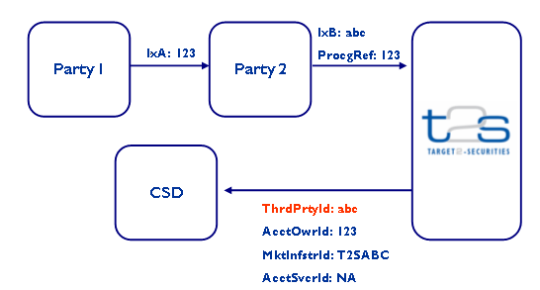

- SEG recommendation:
This section is not to be taken care of by the submitter of the change request. It will be completed in due time by the SEG(s) in charge of the related ISO 20022 messages.

Consider |  |  | Timing
 |  |  | - Next yearly cycle: 2010/2011  (the change will be considered for implementation in the yearly maintenance cycle which starts in 2010 and completes with the publication of new message versions in the spring of 2011) |  |  | Priority:  high  medium  low
- At the occasion of the next maintenance of the messages
(the change will be considered for implementation, but does not justify maintenance of the messages in its own right – will be pending until more critical change requests are received for the messages)
- Urgent unscheduled
(the change justifies an urgent implementation outside of the normal yearly cycle)
 |  |  | - Other timing:
Comments:

Reject | Y
Reason for rejection:
Not clear what the business need is. Better and more consistent representation of business flows and scenario is required.
SEG agreed to wait for MWG decision.

