Change Request
for the update of ISO 20022 financial repository items
- Origin of the request:
A.1 Submitter: Febelfin – Belgian Bankers’ Association
A.2 Contact person:
Patrick Wynant | patrick.wynant@febelfin.be | +32 2 507 68 51
Philippe Minnaert | philippe.minnaert@fortis.com | +32 2 228 37 42
Benoît Baijot | benoit.baijot@dexia.com | +32 2 222 62 69
Steven Bogaert | steven.bogaert@ing.be
Elke De Bruyckere | elke.debruyckere@kbc.be | +32 2 429 23 39
Jurgen Declerck | Jurgen.declerck@kbc.be | +32 2 429 91 38

A.3 Sponsors:
  - Febelfin – Belgian Bankers’ Association
  - Federation of Finnish Financial Services
  - Danish Bankers Association
Related messages:
- camt052.001.02
- camt053.001.02
- camt054.001.02
- Description of the change request:
Add additional items to report on POS-transactions.
This set of elements should be added at ‘TransactionDetails’-level, as a new composite element in TransactionDetails <TxDtls> in all three of the related messages (see above).

- Purpose of the change:
Account Reporting functionality needs to be extended to explicitly cater for the reporting of Card-transactions along with the underlying details. This extension will serve the reconciliation needs of Card-transactions in addition to simply reporting the monetary amount.
The proposed reporting container for card-transactions englobes data related to the Card (Number*, Scheme), data regarding the Terminal (Number, ID (i.e. Name and Townname)) and transactional data. In the proposed transactional data block, it is possible to report Global Transaction information and/or Individual Transaction information and/or cash deposit Transactions
* Card Number : in application of the PCI regulation, the Card Number can be trunqued.
- Urgency of the request:
Next ISO 20022 version, camt.052.001.03, camt.053.001.03, and camt.054.001.03.

- Business examples:
Currently forms part of account reporting market practice within Belgium (FEBELFIN), applicable to global implementations where such information is available and required for account reporting purposes.
- SEG recommendation:
This section is not to be taken care of by the submitter of the change request. It will be completed in due time by the SEG(s) in charge of the related ISO 20022 messages.

Consider |  | X | Timing
 |  |  | - Next yearly cycle: 2010/2011  (the change will be considered for implementation in the yearly maintenance cycle which starts in 2010 and completes with the publication of new message versions in the spring of 2011) |  |  | Priority:  high  medium  low
 |  |  | - At the occasion of the next maintenance of the messages  (the change will be considered for implementation, but does not justify maintenance of the messages in its own right – will be pending until more critical change requests are received for the messages) |  | X
- Urgent unscheduled
(the change justifies an urgent implementation outside of the normal yearly cycle)
 |  |  | - Other timing:
Comments:
Defer to the 2011/2012 maintenance cycle, for implementation in 2012

Reject
Reason for rejection:

Results from the
Workshop 10 February 2012

Introduction:
The resulting structure and components are based on discussions between Febelfin, representant from EPAS and/or Berlin Group and SWIFT, during 3 workshops that took place on 18 January, 02 February and 12 February 2012.
In order to define the new structures, the requirements of the existing EPAS components, the Febelfin requirements, the new SEPA card requirements have been taken into considerations.

Possible scenarios:
Based on the input provided during the 3 workshops, we identified actually 3 different scenarios for the reporting of Card Transactions:
- An aggregation of the data performed by the Account Servicer, at the entry level.
This scenario corresponds for example to one entry that aggregates all monthly deferred debit card transactions for a card holder into a single entry or for a specific POI for a merchant. No further details are available on the account statement.
CardTransaction component to be added at the Entry level:
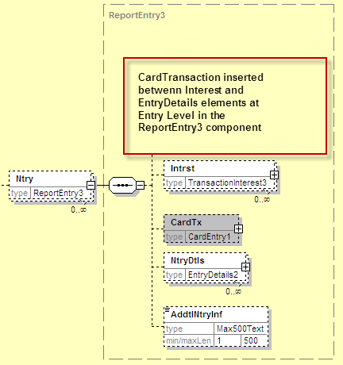
Defined with the following elements
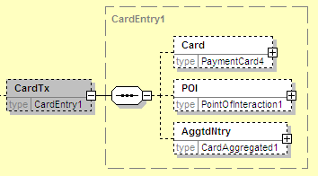
All elements will be detailed in the sections below.
- An aggregation of the data performed by the Card Acquirer, at the transaction level. This scenario corresponds to the possibilities offered to the merchants to aggregate the reporting for a specific POI or per location or sub-division (such as per shop for a large retail corporate). In this case, the reporting information provided in the cash entry will be limited to a range of card transaction sequence numbers and a date period.
CardTransaction component to be added at the Transaction Details level:
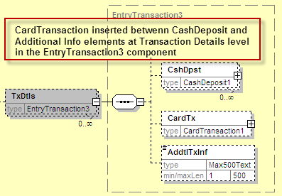
Defined with the following elements
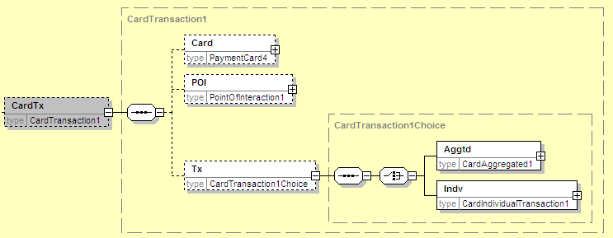
For aggregated entries, the Tx/Aggtd element will be used.
- Details reported for all transactions reported in the entry
All individual card transactions will be reported for a specific entry and the same Transaction Details component will be used, except that the Individual element will be used in the above choice:

Detailed elements in Card Transactions:

For all 3 scenarios, the Card and POI elements must be available and have been defined as follows, based on the components already defined in the Dictionary by the Card experts:

- PaymentCard4 message component used to type the Card element:
Remark: this component is a reduced version of the elements used in the EPAS messages, as we have removed the elements not required for cash reporting to identify the card.
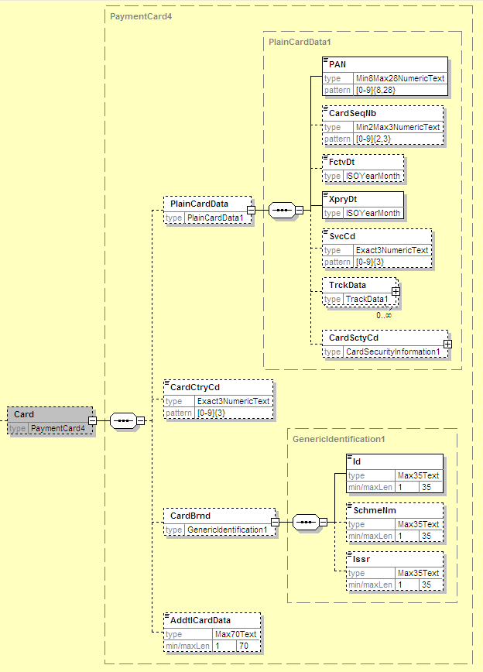

- PointOfInteraction1 element used to type Point Of Interaction elements:
Remark: this component has been reused as already defined in the ISO 20022 dictionary.
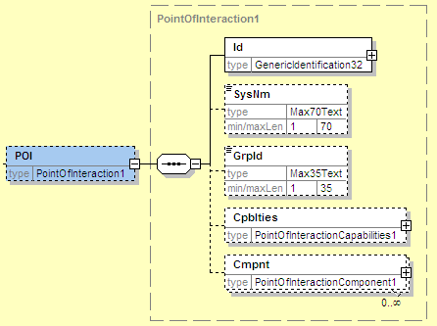
Detailed description of the fields – see message spreadsheet at the bottom of this document.

- CardAggregated1:
Remark: the same component has been reused both at the Entry and TransactionDetails levels, as the same information has to be provided for aggregated card transactions, independently of which organisation has performed the aggregation.
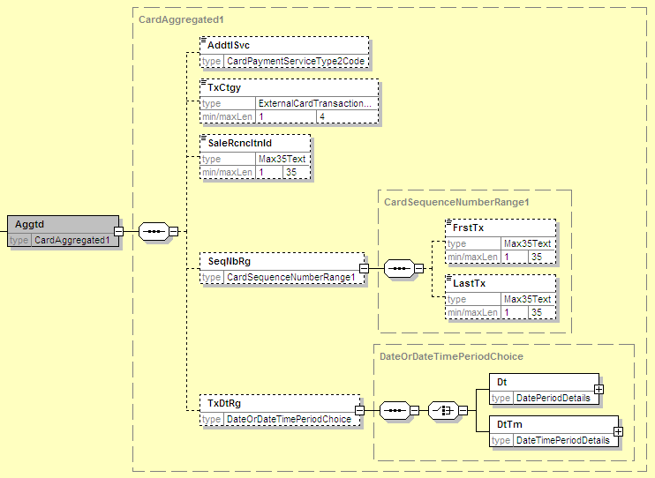

- Transaction element in CardTransaction:
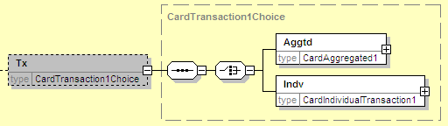
Composed of the aggregated card transaction described above or the Individual transaction, as follows:
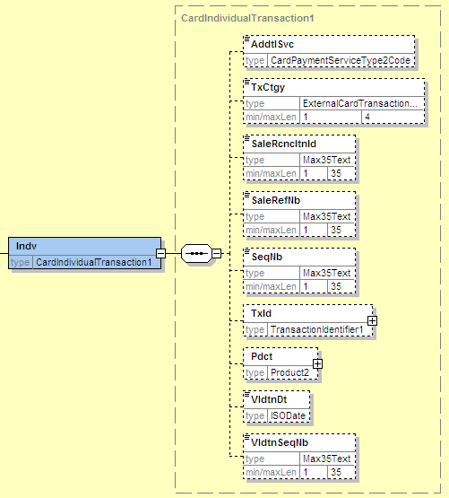

- Documentation of CardEntry1 and CardTransaction1 message components:

