Change Request
for the update of an External Code List used in ISO 20022
- Origin of the request:
A.1 Submitter:
Deutsche Bundesbank

A.2 Contact person:
Markus Gross
e-mail markus.gross@bundesbank.de
phone: +49 69 95 66 37 26

A.3 Sponsors:

./.
- Related External Code List:

ExternalCashClearingSystem1Code

- Description of the change request:

Please add the following code to the code list:
Code | Name | Definition
SCL | RPS SEPA-Clearer | DE – SEPA-Clearer of the Retail Payment System operated by Deutsche Bundesbank

- Purpose of the change:

Currently, in ISO 20022-based SEPA payment messages, the SEPA-Clearer of the Retail Payment System (RPS) owned and operated by Deutsche Bundesbank is addressed by a proprietary code in the “Clearing System” data element (sub-element “Proprietary”).

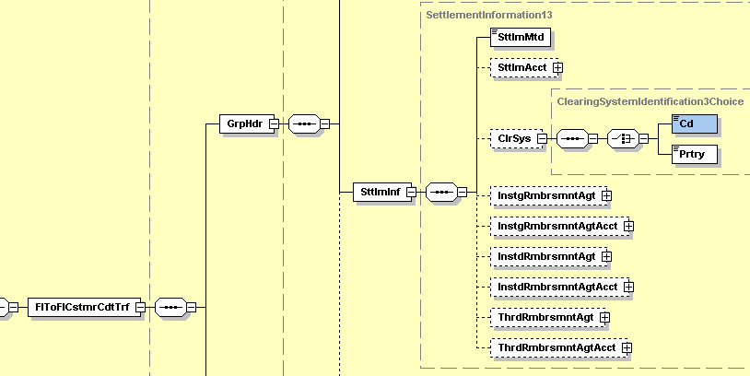

In order to be able to adequately address the service with a standardised code in the sub-element “Code”, the extension of the current list of External Cash Clearing Codes with a new code identifying the SEPA-Clearer of the Retail Payment System is requested.

- Urgency of the request:

The change should be reflected in the next possible quarterly release of the External Code List.

- Business examples:
The code “SCL” shall specify the clearing system “SEPA-Clearer of the Bundesbank’s Retail Payment System (RPS)” in SEPA related payment instructions (eg SEPA credit transfer using a pacs.008.001.02, SEPA core direct debit using a pacs.003.001.02).

- Comments from the SEG and disposition of comment by the submitter
This section will be used in case the SEG requires any clarification from the submitter on the change request
- SEG recommendation:
This section will be completed in due time by the SEG in charge of the related External Code List.

Accept |  | V | Timing
 |  |  | - Next possible quarterly release |  | Second quarter 2010
 |  |  | - Other timing:
Comments:

Reject
Reason for rejection:

